Count and write the numbers.
How many pencilcases are there?

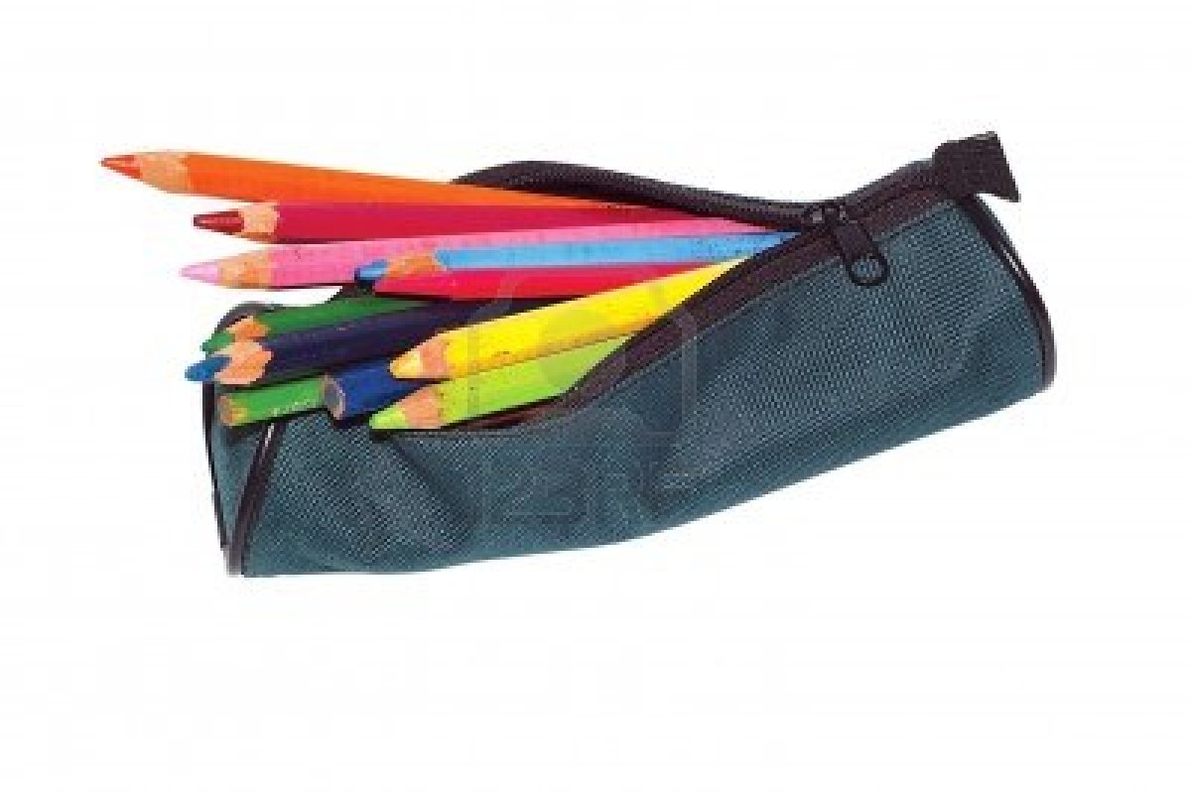

…………………….

How many books are there?


…………………….

How many schoolbags are there?

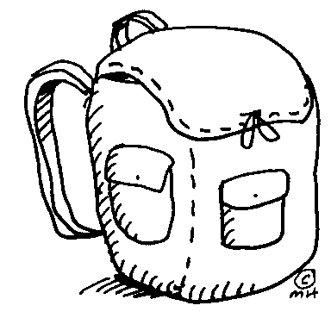

…………………….

How many tables are there?

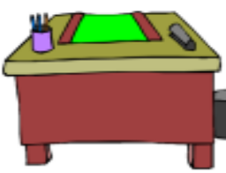

…………………….
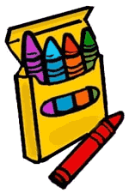
How many crayons are there?

…………………….

How many chairs are there?

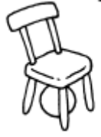
…………………….


How many scissors are there?

…………………….

How many pens are there?



…………………….

How many glues are there?

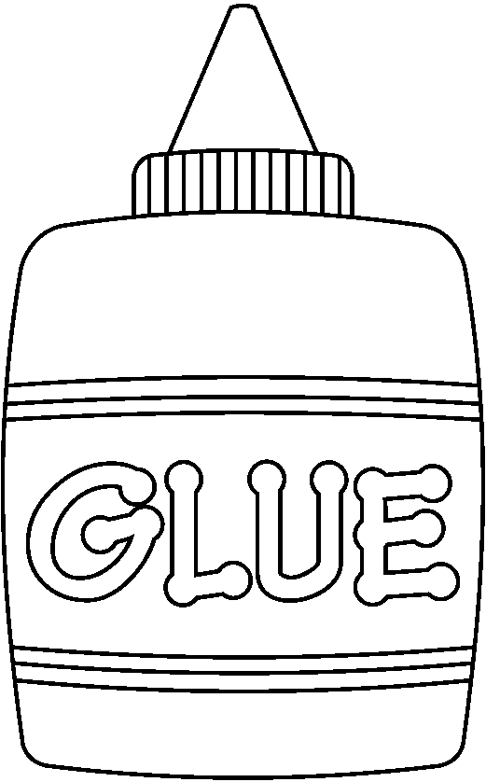

…………………….

How many schools are there?



Elif ARSLAN ÇELE
English Language Teacher
…………………….

