AKPINAR ŞEHİT VAHİT ELMAS SECONDARY SCHOOL … ACADEMIC YEAR 1st TERM 1st WRITTEN ENGLISH EXAM FOR THE 8th GRADE
NAME / SURNAME: NUMBER:

A. Choose the correct options. 3px20=60p
1) JACK: Hello, NİCK. My classmates and I are getting together after school. Would you like to come with us?
NICK: I would love to, but I can’t, sorry. My relatives
are going to come over. Maybe next time.
JACK: Ok, then. See you.
According to the dialogue above, Nick ………………
a. refuses jack’s offer and he doesn’t make an excuse.
b. invites his cousins to spend some time on Monday.
c. refuses his invitation by giving a reason.
d. accepts meeting with JACK’s classmates

2) DENİZ : Zeynep and I are organizing a birthday party for Akif. It will be at Akif’s house. Would you like to come?
EZGİ: Who else will come to the party?
DENİZ: NİSA and AYLİN.
EZGİ: Oh! I ‘d love to come , but I can’t. …………………..

a. I don’t get on well with them.
b. Aylin always backs me up.
c. Nisa and I are best friends.
d. I always count on them.

3) “My best friend and I attach importance to each other ; and we trust each other. We never forget our birthdays and we celebrate our birthdays every year. “
Which of the following has similar meaning with the paragraph above?
a. We sometimes lie , but we are friends anyway.
b. We always argue with each other.
c. My best friend and I have nothing in common.
d. I always support her and I know that she always backs me up.

4 ) Waiter : May I help you ?
Customer: Yes, Can I have today’s soup please ?
Waiter: _______________________________
Customer: I’d like grilled chicken, please.

a. Would you like to eat dessert ?
b. What would you like to have for a main course ?
c. Would you like anything to drink ?
d. Do you want to have salad ?

5) Pam: James and I are great buddies. We like spending time together. We usually go _____________ on weekdays. Western films are our favorite.
a. for a walk b. book fairs
c. to the cinema d. to the concert

6) JESS: Listen, Tim. Are you busy tonight?
TIM: ……………………………Why?
JESS: I have two tickets for a band’s concert tonight. Would you like to go with me?
TIM: I’ d love to.
Which expression can you use in the blank?
a. Of course. Where is it?
b. No, not at all.
c. Yeah, sure. Thanks for inviting me.
d. Sure. It sounds awesome.

7) A good friend should be ………………… but She / he shouldn’t be ………………
a. sneaky / arrogant c. tactful / sneaky
b. caring / reliable d. aggressive / helpful

8) SAM: Mike ! I am so bored at the moment. Shall we watch a film?
MIKE :Sorry, but I can’t watch it now. I must study for the exam.
SAM: How about watching a thriller on Saturday night?
MIKE: That sounds awesome. See you at the weekend.
SAM: Ok. See you then.
Read the dialogue above. Which sentence is Mike’s excuse for refusing the invitation.
a. I am so bored at the moment.
b. I must study for the exam.
c. Shall we see a movie?
d. That sounds awesome.

9 )
Dear Kelly,
Thank you for the nice invitation. I am sorry but I can’t attend the event. I‘d love to see all my old classmates, but we are going on holiday on July 1.
See you later,
Sincerely
BRIAN
According to the letter which sentence is the closing part?
a. Dear Kelly ,
b. Sincerely.
c. I am sorry but I can’t attend the event.
d. Thank you for the nice invitation.

10) ( 1 ) Jessica likes music a lot. ( 2 )She loves rap, but she doesn’t listen to pop. ( 3 ) She listens to music when she skates to school. ( 4)She can’t stand it. Because she thinks pop music is unbearable.

Which sentence is not related to the paragraph?
a. 1 b. 2 c. 3 d . 4

11 ) BRENDA: ………………………………?
SHEILA: I usually surf the net or play tennis.
Hello! My name’s Hillary Peterson. We live in Ohio, USA. My mother wakes my sisters and me up at 7.15 every morning. I brush my teeth, take a bath and get dressed for school in the mornings. After I have breakfast, I take my huge bag and run for school bus. On the bus, I listen to rap music on my cell phone. Rap music and dance are very popular in USA. When I get to school, I greet my friends and we have a chat. I love my teachers, but they always give us a lot of homework.

a. What do you do at weekends?
b. Do you surf the net?
c. How about playing tennis?
d. When do you play tennis?

12) I. Hip-hop? No,I don’t think so. I prefer listening to jazz.
II. That’s interesting. Who is your favourite singer ?
III. Dad, do you like listening to Hip-hop ?
IV. It’s Ray Charles. I really love him.
Which one shows the correct order of the dialogue ?

a. III - I - II - IV b. IV - I - II - III
c. I - II - III - IV d. III - I - IV - II

13) ANN: We are planning a slumber party in Hailey’s house.
Would you like to join us ?
BILL: Awesome. Of course I will. ___________?
ANN: On Friday night.
a. Where are you going to meet ?
b. What time do you come over ?
c. When are you going to have it ?
d. How often do you go to parties ?

14.
Teenagers shopping behaviour
% 55 | buy clothing items
% 25 | buy beauty & health products
% 15 | buy electronic items
% 5 | buy books

Which one is true according to the chart ?
a. Buying clothes is more popular among teenagers.
b. Teenagers mostly buy books.
c. Teenagers don’t buy electronic items.
d. Teenagers don’t use beauty products.

15. Complete the sentences with appropriate words
A. my room
B. instagram
C. playing piano
D. exams
I. I am worried about my…..
II. I am skilled at ……
III. My favorite Smartphone
application is ….
IV. My favorite place is ……..

a. I-D II-B III-A IV-C
b. I-D II-C III-B IV-A
c. I-B II-C III-D IV-A
d. I-A II-D III-C IV-B

Answer the questions 16, 17 and 18 according to the text.

16. What does Hillary regularly do ?
a. She listens to jazz music on her cell phone.
b. She walks to school.
c. She takes a bath before sleeping.
d. She takes her bag and runs to school bus.

17. What does Hillary do when she gets to school ?
a. She takes a bath.
b. She has breakfast.
c. She says “hello” to her friends.
d. She gets dressed.

18. Before Hillary has breakfast, ……………..
a. She takes her big bag and walks to school.
b. She listens to rap music on the school bus.
c. She takes a bath and gets dressed
d. She chats with her school friends.

Questions 19 and 20 are related to the invitation below.
WEST HILL SECONDARY SCHOOL & THE CLASS OF 2013
We are organizing a class reunion. We all want to see you with us. Our teachers will be there,too. Don’t miss this chance.
Sunday, November 18 Olive Restaurant
At 8 pm.
60 euro per person
For more information, contact David Black.
PS: If you can attend, inform us at least 4 days before the event !

19. What is deadline for joining the reunion ?
a. 60 euro b. 2013
c. 8 pm d. November 14

20. How can you get more information ?
a. You can inform until November 14.
b. You can contact teachers.
c. You should pay 60 euro first.
d. You can ask David Black.
B) fill in the blanks with the correct words. 11x2p=22 p
slice grate roast peel stove sprinkle fork chop saucepan dice spread
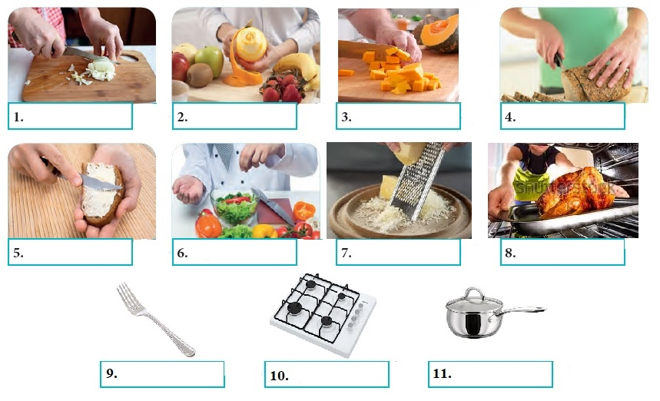

C) Answer the questions 1-6 according to the related recipes above.
(3px6=18p)
First, dissolve 1 pocket of yeast in a warm water. Second, add a spoon of sugar, a tea spoon of salt, a cup of oil and 3 cups of flour. Next, stir the mixture and knead the dough. Then, spread some oil into the cake pan. After that, pour the mixture into the cake pan. Finally, bake it at 200° for 50-55 minutes. Enjoy your bread.
PS : For better taste, wait for an hour before baking.
- Which picture shows the step after pouring the mixture into the cake pan?
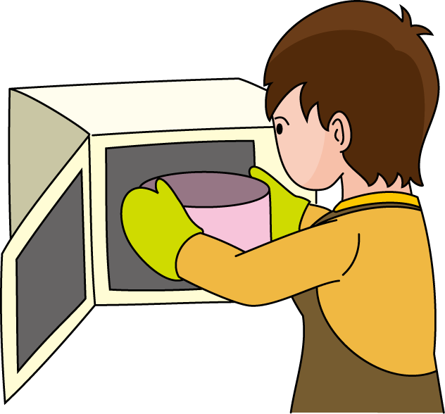
A) B)

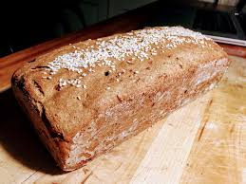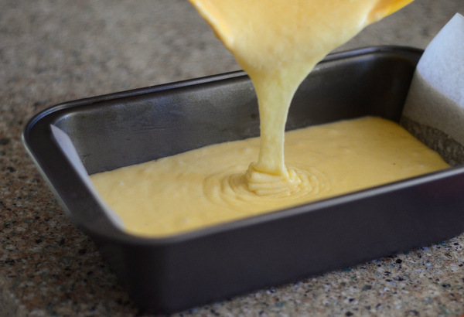
C) D)

- 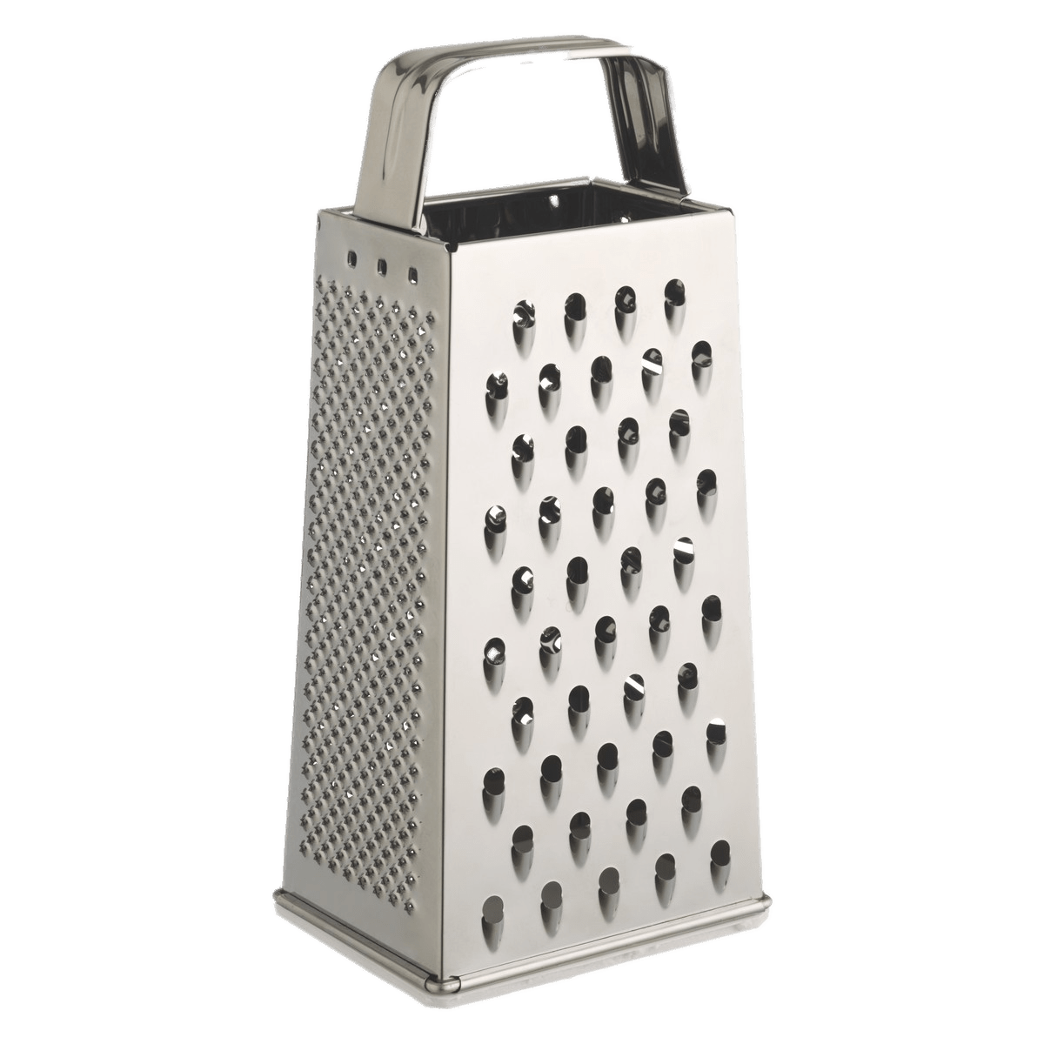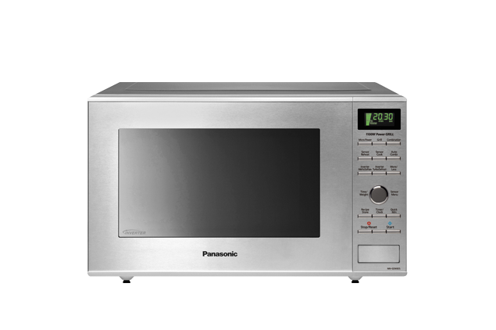Which tool will NOT we use while baking the bread according to the recipe?
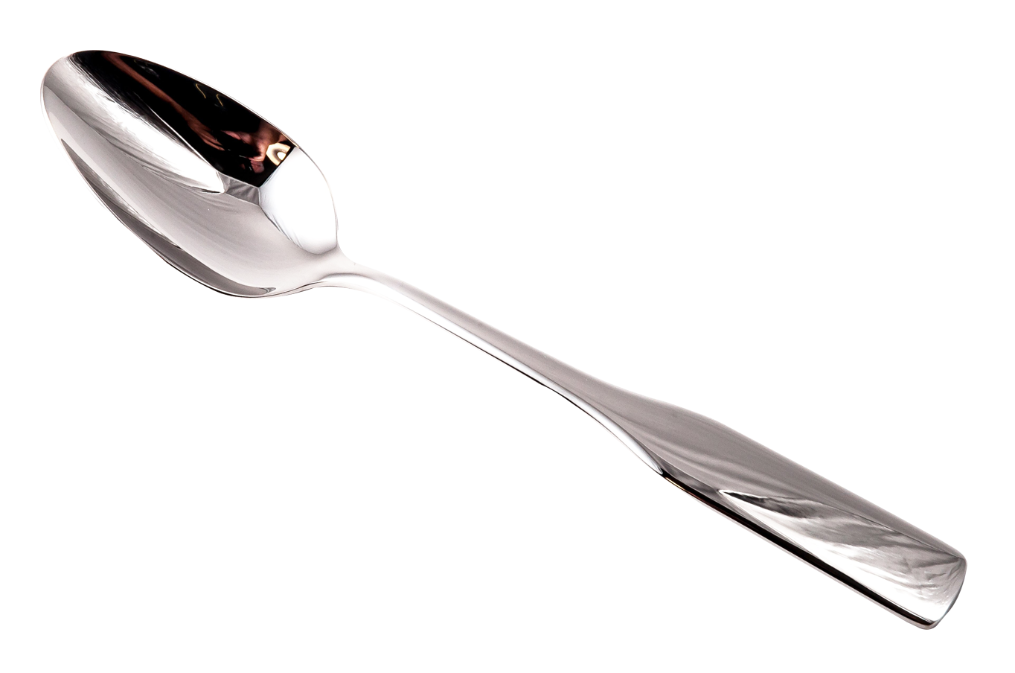
A) B) C) D)

- You will have more delicious bread if you …..
- wait sixty minutes before baking.
- bake it at 200° for 55 minutes.
- spread some oil into the cake.
- knead the dough after mixing.
Pizza Recipe
First, in a large bowl, dissolve yeast and sugar in water. Add oil, two cups of flour and salt. Stir all of them. Knead about 2-3 minutes. Second, Put it into a greased bowl. Cover and wait about 45 minutes. Meanwhile, chop sausages, peppers, and some cheese. Next, put the dough into baking tray. Then, spread tomato sauce over the dough. After that, put chopped pepper, sausages and some corn before sprinkling cheese on the top. Bake it at 200° for 25-30 minutes. Pizza is ready. Enjoy it.
Note: For a better pizza, use mozzarella cheese.
- Which question is not answered in the text?
- How long should we bake it?
- How much flour do we have to use?
- When should we add some cheese?
- How should we make tomato sauce?

- Which of the ingredients will NOT we use for the pizza?

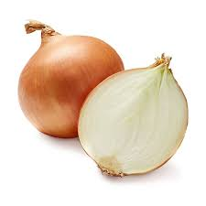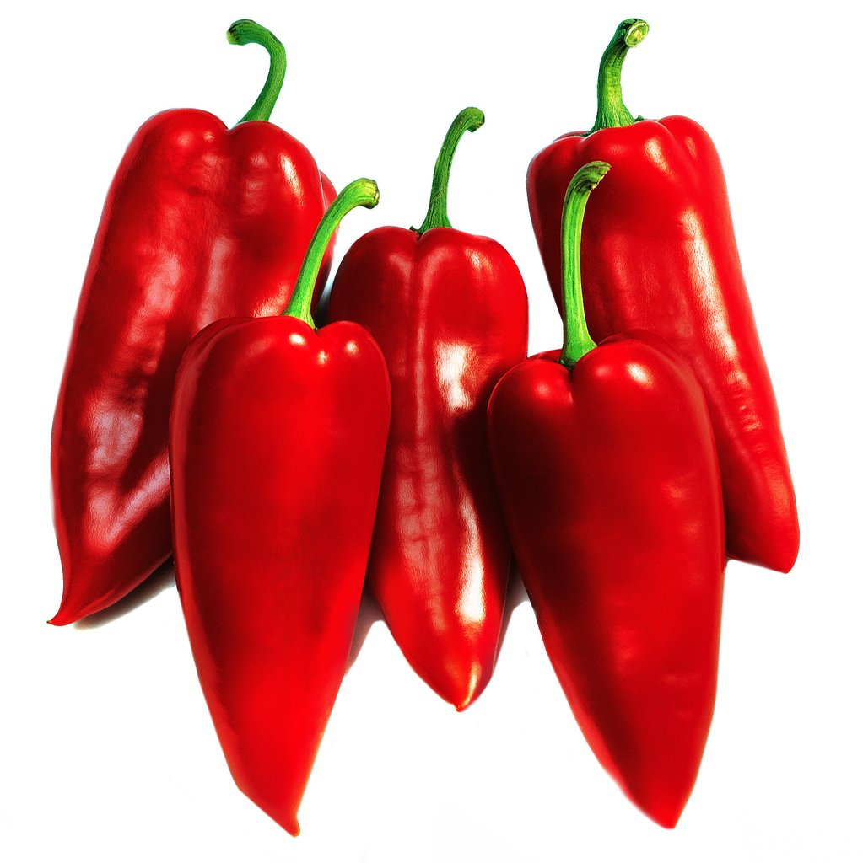 A) B)

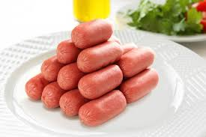
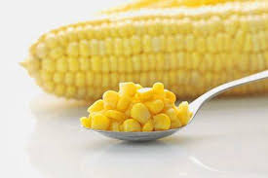 C) D)

- What is the last step before baking the pizza ?
- Put chopped pepper, sausages and some corn.
- Bake it at 200° for 25-30 minutes.
- Sprinkle cheese on the top.
- Use mozzarella cheese.

