1- Look at the pictures and answer the questions.
WHAT IS THIS ?

A : What is this ?
B : This is a pencil.
pencil

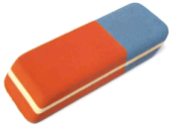
A : What is this ?
B : .........................
eraser


A : ..........................?
B : ..........................
notebook

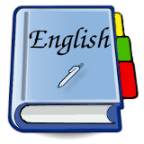
A : ..........................?
B :............................
book

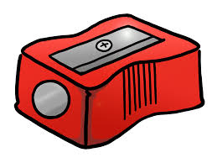
A : ...........................?
B : ............................
sharpener

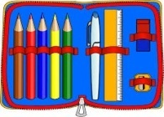
A : ............................?
B : ..............................
pencilcase

A : ...........................?
B : ............................
paper

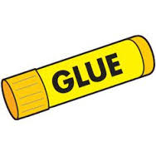
A : ............................?
B : .............................
glue
2- Look at the pictures and answer the questions.
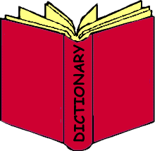
A: What is this ?
B : This is .................. .
dictionary


A : What is this ?
B : .......................
whiteboard

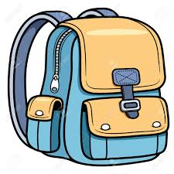
A : ......................?
B : ......................
schoolbag

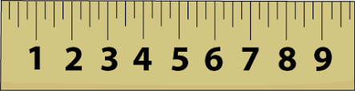
A : ...................... ?
B : ...... ..................
ruler

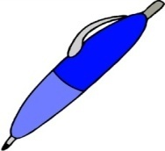
A : ......................... ?
B : ..........................
pen
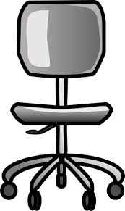

A : .......................... ?
B : ............................
chair
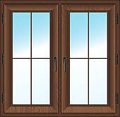
A : .......................... ?
B : ..........................
window
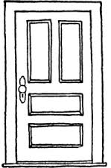
A : ........................... ?
B : ............................

door

İLKOKULU 2. SINIF İNGİLİZCE ÜNİTE 1 – 2 ÇALIŞMA KAĞIDI

Boşlukları uygun şekilde doldurup anlamlarıyla eşleştirin.
( 1 ) What’s ................name? ( ) Nasılsın?
( 2 ) My name is ........................ ( ) Adın ne?
( 3 ) How .............you? ( ) Merhaba
( 4 ) Nice to .................you. ( ) Benim adım..................
( 5 ) Hello ( ) Günaydın
( 6 ) Good ......................... ( ) İyi geceler
( 7 )................. night. ( ) Sonra görüşürüz
( 8 ) See.......................later ( ) Hoşçakal
( 9 ) ................bye ( ) Tanıştığıma memnun oldum

( a ) ambulance ( ) tenis
( b ) train ( ) televiyon
( c ) tennis ( ) spor
( ç ) balloon ( ) tren
( d ) hamburger ( ) doktor
( e ) cake ( ) garaj
( f ) lemon ( ) radyo
( g ) doctor ( ) ambulans
( ğ ) police ( ) kek
( h ) garage ( ) pizza
( ı ) football ( ) limon
( i ) television ( ) hamburger
( j ) radio ( ) polis
( k ) sport ( ) balon
( l ) pizza ( ) futbol

