LIFE

A)Match the activities with the pictures
1-Finish all the homework 2-Take a nap 3-Run errands 4-Visit grandparents 5-Take folk dance classes 6-Help Mom 7-Take care of the pet

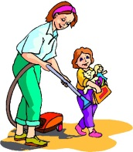
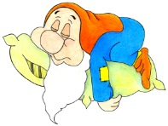

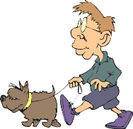
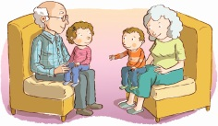

B)Write the time
03.20 |  | 10.30
12.15 |  | 08.45
02.55 |  | 09.25
11.05 |  | 06.00
06.35 |  | 01.10

It is half past six |  | It is twelve o’clock
It is a quarter past one |  | It is ten past eight
It is five to six |  | It is twenty past nine
It is a quarter to two |  | It is twenty five to eleven
It is ten to nine |  | It is twenty to six

C) Read the text and answer the questions.
Emily is thirteen years old. She is a student in the seventh grade. She wakes up at seven o’clock. She has breakfast at half past seven. She gets dressed and She leaves home at a quarter to eight. Her lessons start at half past eight. She has lunch at school canteen at twelve o’clock. After school, she takes a nap at a quarter past four. Then, she helps her mother and takes care of her dog at six o’clock. She finishes all her homework before dinner. She watches tv until nine o’clock. She writes in her diary before she goes to bed.
1-What time does Emily leave home?
___________________________________________
2-What does she do after school?
____________________________________________
3-Does she wake up at seven o’clock?
____________________________________________
4-Does she take care of her cat?
____________________________________________

D)Write TRUE or FALSE according to the text
1-Emily takes a nap at 04.15._______
2-She watches tv until 9 o’clock._______
3-She finishes all her homework after dinner._______
4-She has breakfast at 07.30.______
5-Her lessons start at 08.15.______
E)Match the questions with the answers
1-What do you do after school?____
2-When do you visit your uncle?___
3-Does she play tennis on Sundays?____
4-What is the date today?____
5-What time does he get up?_____
6-What does your best friend do at break time?_________
A)Yes, she does.
B) At half past seven.
C)She plays hide and seek.
D)29 October 2018
E)On Saturdays
F)I take a nap.

Duygu Senyer-Elt

F)Look at Jack’s Daily routines and make sentences according to the chart
- Jack gets up at half past seven.

ROUTINES TIME
Get up 07.30 a.m
Have breakfast 08.00 a.m
Go to school 08.15 a.m
Lessons start 08.30 a.m
Have lunch 12.10 p.m
Lessons finish 03.00 p.m
Play basketball 04.10 p.m
Run errands 05.05 p.m
Have a rest 06.30 p.m
Study English 07.00 p.m
Write diary 10.20 p.m

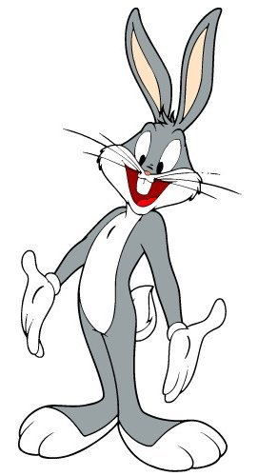
G) Fill in the blanks with Simple Present Tense
1- They_______(get) ready for school at half past nine.
2-She_________(play) chess after school.
3-He_________(go) to dance clup on Fridays.
4-I___________(do) yoga at the weekend.
5-My brother__________(finish) all his homework at six o’clock
6-Daisy and Joe ______________(take) a nap after school.
7-Alex__________(have) breakfast every morning .
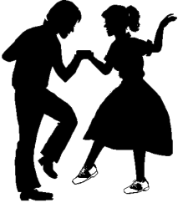
H)Circle the correct option
1) Sue : Would you like to learn dancing?
Mary : Yes. - - - -?
Sue : On Thursday at 4 p.m.
A) What does traditional dance mean B) How often do you join the courses
C) Who is your dance trainer D) When is the dance class

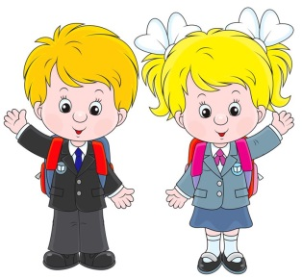
2) George : - - - -?
Maria : At half past three p.m.
A) Do you go to bed late
B) What time do you leave school
C) How often do you visit your aunt
D) What’s the first day of the week
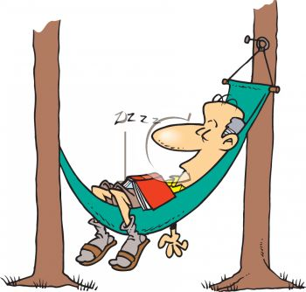
3)She___________________before dinner.
A)Has a rest B)Takes care of the pet
C)Runs errands D)Writes in her diary

4)Lilly: What do you do after school?
Susan:______________________________
A)at nine o’clock B)He plays soccer.
C)I do my homework D)No, they don’t run errands
Duygu Senyer-Elt

