6th PRESEASON CHECK UP TEST

1. I always go online in the afternoon.
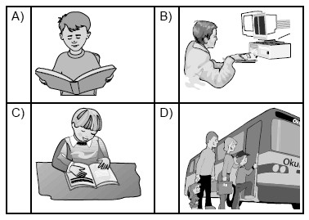
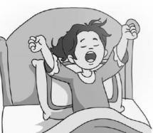
2. Amy - - - - .

- gets out of bed at 8
- has breakfast at home
- has a bath in the morning
- washes his hands

3. Jane: - - - - ?
Bob: By school bus.

- How do you go to school?
- What time do you get up?
- When do you go to bed?
- Do you have breakfast at home?

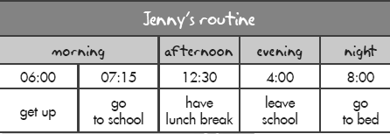
4.

Tabloya gore aşağıdakilerden hangisi doğrudur?
- She goes to school at quarter to seven a.m.
- She goes to bed at eight a.m.
- She has a lunch break at half past twelwe p.m.
- She leaves school at six a.m.

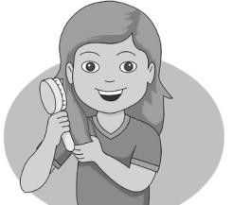
- Görselin ifade ettiği Seçenek aşağıdakilerden hangisidir?

- get out of bed
- get dressed
- comb hair
- do homework

- Eşleştirmelerden hangisi yanlıştır?

- toyshop doll
- bakery bread
- butcher’s meat
- museum flower
7 ve 8. Soruları verilen plana gore cevaplayınız.

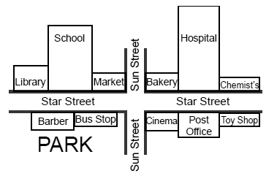
- Where is the school?

- It is next to the hospital.
- It is opposite the cinema.
- It is near the toy shop.
- It is between library and market.

- Tarife göre anlatılan yeri bulunuz.
You are between market and bakery on Sun Street. Go straight and turn left. Pass bakery and hospital. It is on your right t opposite the Chemist’s.

a)Barber b)Toy Shop
c)Market d) Post Office

- You want to rest and eat or drink something, so you are in a - - - - .

a) toy shop b) cafe
c) florist’s d) barber

- 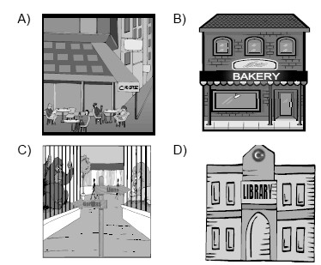Garry wants to but some muffins and bread . Where is he now?
11.
COUNTRIES
- - - - - - -

Tablo aşağıdakilerden hangisiyle tamamlanamaz?

a) Spain b) Greece
c) Portuguese d) France

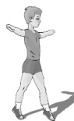
- Eşleştirmelerden hangisi doğrudur?

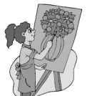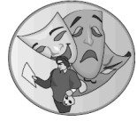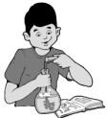
a) Math b) History c) Drama d) P.E.

- I am Jack. My favorite lesson is - - - - .I like making experiment in the school lab.

a) Science b) Drama
c) Information Technology d) Music.

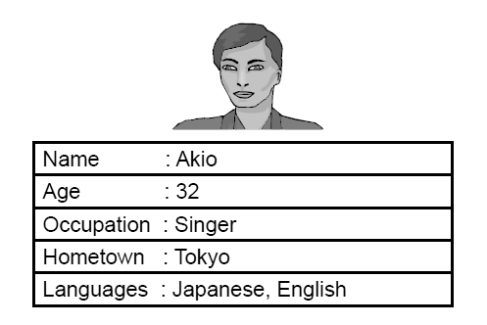

Which one is false?

- He is from Tokyo.
- He sings songs.
- He can speak Turkish.
- He is thirty two years old.

- In the morning I have double Science , Social Studies and Art, in the afternoon I have double Turkish.

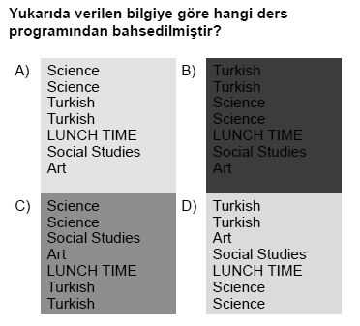

- Sally: I am bored. Can we play - - - - ? Mark: I am sorry because it is rainy.

a) Taboo b) Tic-tac-toe
c) Checkers d) Tag

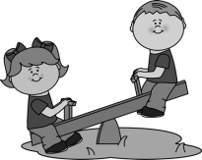
- My favorite activity is playing - - - - .

- hopscotch
- see saw
- tag
- hula hop

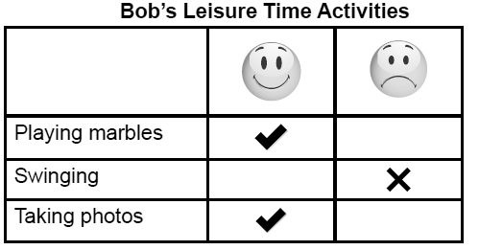

- Tabloya gore hangisi yanlıştır?

- He likes playing marbles and taking photos.
- He doesn’t like swinging but he likes taking photos.
- He likes playing marbles but he doesn’t like taking photos.
- He doesn’t like swinging but he likes playing marbles.

- “I like playing Hide and Seek.” Ifadesini anlatan görsel aşağıdakilerden hangisidir?

Yukarıda bahsedilmeyen oyun aşağıdakilerden hangisidir?

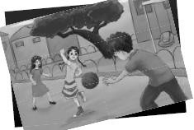
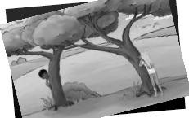
a) b)

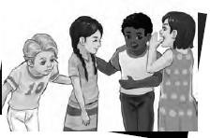
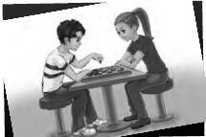
c) d)

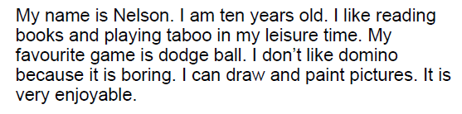
- Parçada hangi sorunun cevabı yoktur?

- What is his favorite game?
- How old is he?
- What does he play in her free time?
- What time does he go to bed?

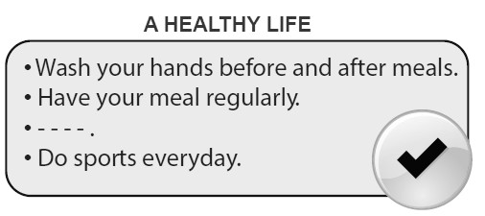

Boşluğa aşağıdakilerden hangisi gelebilir?

- Eat junk food and chocolate.
- Sleep just three hours a day.
- Eat fresh fruit and vegetables.
- Never does exercises.

- Patient: I have a sore throat. Doctor: You should - - - - .

a) go to school b) drink cold water
c) lift heavy things d) take some medicine

23. Cem: - - - - ?
Burak: I have a terrible headache.

- What’s the matter with you
- What do you do in the evening
- Do you see the dentist
- What should you do

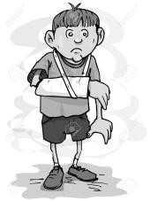
- Görseli ifade eden seçeneği Işaretleyiniz.

- sore throat
- measles
- broken arm
- cough

- Henry: I have a stomachache. - - - - ?
Doctor: Don’t eat junk food and take medicine.

- What’s the matter with you
- What should I do
- Do you have high fever
- Is your leg broken

- Kate: Let’s watch Ice Age 3? Pam: - - - - ?
Kate: It is an action and animation. Pam: Great! I love animations.

- What time is it?
- Who are the main characters?
- What type of movie is it?
- Do you like horror films?


- Lily likes - - - - .

- romances
- cartoons
- horror films
- the news

- Pelin: Let’s watch a documentary! Sude: - - - - - . I think they are boring.

- Great idea
- I love them
- I am sorry I can’t
- I am interested in them

29 ve 30. Soruları aşağıdaki paragrafa gore cevaplayınız.

I am Amy. I love watching films so much. My favorite movie type is romance because I like watching love stories. My dad, Adam watches news every day. He doesn’t like watch comedies because they are boring for him. My mother likes adventures but she hates horror films. My little sister loves animations very much. Madagaskar is her favorite one.
- Parçaya gore doğru olan hangisidir?

- Adam loves comedies.
- Her mother likes watching adventures.
- His little sister’s favorite movie type is romance.
- Amy loves watching news.

- Amy loves romances because - - - - .

- they are boring for her
- she is interested in love stories
- her favorite movie type is animation
- she doesn’t like them.

31. Frank: - - - - ?
Robb: Food, drinks, pillows and DVDs.

- What is your favorite party type
- Can you buy decorations for me
- What do you need for a pyjamas party
- What time is the party

- “My favorite party type is New Year’s Party.”

Ifadesini anlatan görsel aşağıdakilerden hangisidir?

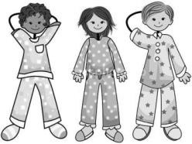
a) b)


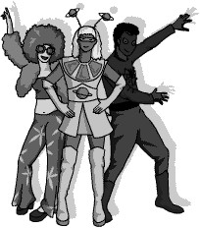
c) d)

- Which one is false?

- January is the first month of the year.
- June is in spring.
- Sunday is after Saturday.
- December is the last month of the year.

- Büşra: I have a dinner party this evening. - - - - ? Selin: Sure I can. What time is it?

- Can I help you
- Can I come to your party
- What do you need
- Would you like to come

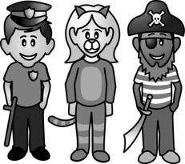
- They are ready for a - - - - party.

- fancy dress
- New Year’s
- birthday
- pyjamas

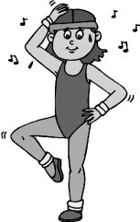
- She is - - - - .

- good at fishing
- interested in weight lifting
- doing aerobics
- fond of cycling

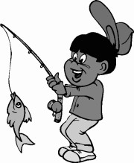
- He likes - - - - .

- horse riding
- climbing
- hiking
- fishing

- Henry: What about going ice skating? Neil: Sorry, - - - - ?
Henry: Let’s go ice skating this weekend! Neil: No,thanks. I don’t have skates.

- can you help me
- can you repeat that, please
- do you like doing it
- is it OK

- “My favorite fitness activity is weight lifting.” Ifadesini anlatan görsel aşağıdakilerden hangisidir?

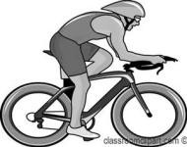
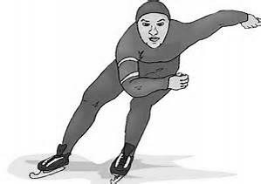
a) b)

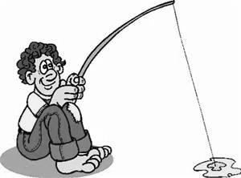
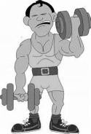
c) d)
44.

Yukarıdaki liste aşağıdakilerin hangisiyle tamamlamaz?
FARM ACTIVITIES
- feeding the cows
- . . . . . . . . . .
- . . . . . . . . . .

a) picking fruits b) watering plants
c) feeding a panda d) cleaning the barn

45. Betty: - - - - ?
Sue: Milking the cows. It is fun.

- Are you afraid of hens
- What are you doing in the zoo
- What’s your favorite farm activity
- Can you water the vegetables

- Karışık halde verilen cümleleri anlamlı bir diyalog oluşturacak şekilde sıralayınız.

- I’m from the Mexico.
- What festival do you celebrate?
- Independence Day.
- Where are you from?

a) IV – I – III – II b) IV – III – II – I
c) II – I – IV– III d) IV – II – II – III

47.
58
27
- - - -
40. + =

  - ninty –seven b) eighty –five
 | Activities
Can | Weight lifting
Cem | Hiking
Cenk | Diving
Caner | Ice skating

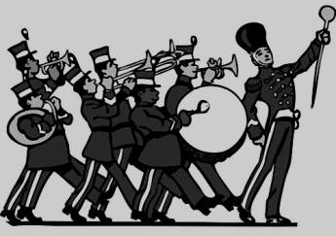
c) ninty – five d) eighty -three

48. They are - - - - .

Which one is false?

- Can wants to be fit.
- Cem loves fresh air and nature.
- Cenk is interested in underwater life.
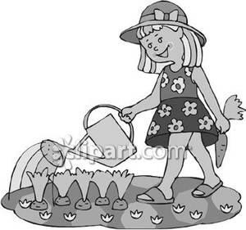
- Caner likes cycling.

41.She is - - - - .

- picking fruits
- milking the cow
- cleaning the barn
- watering the vegetables

42. Rose: - - - - ?
Derek: Good idea! Let’s go to an animal shelter.

- What about going to a circus
- Shall we see some wild animals
- Why don’t we adopt a rabbit
- What are you doing

43. James loves helping homeless animals. He - - - -.

- donates some money to the animal shelter
- goes to zoo to see different birds
- is afraid of street animals
- hates having a pet
- hiding eggs
- wearing dragon costume.
- doing aerobics
- walking in the parade.

49. Gary: - - - - ?
Helen: It is on 31st October?

- When is Halloween Festival
- How do you celebrate Halloween Festival
- What is the name of festival
- Do you celebrate it

50. “We celebrate Children’s Day on 23rd April.”
ifadesini anlatan görsel aşağıdakilerden hangisidir?

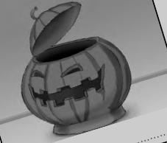

a) b)

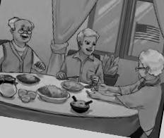
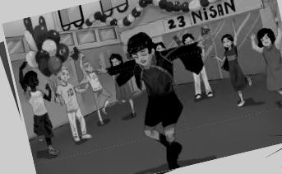
c) d)

By Tuğum

