5TH PRESEASON CHECK UP TEST

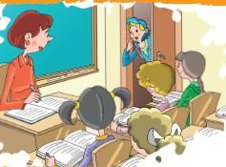
Mark: May I ?
Teacher: Yes, you may.

- open the window
- come in
- drink water
- sit down

Sally:Can you give me the ?

Mark: Sure
- pencil case
- ruler
- eraser
- sharpener


Sam : May I - - - -
Jessy: I am sorry but you may not.

- swim in the pool
- cycle in the garden
- eat in the classroom
- take a photo in the museum

4. forty-seven

Yukarıda okunuşu verilen sayı aşağıdakilerden hangisidir?

a) 35 b) 62 c) 27 d) 47

5.
I. | 38 | Thirty-eight
II. | 56 | fifty –six
III. | 70 | seventeen
IV. | 29 | twenty nine
Hangi basamakta verilen bilgi yanlıştır?
8.
Name | Pam Sanders
Age | 11
Country | England
Nationality | English


Tabloya gore aşağıdakilerden hangisi yanlıştır?

- Her name is Pam.
- She lives in America.
- She is English.
- She is eleven yerars old.


Hans has a yellow ,red and black flag. It is a German flag.

a) b) c) d)

- “Hi! I am Carlos Ramirez. I am ten. I am from Mexico. I am Mexican. Mexico is in North America.” Ifadesini aşağıdakilerden hangisi söylemiş olabilir?





a) b) c) d)


Brad likes - - - - .

- playing guitar
- playing football
- fishing

a) I b) II c) III d) IV

Susan: Where are you from? Henry: - - - -.

- I am from France
- It is a French flag
- It is in Europe
- I am ten years old


Amy: Look at the boy in shalvar. I think he is Turkish.
Betty: - - - - . I think he is Indian

- I don’t think so
- Maybe
- Yes, he is
- I think so
d) taking photographs

Eşleştirmelerden hangisi yanlıştır?



a) b)

collecting old coins playing chess

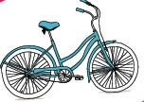
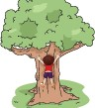
c) d)

riding a bike swimming


- Judy and Jack like - - - - .

- reading a book
- drawing pictures
- dancing
- playing tennis

Ken: Do you like watching TV? Robb: - - - -.
Ken : Do you like watching TV?

Robb: Yes, I like

a)Sure b) Repeat, please
c) I dislike d) No, I don’t

 | doing puzzle | watching cartoons
Sue |  | ❒
Sally |  | ❒
Betty | ❒ | 
Linda |  | ❒

19 ve 20. Soruları tabloya göre cevaplayınız.

 | can | can’t
Kaan | play guitar | swim
Cem | sing a song | run fast
Can | ride a bike | catch a fish
Burak | take photographs | ride a horse

Who can sing a song?

a) Kaan b) Cem c) Can d) Burak

Who has a camera?

a) Kaan b) Cem c) Can d) Burak

Like = 

Dislike = 

I in the afternoon.

- 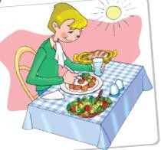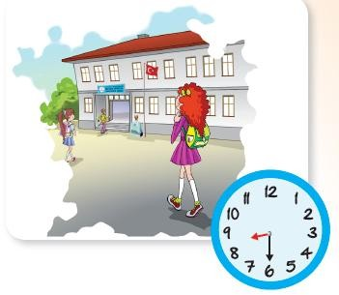go to bed
- have dinner
- have lunch
- wash my hair

Tabloya gore hangisi yanlıştır?

- Sue dislikes doing puzzle.
- Sally dislikes watching cartoons.
- Betty likes watching cartoons.
- Linda likes doing puzzle.

I am an elephant. I can - - - -.

a) fly b) jump c) walk d) run fast.

- “It is my racket. I can play tennis.”ifadesni anlatan görsel aşağıdakilerden hangisidir?



a) b)

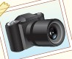
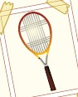
c) d)


A cow can - - - - .

- sing a song
- fly
- dance well
- give milk

I go to school at - - - - .

- seven o’clock
- half past eight
- nine o’clock
- quarter past eigth

Tuesday / - - - - / Thursday/ / Saturday
Boşluklar sırasıyla aşağıdakilerden hangisiyle tamamlanmalıdır?

- Monday / Sunday
- Wednesday / Monday
- Friday/ Sunday
- Wedesday / Friday

at 08.15 | get up
at 09.00 | go to school
at 18.00 | have dinner
at 21.30 | go to bed

What do you do at twenty one thirty?

- I get up
- I go to school
- I have dinner
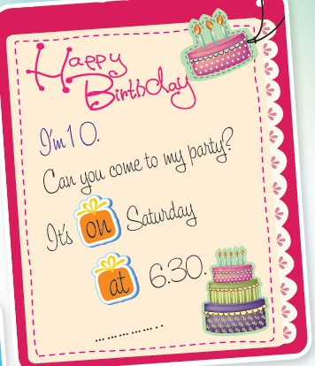
- I go to bed

When is the party?

- Brithday party
- Ten years old
- On Saturday
- Birthday Cake

Aşağıdaki eşleştirmelerden hangisi yanlıştır?

a) goggles b) tube



c) miscroscope d) magnifier



Where is the pencil box? It is the laptop PC.

- on
- in front of
- near
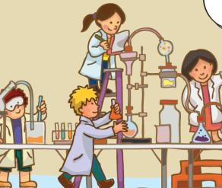
- behind

The children are - - - -.

- in the lab
- at the school canteen
- in class
- at the gym

What is “büyüteç” in English?

- food colorings
- goggles
- magnifier
- microscope

- “ You need some baking soda, a lemon, some water, a glass and some sugar.” ifadesini anlatan görsel aşağıdakilerden hangisidir?

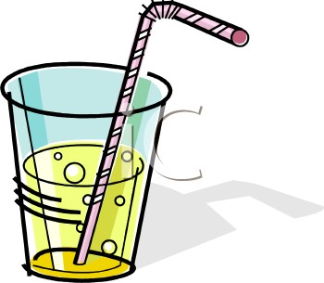

a) b)

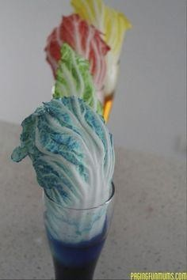
d)
c)

It is a/an - - - -.

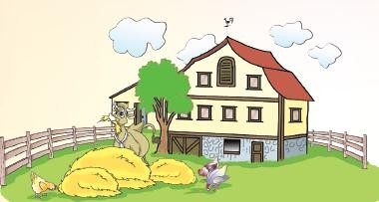
- office
- farm
- hospital
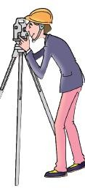
- theater

What is his job? He is a/an - - - -.

- doctor
- engineer
- actor
- worker

Ken : Where does a teacher work? Linda: In a - - - -.

- farm
- fire station
- tractor factory
- school

I. Where do you work?
  - I am a nurse.

I work in a hospital.
  - What is your job?

Yukarıda karışık halde verilen cümleleri anlamlı bir dialog oluşturacak şekilde sıralayınız.

a) IV - I – III – II b) IV – II – I – IV
c) I – III – II – IV d) I – II – IV - III

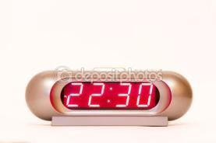
Jeff sleeps - - - -.

- in the morning
- in the afternoon
- in the evening
- at night


He is a / He - - - - .

- farmer / drives a tractor
- postman/ rides a bike
- policeman / a police car
- pilot/ flies a plane

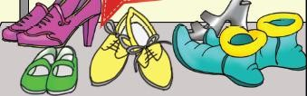

Hi! I am Laura. These are my - - - - .

a) shoes b) jackets
c) hats d) dresses

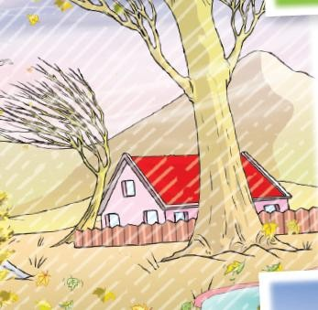
Which season is it ?

- Spring
- Summer
- Winter
- Fall

Aşağıdaki eşleştirmelerden hangisi yanlıştır?

a) | summer | sunglasses, T-shirt
b) | fall | sweatshirt, umbrella
c) | winter | shorts, hat,flip flops
d) | spring | raincoat ,shirt

- What’s the weather like today?

- It is sunny and hot.
- It is warm and cloudy.
- It is rainy and cool.
- It is snowy and cold.

Andy: Can I borrow your umbrella? Sue: I am sorry but - - - - .

- wear it,please
- it is broken
- here you are
- I need it

Görsele göre aşağıdakilerden hangisi yanlıştır?


- He has a moustache.
- He has straight hair.
- He has glasses.
- He has blonde hair.

Jessy : What is your mother like? Robb: - - - - .
- She has fair and long hair..
- She has blue eyes.
- She is tall and slim.
- She is shy.

Martha is short and fat. She has short straight red hair. She has a pink dress. She is polite and hardworking.

Yukarıdaki metinde aşağıdaki sorulardan hangisinin cevabı yoktur?

- What’s she like?
- How old is she
- What does she look like
- What color is her dress

Sandra always helps old people. She is - - - - .


- helpful
- rude
- funny
- shy

Kate: Would you like coke? Betty: Not now. - - - -.

a) I am hungry. b) I am not thirsty
c) Yes, please d) Set menu A is for you

- ”I eat fish, salad and drink coke for my dinner on Monday.” Ifadesinde yer almayan görsel aşağıdakilerden hangisidir?

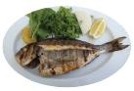
a) b)

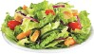

c) d)

Rose: I am hungry? May I eat something? Derek: What about a hot dog?
Rose: Yummy! - - - - .

- No, thanks
- I dislike it
- I want to eat it
- I am full


49. He is - - - - .

- hungry
- thirsty
- full
- vegetarian

50.
What does Sally eat this week?
 | breakfast | lunch | dinner
Monday | toast, tea | pizza, lemonade | chicken,salad, pudding
Friday | hot dog, orange juice | meatball, coke, ice cream | fish,chips, cupcake

Tabloya gore hangisi yanlıştır?

- Sally eats pizza for lunch on Monday.
- She eats fish and cupcake for dinner on Friday.
- She drinks orange juice for breakfast on Monday.
- She drinks coke for lunch on Friday.

By Tuğum

