………… EDUCATIONAL YEAR İSMAİL KAYA ANATOLIAN IMAM HATIP HIGH SCHOOL SECOND TERM SECOND EXAM FOR THE 9TH GRADES
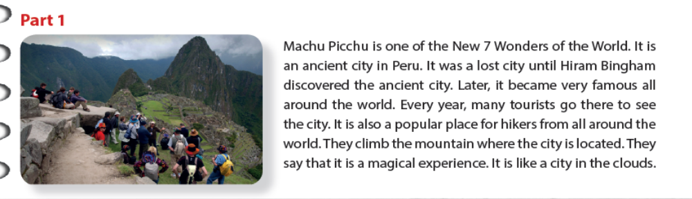

A-Complete the sentences (Cümleleri tamamlayınız):(6X1=6 pts)
1-Machu Picchu is in _________. 2- Machu Picchu is one of the 7 _____________ .
(3) MachuPicchu is a/an ___________ city and one of the seven wonders of the world. It is a very
(4) __________place in the world. A lot of (5) __________go to see this great place. It is a good place for (6) __________ because it is on the top of a mountain and you can walk all the way up.
It is fascinating.

B-Answer the following questions(Aşağıdaki soruları cevaplayınız).( 4X2=8 )
- Who discovered Machu Picchu?......................................................................................
- Where is Machu Picchu?………………………………………………………………………………………………
- Where did they build it? ……………………………………………………………………………………………….
- What is it like?………………………………………………………………………………………………………………

C-Fill in theblanks with ‘SHOULD / SHOULD’T’(Boşlukları’ should/shouldn’t’ ile doldurunuz):(5x1=5pts)
1.Tom _____________ eat so many lollipops. It’s bad for his teeth. 2.They have a test tomorrow. They ___________ go to the cinema . They ___________ stay at home and study. 3.Children ____________ eat lots of vegetables but they ______________ eat lots of sweets.

D-Fill in the blanks with a suitable word(Boşlukları uygun kelimelerle doldurunuz) :(5x1=5pts)

tomb /craftsman /can’t take their eyes off /homeland /ruins 1. Only a good ________________________can build beautiful buildings . 2. You can only see the ________________ of the castle in the open air museum. 3. Egypt is the _____________________________ of pharaohs and pyramids. 4. The ___________________ of the queen is made of marble. 5.T he temple is so beautiful that the visitors _________________________________ it.

E- S.Past Tense ‘e göre fiillerin uygun hallerini yazınız(write the past forms of the verbs) (7x1= 7 pts)
1-It (not-rain )…………………….a lot but we (see) ………………… some beautiful rainbows.
2-The Hanging Gardens ………………. (be ) in Iraq.
3-What (be ) ………… the weather like when you were in London?
4-We didn’t watch that soap opera last night because we …………… (feel ) tired.
5-Mr Oz ………………….. (study ) medicine when he was at university.
6-………… Turkey …………………… (start ) a campaign to choose the 7 Wonders?

F-Complete the questions with a suitable tag (Boşlukları uygun ‘Question Tag ‘ ile doldurunuz):(9X1=9pts)
1-There weren’t any scyscrapers in Konya 20 years ago,__________________ ? 2-Your mother cooked fish and chips for dinner yesterday,___________________ ? 3-The students didn’t study for the exam last night ,_____________________? 4- Tom has an expensive mobile phone ,______________________ ? 5- We don’t get up early on Sundays,_______________________ ? 6-There was a cinema next to that bookstore last year ,___________________ ? 7- Jane’s grandmother can’t use the computer efficiently ,_____________________ ?
8- All the students are running in the school garden at the moment ,__________________?
9- We haven’t got any bread at home ,________________________ ?
G-WRITING Use the phrases in past tense to make a meaningful paragraph about yourself
( Verilenleri geçmiş zamanda kullanarak kendiniz hakkında anlamlı bir paragraf oluşturunuz):(10x1=10pts)
1.get up at 9 o’ clock in the morning 2. take a shower
3. have breakfast with my family at 10 o’clock 4.leave home at 11 am
5. meet my friends at Kulesite 6. we do some shopping
7. then we go to the cinema
8 .after the cinema we eat hamburger and pizza at Mc Donalds together
9. arrive home at 11 pm 10. brush my teeth and go to bed
Last Saturday , I ____________________________________________________________________ __________________________________________________________________________________ ________________________________________________________________________________________________________________________________________________________________________________________________________________________________________________________________________________________________________________________________________

