………. GAZİ MESLEKİ VE TEKNİK ANADOLU LİSESİ
9.Sınıf İngilizce Dersi 2.Dönem 1.Ortak Yazılı (Group – A)

Name and Surname: Number: Class:

- Read the text and write (T) True or (F) False: (4 x 5 = 20 pts)

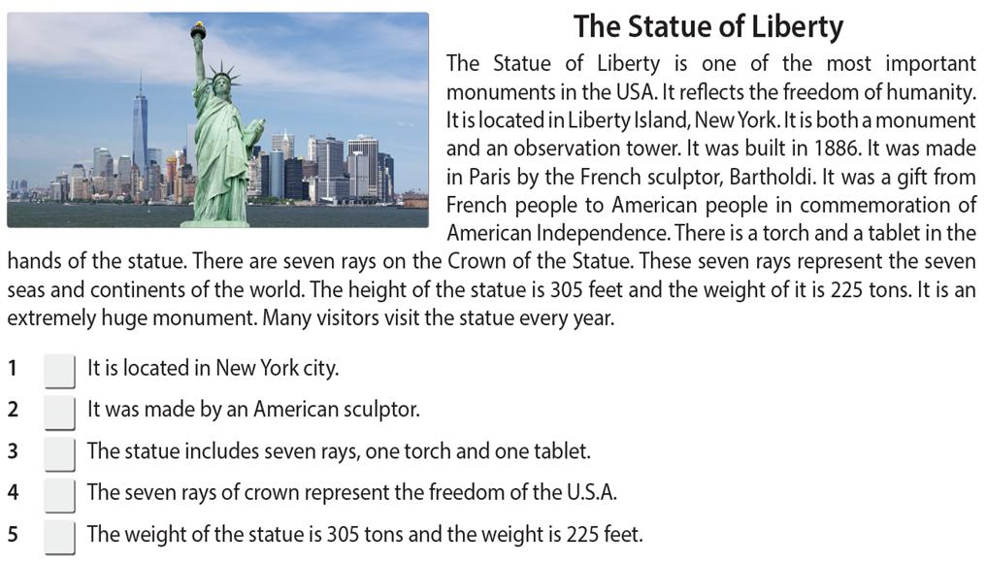

- Fill in the blanks with the past form of the verbs : (4 x 5 = 20 pts)

1. I ………………………… a lot of milk yesterday. (drink)
2. She……………………… shopping with her mom last Saturday. (go)
3. He………………………… his homework last night. (do)
4. Pablo………………………… tennis with Sarah last weekend. (play)
5. We…………………………lunch with our friends yesterday afternoon. (have)

- Fill in the blanks with “WAS or WERE” : (4 x 5 = 20 pts)

1. The weather ..................... very hot last Saturday.
2. Gizem and Hande ...................... ill yesterday.
3. The students ...................... at the cinema last night.
4. My brother ......................... five years old last year.
5. I ……............. in Germany 3 years ago.

- Match the pictures and find the correct advice. (2 x 10 = 20 pts)

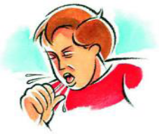
1 2 3 4 5

___broken leg ___headache ___toothache ___cough ___cold
____ He shouldn’t walk. ____ He should drink some syrup.
____ He shouldn’t eat sweet or ice-cream. ____ She should take an aspirin. ____ She should drink herbal tea.

E) Fill in the blanks with FOR or SINCE : ( 1 x 10 = 10 pts )

- ……………… 1997. 6- ……………… yesterday morning.
- ……………… ten years. 7- ……………… last Monday.
- ……………… a long time. 8- ……………… January.
- ……………… last week. 9- ……………… 5 days.
- ……………… two hours. 10- …………… 3 o’clock.
F) Answer these questions : ( 2 x 5 = 10 pts )
1- What did you eat yesterday morning ? ………………………………………………………………………
2- What time did you get up yesterday ? ………………………………………………………………………
3- What did your mother cook yesterday ? ……………………………………………………………………
4- What time did you come to school today ? …………………………………………………………………
5- Where did you go last summer ? ……………………………………………………………………………………

Yusuf ÖZSOY Banu SARI İlknur ONDUN Gaye KURT

Hakan UZ Gülin ERHAN Cemile TERZİER

