Name: Surname: Class: Number: Point:
………….. Educational Year …………….. Vocational and Technical Anatolian High School
Second Term Second English Exam for 9th Grades
A.Match the illness names with the pictures correctly. One word is extra. (Hastalık isimleri ile fotoğrafları eşleştiriniz. Bir kelime fazladan verilmiştir.)2x5=10p.
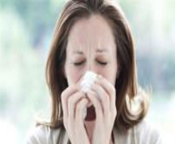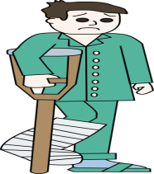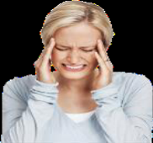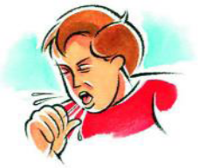
1 2 3 4 5
……. a runny nose …... a cough …… a headache ……a brokenleg ..…. a toothache

B. Fill in the blanks with the correct form of “will” or “be going to”. (Cümlelerdeki boşlukları “will” yada “be going to” yapısına uygun olarak, parantez içinde verilen fiiller ile doldurunuz.) 3x5=15p.
1. It is 22nd of April today. So it ………………………………………… (be) holiday tomorrow.
2. They have got a plane ticket. They………………………………………………….. (go) to Paris in the following week.
3. John: This film is boring.
Mary: I …………………………………. (change) the channel.
4. I think the food……………………………….. (be) ready soon.
5.Look at this child! If he doesn’t be careful, he ……………………………………. (fall) down from his bike.

C. Choosethecorrectoptions. ( Doğru olan seçeneği işaretleyiniz.) 2x5=10p.
1. I have had a terrible headache since / for two days.
2. Have you ever / never met a famous person?
3. She has just / already bought a new T-shirt. She is paying for it now.
4. Have you opened your birthday presents already / yet?
5. My son is really excited about going to France. Because he has never / just been abroad.

D. Choose the correct option. (Doğru olan seçeneği işaretleyiniz.) 3x5=15p.
1. You had better not / should / don’t have to be late again or you will lose your job.
2. Children don’t have to / mustn’t / should walk in the middle of the street. It is very dangerous.
3. I can’t go out now. I must / shouldn’t / don’t have to finish my homework first.
4. You should / have to / had better take your sun cream with you or you will get a sunburn.
5. I think you must / don’t have to / shouldn’t wear that dress. It doesn’t suit you.

E. Choose the correct options. (Doğru olan seçeneği işaretleyiniz.) 2x10=20p.
1. A. How much / many time do we have?
B. Hurry up! We don’t have some / any time.
2. A. I can buy drinks fort he party. How much / many cans of coke do you need?
B. We have a lot of / any drinks but we need to buy any / some snacks.
3. A. How much / many tea do you drink a day?
B. I drink a lot of / any tea.
4. A. Would you like any / some orange juice?
B. No thanks. But can I have some / any water, please?
5. I am going to shopping. How much / many cheese shall I buy?

F. Answer the question below by making 4 different sentences. You can use the verbs given. (Aşağıdaki soruyu birbirinden farklı 4 cümle kurarak yanıtlayınız. Verilen fiilleri kullanabilirsiniz.) 4x4=16p.
visit my grandparents / work / go to Bandırma / attend Dursunbey fair / help my family / feed the animals
What are you going to do next summer?
1) ……………………………………………………………………………………
2)…………………………………………………………………………………….
3) …………………………………………………………………………………….
4) …………………………………………………………………………………….

G. Read Angelica’s plans for her 18th birthday party and answer the questions according to it. (Angelica’nın 18. doğum günü partisi için planlarını okuyun ve soruları bu metne göre yanıtlayın.) 2x7=14p.
1. Angelica’s friends are going to leave after party. True / False
2. She doesn’t feel very excited about her new age. True / False
3. The party is going to start at 5 p.m. True / False
4. Her father is going to cook burgers and sausages. True / False
5. She is not looking forward to her new age. True / False
6. There is going to be music and dance. True / False
7. The party is going to be on Sunday. True / False

It’s my 18th birthday next Friday. All of my friends are going to come to my grandparents’ house for a barbecue party. They have got a big green garden. My father is going to cook burgers and sausages for us. The party starts at 5:00 o’clock in the afternoon. There is going to be good music and lots of fun. After the barbecue, we are going to dance and sing karaoke. I am preparing some games, too. My mother is going to give surprise gifts to the winners. Most of my friends are going to stay for the night. We are going to stay up late. Turning 18 is going to be really exciting, so I am really looking forward to it.
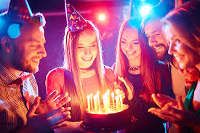

…………………… …………………… Exam Duration: 40 minutes
English Instructor English Instructor Good Luck

