……… EDUCATIONAL YEAR THE LAST EXAM OF THE 8TH GRADE
NAME SURNAME:....................................................
CLASS / NUMBER:...................................................

1. - Büşra is in the kitchen. She is …………..
A) doing the laundry
B) hanging out the clothes
C) loading the dishwasher
D) making the bed

****************************************

2.‘’Last summer I went to Nevşehir with my
friend Kate. I tried a hot air balloon ride. It was wonderful.’
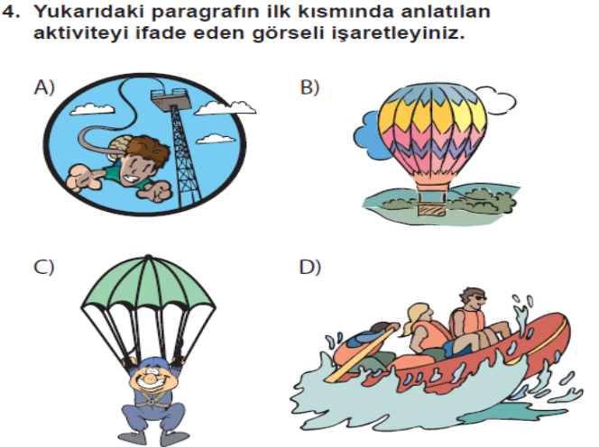

****************************************

3- Alexander Graham Bell ........the telephone and phonograph.

A) invented B) looked for
C) explored D) discovered

4.Ali:Would you like to visit Eiffel Tower?
Veli:……….……It is a great idea.

A) No, thanks B) Maybe later
C) I am sorry D) I’d love to

**********************************

5..Paul : What are the - - - - of İstanbul?
Burcu : Some of them are Topkapı Palace, Blue Mosque and Galata Tower.

A) tourist attractions B) tour guide
C) Squares D) resort

**********************************

6. Hangi seçenek aşağıdaki ifadeyle aynı
anlama gelir?
“Good health is more important than money.”
A) Money is more important than good health.
B) Money and good health are important.
C) Good health is not important.
D) Money is less important than good health.

7.Ali : .............................?
Murat : About 60.000.

A )Where did the earthquake take place?
B) How many people lost their homes?
C )What should we do during an earthquake?
D )When did the earthquake take place?

8. Ali : .............................?
Murat : We should stay calm. We shouldn’t use the elevator.

A ) What should we do during an earthquake?
B) When did the earthquake take place?
C) How many people lost their homes?
D ) What is the highest magnitude of the earthquakes?

***************************************

9.An earthquake ............ the city of Van in eastern Turkey at 13:41 on Sunday, October 23, 2011.

A) processed B) hit
C) evacuated D) prevented

***************************************

10-Mehmet: Who …………. in your family?
Batuhan: My sister does it. She loves helping my mum in the kitchen.

A) does the ironing B) makes the bed
C) sets the table D) feeds the cat

***************************************

11. VE 12.SORULARI METNE GÖRE CEVAPLANDIRINIZ.
Hi, I’m Jason. I think it’s necessary to help our parents with the housework because it makes life easier for everybody at home. First of all, we should prepare a to-do list. Everybody must do the chores on time. In my family, my father is responsible for outside chores and I must help him. My mum cooks the meals, washes the dishes, does the laundry and my sister Linda helps her. My sister and I are also responsible for our rooms. We must always keep it tidy and clean.

11-According to the text, - - - - .
A) only parents do the chores at home
B) everybody must share the chores
C) it’s easier for one person to do all chores
D) Jason and Linda are responsible for all chores

12- We must help our parents at home because - - - -.
A) we should do our homework regularly
B) making a to-do list isn’t necessary
C) laundry is Jason’s responsibility
D) it makes life easier for us

**************************************

13-Irmak : Does your husband help you in the kitchen?
Elif : No, never.…………………………………

A) He sets the table before meals
B) He is a very responsible person
C) He prepares breakfast every morning
D) He isn’t interested in doing any chores

(14. ve 15. soruları metne göre cevaplayınız.)
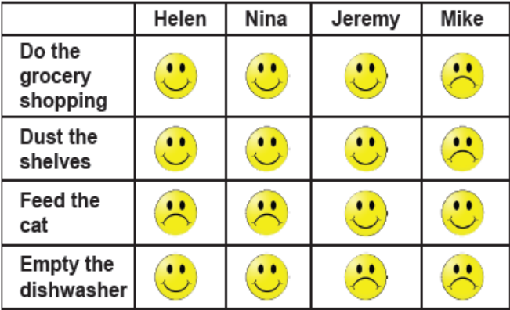

14-Nina …………………………….. .

A) doesn’t like doing the grocery shopping
B) hates emptying the dishwasher
C) loves dusting the shelves
D) loves feeding the cat

15-Mike and Jeremy hate …………… .

A) doing the grocery shopping
B) dusting the shelves
C) emptying the dishwasher
D) feeding the cat

************************************

16.Earl : What do you do on Sundays?
Peter : I wash the car.
Earl : …………………………………?
Peter : No, it isn’t. It’s my favorite chore.

A) Is it boring
B) Do you like doing it
C) What is your favorite chore
D) How often do you wash your car

17. Elif’s husband is ………………… setting the
table. Elif cooks and her husband sets the table.

A) necessary B) in charge
C) responsibility D) responsible for

****************************************

18. Adventure lovers prefer extreme sports
because they are ………… .

A) easy and embarrassing
B) safe and amusing
C) boring and disappointing
D) fast and challenging

*******************************************

19. "Prof. Dr. Oktay Sinanoğlu was born in 1935. He became the youngest professor in the world when he was at the age of 28. He was a scientist, a chemist, a biophysicist and a biochemist. He died in 2015 in the USA."

Yukarıdaki metinde aşağıdaki sorulardan hangisinin cevabı yoktur?

A) When was he born?
B) Where was he born?
C) When did he die?
D) When did he become a proffessor?

**************************************

20.How do people destroy the nature?
Aşağıdakilerden hangisi sorunun cevabı olamaz?

A) They cut down the trees.
B) They pollute the environment.
C) They use renewable energy.
D) They waste too much water.

21. Which of the following is a school rule?

A) We must take off our shoes before we enter.
B) We should keep our bedrooms very tidy.
C) We mustn’t talk while our teacher is talking.
D) We have to do what our boss asks us to do.

****************************************

22. I would rather stay in an all-inclusive resort on
my holidays.”

Yukarıdaki cümleyle ilişkili seçneği işaretleyiniz.

A) transportation B) attraction
C) accommodation D) location

***************************************

23. . Isaac Newton …………… the law of gravity.

A) invented B) designed
C) created D) discovered

***************************************

24.
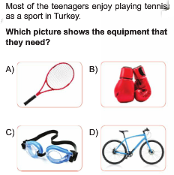

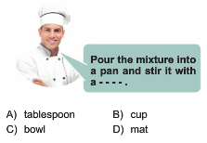
25.

****************************************

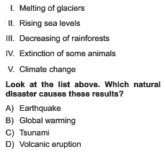
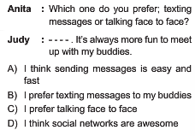
26.

(I) İlayda Şamilgil was a 12th grade student when she got a prize with her project.
(II) She graduated from a private high-school in İstanbul.
(III) The name of the prize is “The first step to Nobel Prize in Pysics.”
(IV) Her project outdistanced five thousand projects from seventy countries.
(V) As a result of her success, she got an invitation from NASA for Mars project.

Yukarıdaki metinde farklı olan cümleyi bulunuz.

A) II B) III
C) IV D) V

