…….. EDUCATIONAL YEAR BÜYÜKÇİFTLİK BELDESİ SECONDARY SCHOOL
ENGLISH LESSON 2nd TERM -2nd EXAM for 8th GRADES

Name-Surname:……………………………………. Class:……….. Number:………..

I’m Ted. I love extreme sports because I find them challenging. I like taking risks and testing myself.

- Yukarideki metinle ilgili ifadelerden doğru olanı işaretleyiniz.

- He doesn’t enjoy adventure.
- He is an adrenalin junkie.
- He can’t stant scary sports.
- He’d rather do safe sports.

- I . Three years ago.
II . Have you ever ridden a camel?
III . Really? When did you go there?
IV . Yes. That was in Nevşehir.

Yukarideki diyaloğun doğru sırlaması nasıl olmalıdır?

- II-IV-III-I C) II-III-I-IV
- III-I-IV-II D) I-IV-II-III

- James: Would you like to try caving?
Dave : ……… It’s too dangerous.

- No way! C) Of course!
- Really? D) Why not

- Mark: I tried kayaking last summer.
Tim : That’s great. Did you like it?
Mark: Not really. ……………..

- I’d like to do it again.
- I prefer air sports.
- I love testing myself.
- I learned about civilications.

- Carol: Which one would you like to do, kayaking or
mountain biking?
Tim : I’d rather do kayaking because …………..

- It’s safer
- I need a bike
- It is horrible
- I love team sports

- Sam : ………………….. ?
James: Yes, I did it last year in Fethiye, but I didn’t
like it.

- What’s your opinion about canoeing?
- Have you ever done hang-gliding?
- Are you an adrenalin junkie?
- What activities do you prefer?

- Kate : We can go parachuting, rafting or scuba divingthis weekend. Whic one do you prefer?
Michael : I’d rather do parachuting. ……….

- I think water sports are entertaining
- To me, winter sports are amazing
- It is the most exciting of all
- It sounds more boring than the others

(8-9-10. Soruları Verilen Bilgilere Göre Cevaplayınız.)
I love swimming in the pool. I wouldn’t like to try dangerous sports.

Ece:

My favorite is bungee jumping. I also love hang-gliding. I think, they are fascinating.

Arda:

I’d rather do rafting and scuba diving. I don’t enjoy air sports. I feel scared.

Tom:

I’d prefer baseball and volleyball. To me, tehy are amusing.

Eda:

- …………… prefers air sports.

- Ece C) Arda
- Tom D) Eda

- Eda ___________

- … is crazy about extreme sports
- … thinks volleyball and baseball are risky
- … Would rather do team sports
- … believes that water sports are challenging

- ………. feels afraid of height.

- Ece C) Arda
- Tom D) Eda

- Aşağıdaki seçeneklerden hangisi doğrudur?
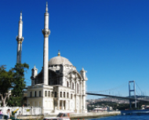
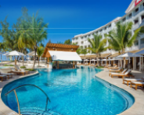
- C)

FOUNTAIN PALACE
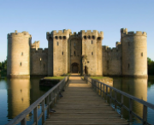
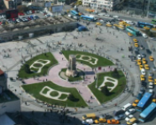
- D)

SQUARE TEMPLE
- I. Which tourist attractions did you see?
II. Yes, I went there last year.
III. Have you ever been to Turkey?
IV. I visited Topkapı Palace and Hagia Sophia.

Yukarıdaki diyaloğun doğru sıralaması nasıl olmalıdır?

- III – II – I – IV C) III – IV – I – II
- I – IV – II – III D) I – II – III – IV

- “Istanbul is a great city.You can go there by plane or by bus. You can stay at all-inclusive resorts or bed and breakfast places.”

Yukarıdaki metinde seçeneklerden hangisi ile ilgili bilgi verilmektedir?

- Architecture C) Civilications
- Weather D) Accommodation

- I went to Fethiye 2 moths ago. (I) I stayed at a small hotel. (II) It was sunny and hot. (III) I would rather visit a ski resort. (IV) We spent all day on the beach.

Yukarıdaki numaralandırılmış cümlelerden hangisi anlam bakımından bu metne uygun değildir?

- I B) II C) III D) IV

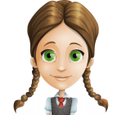
I’d rahter visit historic sites.
To me, …………

- … they are worse than modern buildings.
- … ancient places are unbearable.
- … historical architecture is fascinating.
- … mountains have a amazing view.

- Jack : You look happy.
Emre: Yes, summer holiday is coming.
Jack : Great! ……….. ?
Emre : About three months.
- What is your plan for holiday?
- How long is the holiday?
- Where are you going to travel?
- When does the holiday start?

- Buse: I went to Beijing last summer.
Mark: ………. ?
Buse: Incredible. I saw the Great Wall and mony other places.

- How was your holiday?
- Who were you with?
- Where did you stay?
- What did you do there?
- Selin : I was in London in 2017.
James: Cool! ……… ?
Selin : Buckingham Palace, The Tower
Bridge and the Big ben.

- How long did your journey the London take
- What makes the Tower Bridge special
- What are the toruist attractions of London
- Where did you stay there

- Eren : I went to uludağ five days ago.
Susan: ……….. ?
Eren : Of course, I’ll upload them to my
website. You can see them later.

- Did you take any photos?
- Have you tried skiing before?
- Did you enjoy the food at the hotel?
- Have you visited the temple?

- Sarah: Iam in Bodrum at the moment.
Leo : Great! …….. ?
Sarah: Not yet, I’m going to visit it tomorrow.

- Did you try scuba diving?
- How was the weather?
- Have you seen the castle?
- When did you go there?

I have to mop the floor. That is my responsibility.

Konuşma balonundaki ifade ile eşleşen görsel hangisidir?
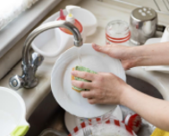
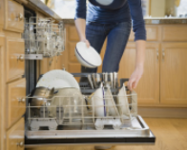
A) B)

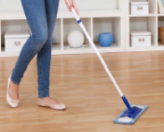
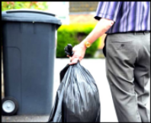
C) D)

- Farklı olanı seçiniz.

- Responsibility C) Task
- Duty D) Load

- Aşağıdaki seçeneklerden doğru olanı işaretleyeniz.

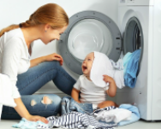
A) B)

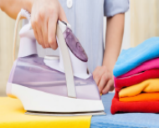
Do the laundry Vacuum the floor
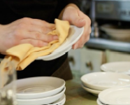
C) D)

Set the table Dry the dishes

I’m Linda. I have some responsibilities at home. I don’t mind cooking the meals, but I can’t stand ironing the clothes.

Yukarıdaki metinde seçeneklerden hangisinin cevabu bulunmamaktadır?

- Does she like doing the laundry?
- Who helps her with the chores?
- What is she responsinle for?
- Has she tidied up her room yet?

- Aşağıdaki tabloya göre doğru seçenek hangisidir?
 | MARY | JOHN
Cook the meal | X
Take out the rubbish out |  | X
Wash the dishes |  | X
Water the flowers | X
- Mary is responsibleloading the dishwasher.
- John has to do washing up.
- Mary musn’t help with household chores.
- John musn’t tidy up the kitchen.

- Sam : ……. ?
Jack : We have to switch off our mobile phones and
“respect” our teachers.

- What are your obligations at school?
- How often do you use your mobile phone?
- Why do you have to respect your teachers?
- When do your lessons start at school?


I can’t stand doing the ironing.
……………………

- It’s quite entertaining. C) It makes me crazy.
- That is so amazing. D) I feel relaxed if I do it.

- Anna: Could you please do the ironing?
Sally : ………. I have to fininsh my homework.

- Of course C) Sure, no problem
- Yes, that’s fine D) I’m sorry, I can’t

- Merve: Rules are everywhere. I can’t stand it.
Lucy : ………. because they make life easier.

- They are necessary
- You are right.
- They are sometime useless
- You don’t have to obey

- Mark : Shall I pay the bill?
Nancy: It’s Helen’s responsibility.

- You don’t have to do it
- You must get back on time
- You can’t get enough money
- You will feel embarrassed

- “I’m doing an experiment in the science lab now”

Yukarıdaki ifade seçeneklerden hangisine aitdir?

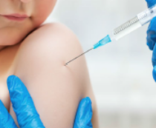
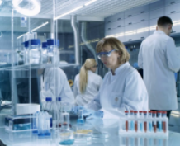

A) B)

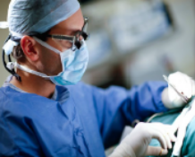

C) D)

Plants use sunlight to turn carbon dioxide and water into oxygen and sugar. This is called photosynthesis.

Yukarıdaki ifadeye göre seçeneklerden hangisi doğrudur?

- Animals need sunlight for photosynthesis
- We should give sugar to plants
- Carbon dioxide isn’t necessary for the plants
- Photosynthesis provides us oxygen

- I. Why is she doing that?
II. What is she doing?
III. Because it protects people from ilnesses.
IV. She is vaccinating the child.
Yukarıdaki diyaloğun doğru sıralaması nasıl olmalıdır?

- II – I – IV – III C) II – IV – I – III
- I – III – IV – II D) I – IV – III – II

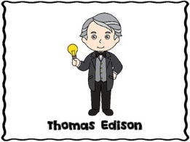

- Yukarıdaki görsele göre doğru seçenek hangisidir?

- Edison invented the light bulb.
- Edison studied with test tubes.
- Edson explored the history of the world.
- Edison explored the light bulb.

- Luke : The children are in the lab.
Mary : …………….?
Luke : They are studying on the bacterias.

- Do they like experiments
- Could you repeat that
- What are they doing
- Are they studying in the lab

- Carol: Isaac Newton was a great man.
Dave: ……………?
Carol: He discovered the gravity.

- What does gravity mean
- Do you think the gravity is important
- When did Isaac Newton discover the gravity
- Did Isaac Newton discover the gravity

- Larry: …………… ?
Bob : To me, the Internet. Life would be very boring without it?

- What’s the most important scientific development
- How often do you use the internet
- When did scientist invent the first computer
- Do you think the internet is very important in our life

- Bruce : Let’s watch the science programme on TV.
Tim : ……………. ?
Bruce: Astronauts on Mars.

- What time does it start
- Which channel is it on
- What is it about
- Why do you think so

- Tina: The discovery of penicilin was a great
development.
Kate: …………….. ?
Tina: Penicilin kills dangerous bacteria in human
body.

- When did they discover it
- Which diseases can it cure
- What do you think about it
- What kind of penicilin do the doctors prefer

- Aşağıda hangi kelimenin tanımı verilmiştir?

- “Somenthing that has been designed or created for the first time.”
- “Finding somenthing that is already in the life/nature”

- 1. Discoverer C) 1. Discovery
2. Scientist 2. Invention

- 1. Research D) 1. Invention
2. Finding 2. Discovery

- Seçeneklerden hangisi diğerlerinden farklıdır?

- Landslide C) Drought
- Avalanche D) Shake

- Aşağıdaki hangi seçenekteki doğal afetin açıklaması verilmemiştir?

- a strong storm with very strong winds
- a long period of time with NO rain
- a series of large, strong waves in the sea

- DROUGHT C) TSUNAMI
- LANDSLIDE D) HURRICANE

- What can we do to stop drought?

- We can use less water
- We can cut down the tress
- We can waste the water
- We can save the energy

- Last year we went to Bursa / Uludağ to skiing but there was a/an ……….. So, we had to come back.

- Avalanche
- Tsunam
- Lightning
- Global warming

- Tim : Have you ever seen an avalanche before?
Brad: ……………. ?
Tim : A large amount of snow falls down the side of a mountain.

- What happens during an avalanche
- What do you do during the avalanche
- Is the avalanche a naturel disaster
- Did you watch the film about avalanche

- We should …………………..

- Hunt the animals
- Pollute the rivers
- Recyle materials such as paper, plastic …
- Waste energy and water

- A. Water shortage 1. Use filters in factories
B. Air pollution 2. Plant tress
C. Drought 3. Don’t throw litter in the sea
D. Water Contamination 4. Have shorter baths

Sorunlarla çözümleri aşağıdaki hangi seçenekte doğru olarak verilmiştir?

- A-1 / B-3 / C-2 / D-4
- A-3 / B-1 / C-4 / D-2
- A-2 / B-1 / C-3 / D-4
- A-4 / B-2 / C-2 / D-3

- A : What does “saving the earth” means?
B : It means ………………… in another word.

- Polluting the environment
- Using eco-friendly products
- Protecting the world
- Causing earthquake

- Which one is NOT a natural disaster below?

- Hurricane C) Famine
- Landslide D) Pollution
- The poeople …………….. recyle paper, glass and plastics to conserve the nature.

- musn’t C) has to
- don’t need to D) should

NOTE: HER BİR TEST SORUSU “2” PUANDIR.

Sınav Hakkındaki Yorumunuz:

………………………………………………………………………………………………………………………………………………………………………………………………………………………………………………………………………………………………………………………………………………………………………………………………………………………………………………………………………………………………………………………………………………………………………………………………………………………………………………………………………………………………………………………………………………………………………………………………………………………………………………………………………………………………………………………………………………………………………………………………………………………………………………………………………………………………………………………………………………
………………………………………………………………………………………………………………………………………………………………………………………


Samet SAYGI ENGLISH TEACHER

