NAME:
CLASS:
NUMBER:

…….. ACADEMIC YEAR…….2ND TERM 2ND WRITTEN EXAM FOR THE 8TH GRADE

A: Match the natural disasters and their explanations. (10 x 2 = 20 pts)
1. avalanche ______  2. drought ______  3. flood ______  4. landslide ______  5. volcanic eruption ______  6. forest fire ______  7. tornado ______  8. tsunami ______  9. hurricane ______  10. earthquake ______ | a. a storm with very strong winds  b. burning trees across the hill  c. huge wave hitting the city  d. collapsed buildings  e. strong wind going round in a circle  f. earth on mountain road  g. lava falling down  h. dry soil  i. snow falling down a mountain  j. cars under the water

B: Fill in the blanks with the correct word from the box. (10 x 2 = 20pts)
photosynthesis bionics experiment laboratory explotion
limbs natural gravity vaccinating light bulb

1- The doctor is _______________________ the baby to protect him from dangerous illnesses.
2- The students are doing an ________________________ in the chemistry class.
3- Isaac Newton discovered the __________________________.
4- ______________________ is the study of living systems to solve engineering problems.
5- Thomas Alva Edison invented the _______________________.
6- __________________ is the way plants use sunlight, carbon dioxide and water to turn into sugar and oxygen.
7- There was a big ____________________ in the car park yesterday.Luckily, noone got injured.
8- Scientists can replace _________________ , organs and even skin by artificial ones.
9- The scientist is working in his _________________________.
10- __________________ disasters such as fires,avalanches and floods happen every year, somewhere in the world.

C: Match the household chores with the pictures. (10 x 2 = 20 pts)

a)dry the dishes b)dust the furniture c)take out the garbage d) mop the floor e)make the bed
f)set the table g)load the dishwasher h)do the ironing i) vacuum the carpet j)do the laundry
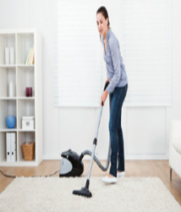
1.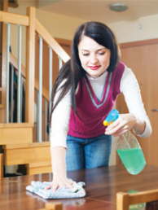 2. 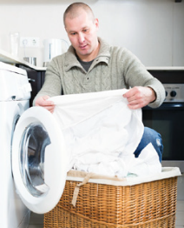 3. 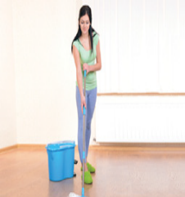 4. 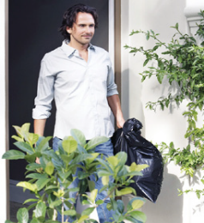5.
………………… ….………………. …………….. ………………….. …..……………………….

6.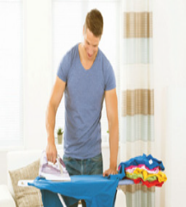 7. 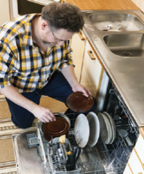8.  9. 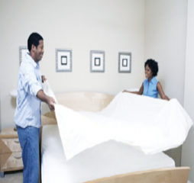 10.
……………….. ……………… ……………….. ………………… …………………………………
D: Fill in the blanks with “must” or “mustn’t” . (5 x 2 =10 pts)

1. We …………………………………..…….……talk each other during a lesson.
2. We ……………………………………………...chew gum in the classroom..
3. We ………………………..………..………… respect to our teachers in the school.
4. We …………………………………..………...use mobile phones during a lesson.
5. We ……………………………………….………come to school late.
E: Choose the correct option. (10 x 3 = 30 pts)  1- My dad always …………. in our family because he loves working in the garden.  A) dusts the furniture B) cleans the windows  C) waters the plants D) vacuums the carpet  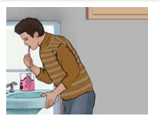  2- ………… water tap while we are brushing our teeth.  A) We should clean  B) We have to wash  C) We must change  D) We should turn off  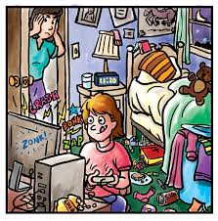  3- Görsele dikkate alarak Deniz annesine ne cevap vermiştir?  Deniz, have you tidied your room honey? | 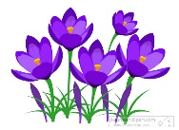  7- Görsellerde bulunmayan seçenek hangisidir?  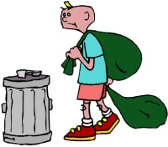  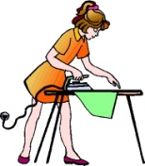  8- Hangi seçenek hatalı ifade edilmiştir?  9- Verilen metinde anlam bütünlüğünü bozan cümlenin bulunduğu seçeneği işaretleyiniz.  Felix Hoffman, a 29-year old chemist invented the drug aspirin in 1899. (I) He gave the first aspirin to his father for his arthritis. (II) Some painkillers can be harmful for health. (III) By 1950, it was the best selling painkiller in the world. (IV) A Spanish philosopher called the 20th century “The Age of Aspirin”.  A) I B) II C) III D) IV  10- Diyalogdaki boşluğa hangi cümle getirilemez?  Alice : Photosynthesis provides us with most of the oxygen we need in order to breathe.  John : ............................Can you say it again?  Alice : Photosynthesis gives us oxygen.  A) I'm sorry, I can't follow you.  B) I think I missed the point.  C) I hope I will pass the exam.  D) I couldn't understand you very well.  11- Hangi seçenek aşağıdaki ifadeyle aynı anlama gelir? (BONUS +3 POINTS)  Good health is more important than money.
  A) No, mum. Not yet.
  B) Of course mum. Let’s come and see.
  C) I have just tidied my room.
  D) I have already tidied my room.
  4- Resme göre boşluğu tamamlayınız.
  Büşra is in the garden. She is----------.
  A) doing the laundry
  B) loading the dishwasher
  C) making the bed
  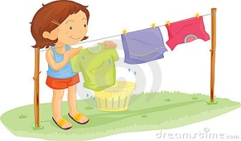
  D) hanging out the washing
  5- Christopher : ……………….?
  Robert : More than 100.000.
  Christopher : It is very sad to hear.
  Robert : Yes, it was one of the biggest disasters in history.
  A) How many people died from disaster
  B) What was the result of the match
  C) What about earthquakes
  D) What do you mean
  - 6- Jack: ...................................?
  Henry: I’m sorry but it’s not my responsibility.
    - Do you help with the household chores at home?
    - Who is responsible for setting the table?
    - Does your father pay the bills in your house?
    - Do you mind doing the washing up?
  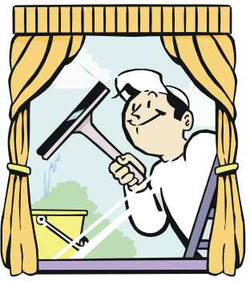
  A) mop the floor | 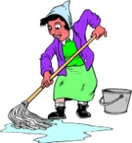  B) clean the window
  C) do the ironing | D) dust the shelves
  A) Chloroplasts make the plants green.
  B) Plants die without water.
  C) Light is necessary for photosynthesis.
  D) Plants never die.
  A) Money is more important than good health.
  B) Money and good health are important.
  C) Good health is important.
  D) Money is less important than good health.
https://www.sorubak.com

