…… EDUCATIONAL YEAR ARPACAY BOARDING SECONDARY SCHOOL 2nd TERM 2nd WRITTEN EXAM for 8th GRADERS
Name- Surname: Class: No: Grade:_______/100
A. Match the sentences with the natural forces. (2x9=18 Pts.)

- I can see dry soil _____ a. avalanche
- I can see burning trees across the hill _____ b. landslide
- I can see snow falling down a mountain _____ c. forest fire
- I can see earth on mountain road _____ d. drought
- I can see huge wave hitting the city _____ e. earthquake
- I can see cars under the water _____ f. tornado
- I can see strong wind going round in a circle _____ g. tsunami
- I can see collapsed buildings _____ h. volcanic eruption
- I can see lava falling down _____ j. flood

B. Choose the correct option. (2x6=12 Pts.)

- Dr Steward is working in his.......................................... a) laboratory b) engineer
- He was designing a ...................that could walk and talk. a) experiment b) robot
- My brother loves making.......................cars at school. a) clever b) electronic
- There was a(n) ....................., but luckily nobody was hurt. a) explosion b) scientist
- First, he made a ....................from cardboard. a) model b) should
- Little ..........is studying with the test tubes in chemistry class. a) built b) scientist

B. Write the suitable comparative forms of the adjectives. (5x2=10 Pts)
- Kayaking is ............................................bungee jumping. (safe)
- Rock climbing is ............................................cycling. (dangerous)
- Hang-gliding is ............................................sport of all. (entertaining)
- Parachuting is ............................................caving. (exciting)
- I tried paragliding but it was ............................................skiing. (bad)

C. Write ‘’prefer’’ or ‘’would rather’’. (5x1=5 Pts)
- I ............................................not go cycling. It is boring.
- Sue ............................................rafting to kayaking.
- We ............................................do caving than windsurfing.
- They ............................................rugby. It is more exciting.
- Bob ............................................swim with the sharks. It is more fascinating.

D. Match the phrases. (1x7=7 P.)
- Water ____ a. reality
- Science ____ b. changes
- Extinction____ c. disasters
- Climate____ d. materials
- Global ____ e. fiction
- Virtual ____ f. shortage
- Toxic ____ g. warming
- Natural ____ h. impaired
- Hearing____ ı. depletion
- Ozone layer____ k. of species

E. Write “must” or “mustn’t” or “ don’t/doesn’t have to” . (5x1=5 Pts)
- He ............................................ cook. I’ll make the dishes.
- We .............................................get to school late.
- Jack ............................................get up early on Sundays.
- You ............................................obey the school rules.
- Girls ............................................wear trousers. They can also wear skirts at school.

E. Kelimeleri eşleştiriniz ve kutucuk içerisine Türkçe karşılıklarını yazınız. (8x1= 8 Pts)
- set...........
- dust...........
- do...........
- vacuum...........
- make...........
- mop...........
- dry...........
- load...........
- the floor
- the carpet
- the table
- the dishwasher
- the furniture
- the dishes
- the bed
- the ironing

1. ....................................... 5. .......................................
2. ....................................... 6. .......................................
3. ....................................... 7. .......................................
4. ....................................... 8. .......................................

F. Write 5 sentences using the words below. (5x2=10 Pts)
- and : ve g. volunteer team : gönüllü ekibi
- collect donations : bağış toplamak h. send: göndermek
- because : çünkü ı. leave home : evi terk etmek
- rescue team : kurtarma ekibi j. medical supplies : tıbbi yardım
- take place : meydana gelmek k. earthquake :deprem

- ....................................................................................................................................................
- ....................................................................................................................................................
- ....................................................................................................................................................
- ....................................................................................................................................................
- ....................................................................................................................................................
G. Read the text and answer the questions. (4x2=8 Pts)
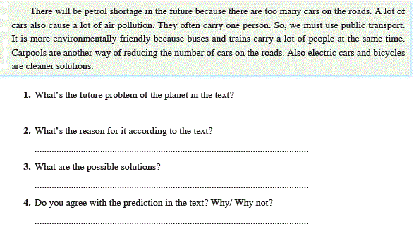
Chose the correct answer. 1x 14=14 Pts)

1. "Explosion" means....
A. Uzay B. Patlama
C. Uydu D. Deney
2. "Surgery" means......
A. Ameliyat B. Cerrah
C. Hasta D. İlaç
3. "Artificial" means.....
A. Yapay B. Yer Çekimi
C. Ayak izi D. Deney

4. Christophe Columbus ………….the continent of America.
A. developed B. invited
C. invented D. discovered
5. What is the natural disaster in the photo?
A)Flood C)Avalanche
B)Earthquake D) Tornado

9. Acar: Virtual reality can help learning by images
Bruce: What do you mean?
Acar: I mean,..................
- it's fake reality.
- you can explore an atom.
- everyone can buy it.
- there are advantages of it.
10. Replacing the human body parts with machines is a part of science called ………
A. physics B. bionics
C. chemistry D. geography
11. He was doing an ……………… in the lab.
A. experience B. experiment C. prosthetic D. implant


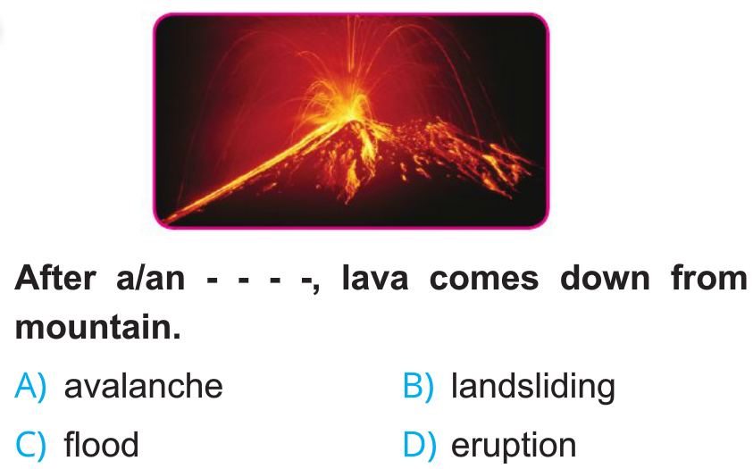

12. Burak: ………. invented the light bulb?
Gökhan: Thomas Edison.
A. Who B. When C. What D. Where
6. Hagia Sophia, Cappadocia, Topkapı Palace are the famous ………..in Turkey.
- coast
- painting
- tourist attractions
- accommodation
7. We were skiing in Uludağ when the snow on the slope above us started to slide down towards us.
- Pollution C)Poverty
- Avalanche D)Famine
8. What should you do during a lightning storm?
- Fly a kite or a model plane
- Ride a bicycle
- Stay low to the ground
- Stay near the windows

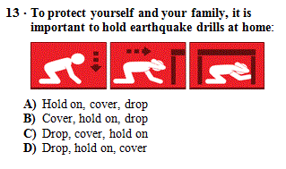
14. Zany: Are you interested in science?
Sue: …………….?
Zany: Are you interested in science?

- Can you repeat it?
- What do you mean?
- I’m sorry.
- I think I missed the bus.

