……….. EDUCATION YEAR ........... SECONDARY SCHOOL THE 2ND TERM 2ND
ENGLISH WRITTEN EXAMINATION FOR 8th GRADERS

Name&Surname: Class: Number:
A) Circle the correct answers. (Doğru cevapları işaretleyiniz) (16x4=64 pts)

1- My dad always …………. in our family because he loves working in the garden.
A) dusts the furniture B) cleans the windows
C) waters the plants D) vacuums the carpet

2- Büşra is in the garden. She is …………..
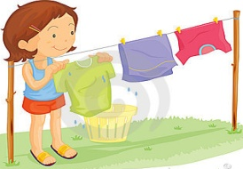
A) hanging out the washing
B) loading the dishwasher
C) making the bed
D) doing the laundry

3- Hangi seçenek aşağıdaki ifadeyle aynı
anlama gelir?
“Good health is more important than money.”
A) Money is more important than good health.
B) Money and good health are important.
C) Good health is not important.
D) Money is less important than good health.

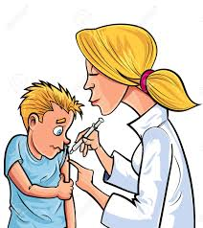
4- Choose the correct answer.
A) The dentist is taking an x-ray of
the school children’s teeth.
B) The nurse is vaccinating the child
against serious diseases.
C) The chemist is conducting an experiment.
D) The scientists are heating the
test tube in the lab.

5- Alexander Graham Bell ........ the telephone and phonograph.
a) discovered b) looked for
c) explored d) invented
6- Choose the correct answer.
a) The dentist is taking an x-ray
of teeth.
b) A man is doing an experiment.
c) The doctor is replacing an artificial limb.
d) An engineer is designing a new project.

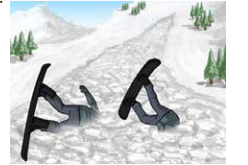
7- Verilen görseli ifade eden seçeneği işaretleyiniz.
A) An earthquake hit Japan at 2 pm.
B) Skiers were injured by the avalanche.
C) Everybody left the city after the flood.
D) Seven people died because of tsunami

8- After an earthquake, people must be prepared for …………… because some objects can fall off shelves.
A) overpopulation B) aftershocks
C) droughts D) famine

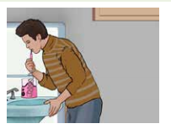
9- ………… water tap while we are brushing our teeth.
A) We should clean
B) We have to wash
C) We must change
D) We should turn off

10- Christopher : ……………….?
Robert : More than 100.000.
Christopher : It is very sad to hear.
Robert : Yes, it was one of the biggest disasters in history.

A) How many people died from disaster
B) What was the result of the match
C) What about earthquakes
D) What do you mean

11- Felix Hoffman, a 29-year old chemist invented the drug aspirin in 1899. (I) He gave the first aspirin to his father for his arthritis. (II) Some painkillers can be harmful for health. (III) By 1950, it was the best selling painkiller in the world. (IV) A Spanish philosopher called the 20th century “The Age of Aspirin”.
Verilen metinde anlam bütünlüğünü bozan cümlenin bulunduğu seçeneği işaretleyiniz.
A) I B) II C) III D) IV

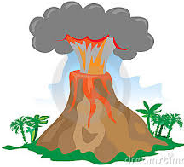
12- Find the wrong match.
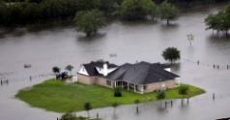

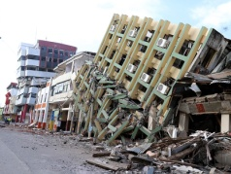
A) Flood B) Tornado
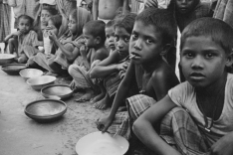

C) Poverty D) Earthquake
13- You're in the Science class. Your teacher is explaining you the process of photosynthesis. One of your friends is talking. What does your teacher say?
A) Can you say it again? I couldn't follow you.
B) Can I give some examples for it.
C) Let's do an experiment about it.
D) Could you listen to me more carefully, please?

14- A: Hello. Is Alex in?
B: Hello. Could I ask who’s calling? A: I’m his neighbour, Harry.
B: I’m sorry. He’s not available now. He’s out. Would you like to leave a message?
A: No, thanks. ………………… .
B: OK.
A) I’ll call back later. B)Tell him to call me, please.
C) I’m his best friend. D) I don’t know his number.

15-Tracey hasn’t tidied her room ..... .
A) almost B) just
C) already D) yet

16- Do you know how to make salad?
Here’s how:
First of all, chop the tomatoes, cucumber, onion and lettuce and put them into a bowl. Then, put some oil and salt in it.
Finally mix them all. It’s ready!
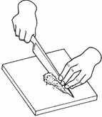
Which one is not mentioned in the text?
A) B)

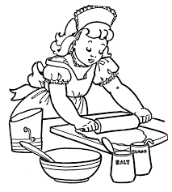
C) D)

B) Write the words under the pictures. (Kelimeleri resimlerin altına yazınız) (5x4=20 pts)
Drought | Landslide | Forest fire | Tornado | Tsunami
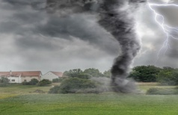
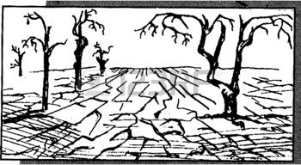
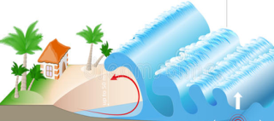
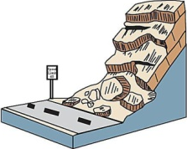

1- ………….…….. 2-……………………. 3-………………..……… 4-…………..…………. 5-…………………………

C) Sınıf kuralıysa (C ) ev kuralıysa (H) harfini yuvarlak içine alınız. (4x2=8 Pts)

- Raise your hand to speak. C / H | - Don’t jump on the bed. C / H
- Follow the directions. C / H | - Be kind to your brother/sister. C / H

D) Fill in the blanks with the given words.(Boşlukları verilen kelimelerle doldurunuz) (4x2=8 pts)
illiteracy | global warming | homeless | child-labour

1-Because of the earthquake, some houses collapsed so a lot of people are ………......……… now.

2-There was ………….......…. in the past. Most of the people couldn’t read or write.

3-The rise in the Earth’s temperature causes ……….…...………… .

4-………………….. is a big problem in some countries. Children work in badly-paid or dangerous jobs.

Good Luck
.....................
ELT

