……… EDUCATION YEAR
2nd TERM 2nd EXAM FOR 7th GRADES
Name Surname: Mark:

- Kutunun içindeki kelimeleri uygun yerlere yazınız. (7x2=14)
Public transportation / Wind energy / Pollute / Turn off / Protect / Recycle / Plastic
1- Don’t use publice transportation Use paper.
2- Recycle plastic bottles, glass, cans, paper and more.
3- Turn off lights, fans and other electronic devices when not in use.
4- We must protect rainforests because they are necessary for oxygen.
5- We must use public transportation We shouldn’t use family cars.
6- Wind energy is a kind of renewable energy.
7- Sea life is in danger because people pollute the lakes, rivers and seas.
- Cümleleri okuyunuz ve doğruysa “True” yanlışsa “False” yazınız. (6x2=12 pts.)
1- Plastics bag are harmful to the environment. ______T_______
2- Global warming causes the greenhouse effect. ______T_______
3- Recycling glass, paper and metal helps the environment. ___T_________
4- Cutting down trees is a good thing to protect nature. _______F______
5- There are nine planets in the solar system. _________F_____
6- Superstitious people don’t believe in fortune telling. ____F___________

- Cümleleri sıraya koyunuz. (4x3=12)

1) environment / people / protect / must PEOPLE MUST PROTECT ENVIRONMENT
2) transportation / use / humans / must / public HUMANS MUST USE PUBLIC TRASNPORTATION
3) glass / must/ recycle / everybody / paper / and. EVERYBODY MUST RECYLCE PAPER AND GLASS
4) Plant / trees / must / we/ water / them/ and WE MUST PLANT TREES AND WATER THEM
- Resimlerin altına kutucuğun içinden uygun olan kelimeyi yazınız. (6x2=12)

Green House Pesticides Global Warming Public Transportation Air Pollution Deforestation
Unplug Paper bag Increase Planet Rubbish bin
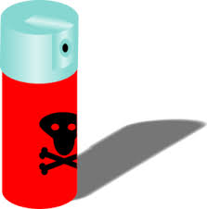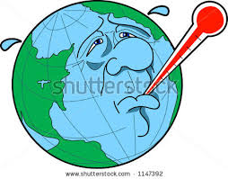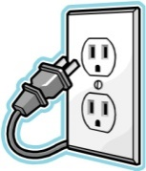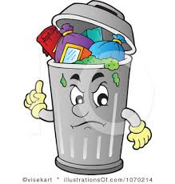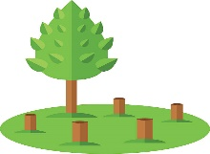
1) increase 2) unplug 3rubbish bin 4) deforestation 5) global warming 6) pesticides

Circle the correct answers. 17x2=34

1) Samet : I think our team will lose the match.
Görkem : ____________________.
A) I hope not B) I hope so
C) I can’t do that D) I hope I will

2) Factories give out greenhouse gases ________________.
A) so, they use eco-friendly deodorants
B) because cars cause air pollution
C) so, people mustn’t use insecticide
D) so, global warming increases

3) My father goes to the ______ to talk about problems of our city.
A) shoe shop B) movie theatre
C) department store D) governorship
4) If you want to be healthy, ____________________

A) you should try to be a couch potato.
B) we should eat more fast food.
C) you should eat fruit and vegetable.
D) we can organise a surprise party.

5) A: What must you do to protect environment?
B: _________________________________

A) We mustn’t use energy-saving light bulbs
B) We must stop destroying forests.
C) We must throw rubbish in the street.
D) We mustn’t use public transportation

6) "................" means the increase in world's temperature.

A) Global Warming B) Greenhouse gases
C) Exhaust Gases D) Acidic Water

7) I sometimes go to a cafe .................... .
Aşağıdakilerden hangisi cümleyi tamamlamak için uygun değildir?

A) to meet my friends B) to have some dessert
C) to eat some ice-cream D) to buy some magazines

8) A: Would you like to go the cinema with me?
B: __________. I have a lot of homework to do.

A) I’m sorry, I can’t B) I can’t come to your party
C) Yes, of course D) Let’s eat something

9) _____________is a big problem. We shouldn’t throw rubbish in the sea.

A) water pollution B) air pollution
C) environment pollution D) saving water

10) In this party the guests can wear any types of costumes. They can wear costumes from films, children’s TV characters, cartoons, different cultures. It is a______________
A) sleepover party B) New Year party
C) engagement party D) fancy dress party
11) Joe went to London last year. He stayed at a hotel with friends. He visited lots of places and took a lot of photos. He had a good time there.
Yukarıdaki metnin içerisinde seçeneklerden hangisinin cevabı bulunmamaktadır?
A) When did he go to London?
B) What did he do in London?
C) What did he eat in London?
D) Where did he stay in London?

 | Mon | Tue | Wed | Thur | Fri | Sat | Sun
Sports center | ✓ | ✓ | ✓ | ✓ | ✓
English course |  |  | ✓ |  |  | ✓ | ✓
12) Hangi cümle doğrudur? (x işareti gittiği gün anlamındadır)
A) I go to sports center at the weekends.
B) I go to English course three times a week.
C) I go to sports center every day.
D) I go to English course only on Wednesday.

13) _______________ like bus, metro and train. We can reduce air pollution.

A) we mustn’t waste energy
B) we mustn’t throw rubbish
C) we must use public transportation
D) we must save energy

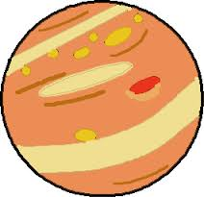
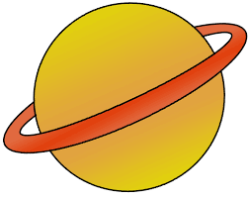
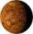

Jupiter Saturn Earth Mercury

14) Jupiter is smaller than Mercury. ………….
Earth is bigger than Saturn. ………….
Mercury is smaller than Jupiter. ………….
Saturn is bigger than Jupiter. ……….....

Yukarıdaki cümlelere TRUE/FALSE olarak bakarsak sırasıyla hangi cevapları veririz?

A) True-False-True-False B) False-False- True - False
C) True-True-False –False D) False- True –False –True

15) ‘’We haven’t got many tomatoes in the fridge.’’ Cümlesinin eş anlamlısı hangisidir?

A) We have got a few tomatoes in the fridge.
B) We have got a little tomato in the fridge.
C) We have got a lot of tomatoes in the fridge.
D) We have got many tomatoes in the fridge.

16) Mr. Smith : Most of wild animals are in danger.
Jane : Why do you think so?
Mr. Smith : Because - - - - .
A) we should turn off the electrical devices
B) they don’t have white and black fur
C) people destroy their habitat
D) we should protect animals
17) Ayşe: ____________ sugar do we need for the cake?
A) How much B) How many
C) Where D) When

