2017-2018 Ş.R.D. SECONDARY SCHOOL 2nd TERM 2nd WRITTEN EXAM FOR 7th GRADES
Name/Surname: Number : Mark:

A.Aşağıdaki boşlukları kutu içinde verilen kelimeler ile doldurunuz. ( 10p )
-Recycle
-Public transportation
-Plant
-Pollute
-Throw
-Turn off
-Cut down
-Save
-Waste
-Protect
1.We must ………………......rainforests because they produce oxygen.
2.We should use …………………………. like buses,trains and planes.
3.We should ……………………… paper, glass and plastics
4.We should …………………….......more trees.
5.People shouldn't ………….................the seas, rivers and lakes with garbage.
6.We shouldn't …………………… electricity and water.
7.We should ………………………. the TV if we aren't watching it.
8.We shouldn't .................................. rubbish around.
9. We shouldn't ………………….. trees because we need them.
10. We should ………………………. energy.
B.Cümleleri zamana uygun bir şekilde kutudaki kelimelerle tamamlayın. (10p)
- finished
- went
- is
- was
- drink
- wrote
- will come
- will live
- slept
- bought
- Yağmur……............. in the classroom now.
- Hazar ……………...….......a few pencils yesterday.
- Yusuf ………………….to İstanbul Last week.
- My father …………………back home next week.
- Seyithan didn't ………………….. coffee yesterday.
- I ................................ my project two days ago.
- Nisanur ................................ a letter to Kübra last week.
- Şeyma ........................ at 10 pm yesterday because she was tired.
- Eda………………..at school an hour ago.
- I believe that people ............................. in the Moon in the future
C) RESİMLERİN ALTINA DOĞRU KELİMEYİ YAZIN.(20p)
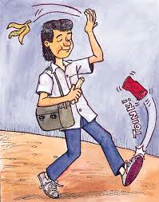
Public transport - Cut trees - Paper - Exhaust fumes - Water Pollution
Global warming - Plant trees - Recycle - Unplug - Throw rubbish
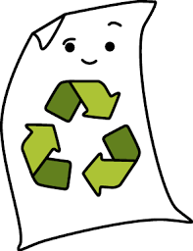
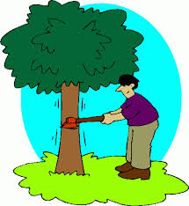
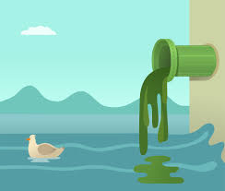
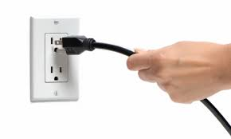

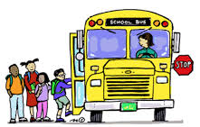
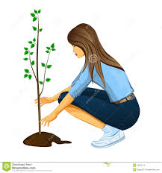
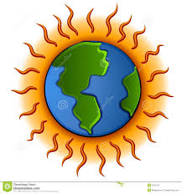

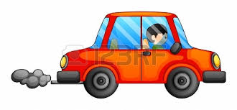

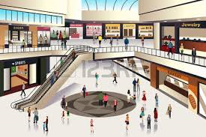
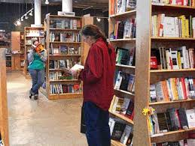
D) BİNALARIN İNGİLİZCELERİNİ YAZIN.(10p)
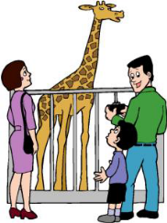
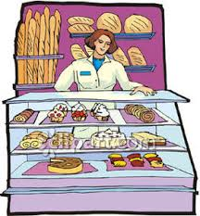
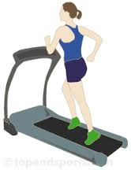

G ............... Z .......................... B ...................... B ................................. S.........................................

F. DOĞRU ŞIKKI İŞARETLEYİNİZ. (50p)
1.There are three eggs. Anlamca en yakın cümle hangisidir?
a) There are a little eggs. c) There are a lot of eggs.
b) There are a few eggs. d) There is an egg.

2.Hangi tavsiye yanlıştır?
a) We shouldn't pollute air
b) We shouldn’t cut down trees
c) We should protect forests
d) We should waste energy and water

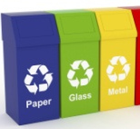
3. We should ……. glass, plastic and paper
a) Pollute b) Turn off
c) Waste d) Recycle

4.Pandas are………………animals.
a) Endangered c) Domesticated
b) Deforestation d) Extinct

5. Hilal: I went to ......................... to buy medicines.
a)pharmacy b)bakery c)grocery d)florist

6.We should ............... if we aren't using them.
a) turn on electronic devices
b) turn off electronic devices
c) leave electronic devices on
d) let water run

7.We shouldn't ...............
a) waste energy c) leave electronic devices off
b) save energy d) use public transport

8:A greengrocer sells ............. and ...........
A)medicine/syrups C)shoes/bags
B)vegetables/fruits D)books/magazines

9) People …………………the lakes, rivers so fish die.
A) pollute B) protect C) heat D) save

10) To protect the enviroment, you………………….
A) should save your money C) should plant more trees
B) should cut more trees D) should waste energy

11) Recep: It's raining. Let's stay at home and watch TV.
Haluk: ............ There are good films on TV today.
A) It's a bad idea C) I hate watching TV
B) I agree with you D) Do you like documentaries?

12) I'm very rich. I have got ……………….. money
A) a little
B) some
C) a few
D) a lot of
13) If you want to join a ………………… party, you need an interesting costume.
a. fancy dress b. invitation
c. pyjama d. birthday

14)............... some cookies? Yes, please
a) Can you eat b) Would you like
c) Do you like d) Do you think

15) We shouldn't throw ............ around.
a) water b) damage c) rubbish d) recycle

16) Sudenaz went to a shoe shop and .......... new shoes yesterday.
A) buy B) will buy C) bought D) buyed

17)They ............last Summer.
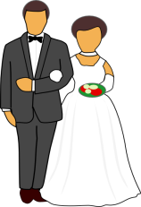
a. get married
b. had an accident
c. got married
d. graduated

18).......... is a big problem for our world.
Boşluğa hangisi gelemez?
A) Pollution B) Global warming
C) Energy waste D) Forests

19)Don’t use your cars .Use ..................!
A) Exhaust gases B) Paper
C) Electricity D) Public transport

20) EARTH means .......................
A) Universe B) Creature C) World D) Ocean

21)We must eat ..........................
A) Junk food B) Fast food
C) a lot of food D) Organic food

22) If you want to save electricity , ........the electronic devices.
A) Unplug B) Plug C) Use D) Protect

23)We go to ..............to have fun.
A) Post office B) Florist
C) Amusement park D) Pharmacy

24)People destroy the ......... so animals can't find a place to live.
A) Beaches C) Vegetables
B) buildings D) forests

25) Efecan:.......... do you sleep late?
Yağız: Never. I always sleep early.
A) How many C) What time
B) Where D) How often

