……….. EDUCATIONAL YEAR 2ND TERM 2ND EXAM OF THE 7TH GRADE
NAME SURNAME:.........................................
CLASS / NUMBER:.............................................

1.Matt often - - - - because he is interested in animals.
A) goes to the zoo
B) buys fresh meat
C) calls police station
D) visits the art gallery

**********************************

2.Jack : - - - -?
Bernard : I will be very rich and buy houses in a big city.
A) Where is your new house
B) Why do you live in a big city
C) How much does a house cost
D) What’s your dream for future

**********************************
3 )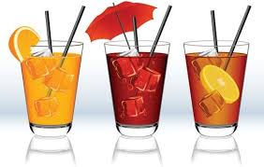Mother: We need some …………… to drink. We don’t have enough.
A) fruit B) hats
C) beverages D) food

4. We need to ______________ the presents with colourful papers.
A) arrange B) order
C) fancy D) wrap

*******************************

5,6,7,8.SORULARI METNE GÖRE YANITLAYINIZ.

Dear Fatih;
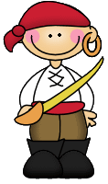
Wear interesting costumes and come to my fancy dress party.It is on 18th of December on Wednesday at 6 o’clock at Star Café. You can bring some CDs.See you there.
Love Mustafa

*DAVETİYEDEKİ BİLGİLERE BAKARAK AŞAĞIDAKİ BOŞLUKLARI DOLDURUNUZ.

5.Date:
6.Place:
7.Time:
8.Party type:

9. You should call the fire station____________
a) to buy sports magazine
b) to report the fire
c) to draw money
d) to see the governor

**********************************

10.There are eight ............., the................and
a lot of ..................in the solar system.

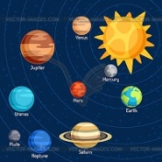
a) planets – Sun - satellites
b) Moon – stars - sun
c) Earth – Suns - satellites
d) Sun – asteroids – comets

*********************************

11. Jupiter is ............... biggest planet in the solar system.
a) very b) the c) a d) most

**********************************

12. Neptune is ................... than Saturn, but Pluto is the .................... planet in the solar system.
a) small / smallest
b) smaller / smallest
c) smaller / smaller
d) smallest / smallest

13. İstanbul is .................. crowded city in Turkey.
a) most b) the most
c) more d) the more

****************************************

14.We ................ save water. So,we ............. waste water while brushing teeth.
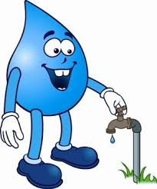
a) must / shouldn't
b) can’t / should
c) won’t / must
d) shouldn’t / doesn’t

**********************************

15. If we ..................... more trees, we can save our planet.

a) plant b) destroy
c) hunt d) cut down

**********************************

16.I think people …… on the moon in the future.
A) is live B) are lives
C) living D) will live

17 ) ...............is a big ball of ice and rock sliding around the Sun with its long tail.

A) a satellite b) observe
c) orbit d) comet

**********************************

18. .................... destroy rainforests!

a) Should b) Don’t
c) Mustn’t d) Won’t

**********************************

19. Farmers shouldn't use ..............on their farm.

A) green house
B) prevent
C) pesticides
D) deforestation

**********************************

20. İbrahim prefers ............. football to ....... music.

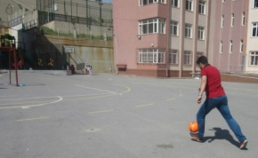
a) playing / listening to
b) play / listen to
c) played / listened to
d) plays / listening to

**********************************

21.A: ______buying a new MP3 player?
B: Yes. It is a great idea.

a) Why don't we b) Why don't you
c) How about d) Let's

**********************************

22.Would you like..............some water?
a) drank b) to drink
c) to drinking d) drinking

**********************************

23.Nihal: .......................... go to the cinema and have some fun together?

English Teacher: Great idea!
Let’s go after school today.

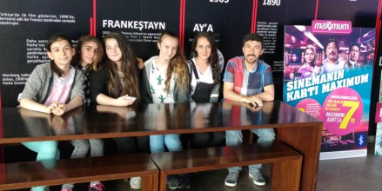
a) Let’s not

b) Would you like

c)Why don’t we

d) Don’t

**********************************

24. . I was in a ......................... party yesterday. My best friend got married to his girl friend.

a) fancy-dress b) wedding
c) birthday d) halloween

**********************************

25.
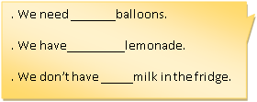

A) any – a few – many
B) a little – many – a lot of
C) much – many - some
D) a lot of – some – any

26.AŞAĞIDAKİ KELİMELERİN ANLAMLARINI YAZINIZ.
(her soru 1 puan)
A) Public transportation:..................................

B) Invitation card:................................................

C) Global warming:..............................................

D) Green House Effect:.......................................

