…………. ACADEMIC YEAR
ŞH. YAVUZ ULUTAŞ ÇELİKOĞLU ORTAOKULU
2ND TERM 2ND ELECTIVE ENGLISH EXAM FOR 7th GRADERS
NAME & SURNAME: CLASS & NUMBER:

1-) Eşleştirme hangi seçenekte doğru sıralanmıştır?
I. People cut down trees | a. to invite his friends to the party.
II. She will take her camera | b. to buy a new car.
III. He wrote invitation cards | c. to take photos on holiday.
IV. You should save a lot of money. | d. to make more farm land.
A) I-a / II-c / III-b / IV-d | B) I-d / II-c / III-a / IV-b
C) I-d / II-a / III-c / IV-b | D) I-d / II-b / III-a / IV-c
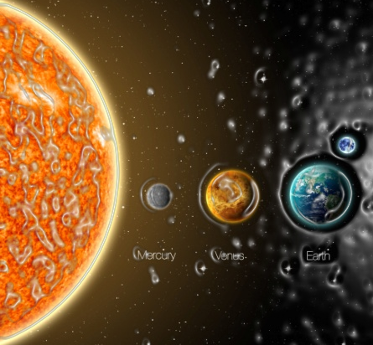
2-) Aşağıdaki bilgilere göre hangi seçenek doğrudur?
Earth is 149,5million km far away from the Sun. Venus is 109 million km far away from the Sun.

A) Earth is closer to the Sun than Venus.
B) Venus is further to the Sun than Earth.
C) Venus is the furthest of all.
D) Earth is further to the Sun than Venus.
3-) Cansu: Where ......... you ............on holiday
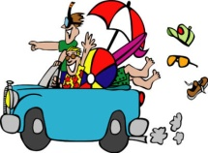
next summer?
Teacher: Antalya.
a) did / go b) will / go
c) are / go d) will / went

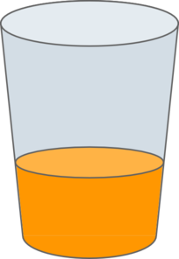
4-)
There is _________orange juice in the glass.

a) a little b) much c) a lot of d) any
5 .
____________brings you good luck.

a) seeing a black cat b) breaking a mirror
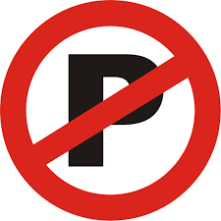
c)opening an umbrella indoors d) finding a four leaf clover
6-) You .................... park your car here!
It’s forbidden zone.

a) should b) can c) mustn’t d) won’t

7-) Aşağıda anlatılan gezegen hangisidir?
I’m called “THE RED PLANET” because my surface is red. I look red and hot, but I ‘m cooler than Earth.Which planet am I?

A) Mars B) Neptune C) Saturn D) Mercury
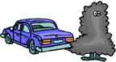
8-) Exhaust gases from cars pollute the air and environment. So, we must use ....................
a) electronic devices b) pesticides
c) public transportation d) bottles

9. ve 10. soruları aşağıdaki bilgilere göre cevaplayınız

BERAT AHMET JONAS
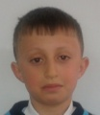
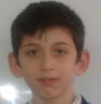
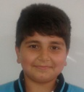

52 kg 63 kg 58 kg
155 cm 170 cm 165 cm
12 years old 14 years old 13 years old
9-) Which sentence is false?
a) Berat is the slimmest of the three.
b) Ahmet is the youngest of the three.
c) Berat is shorter than Ahmet.
d) Jonas is older than Berat

10-) Which sentence is true?
a) Jonas is the fattest of the three.
b) Berat is taller than Ahmet
c) Ahmet is slimmer than Jonas
d) Berat is the shortest of the three.

11-) There are the ............. , eight .............
and a lot of .................. in the solar system.
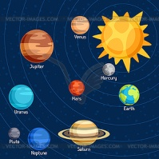
a) Sun – planets - comets
b) Moon – stars - astroids
c) Earth – Suns - satellites
d) Sun – astroids - comets

12-) We ................ save water.
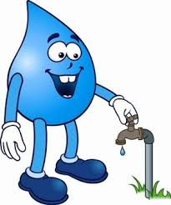
So, ............. let water run while brushing teeth

a) must / don’t b) can’t / should
c) won’t / must d) shouldn’t / doesn’t

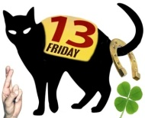
13-) Which one is not a superstition?
a) Finding a four-leaf clover
b) Buying an umbrella
c) Cutting nails at night
d) Breaking a mirror

14-) İrem: The English exam was too difficult.
Hilal: .....................................
I think it was very easy!

a) I don’t agree with you b) OK.
c) Yes, it was. d) Great idea!


15-) FB is ........... than BJK but GS is the .............. team in Turkish League

a) gooder / best b) worse / bader


c) worst / better d) better / best

16-)
Unfortunately, you will have a difficult week._________so you won’t go to work for a few days.

A) You will have health problems
B) You will hear some good news
C) You will be very successful
D) You will pass the exam

17) Anlam bütünlüğünü bozan cümle hangisidir?
(I)I prefer going to Mavi Bahçe to buy new clothes.(II) Because there are a lot of shops in it.(III).I saw a nice film at the movie theatre last night.(IV) So I can find everything there.

a) I B) II C) III D) IV

18-) Aşağıdaki diyalogda boşluğa hangi soru getirilemez?
I watched a documentary about global warming last night.
________?

A) What did you do last night | B) What kind of a film did you watch
C) When did you watch a documentary | D) What time did you watch a documentary

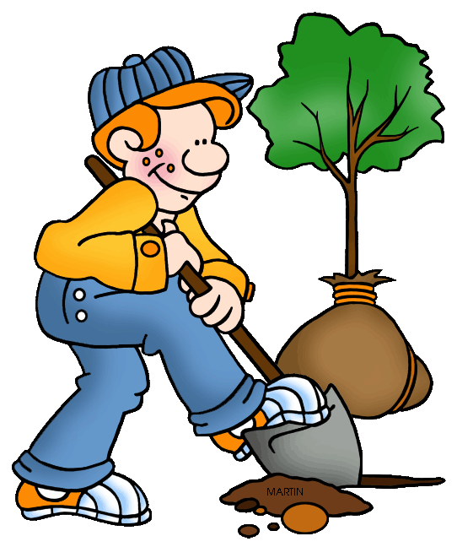
19-) If you ..................... more trees, you can
save our planet.

a) plant b) destroy
c) hunt d) cut down

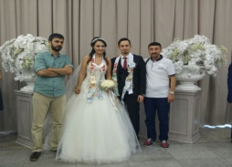
20-) I was in a ......................... party yesterday. My best friend got married to his girl friend.

a) fancy-dress b) wedding
c) birthday d) halloween

21-) Nihal: .......................... go to the cinema
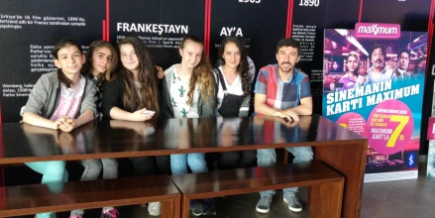
and have some fun together?

English Teacher: Great idea!
Let’s go after school today.

a) Let’s not
b) Would you like
c) Why don’t we
d) Should

22. glass / must / recycle / we / . / paper / and
Hangisinin cümle sıralanışı doğrudur?

a) We recycle must paper and glass.
b) We paper and glass recycle must.
c) We paper and glass must recycle.
d) We must recycle paper and glass.

23. Sam: Where are they going to have Pam’s birthday party?
Maria: ________
a) on 2nd of June b) next Friday
c) at 16:30 d) at the café

24. Tablodaki bilgilere göre hangisi doğrudur?

 | Neptune | Mercury | Venus | Earth
Orbit period | 168 | 88 | 225 | 368
Surface temperature | -200 | 450°C | 422°C | 30°C
a) Neptune is the hottest planet.
b) The earth is cooler than Venus.
c) Mercury is the coolest planet.
d) It takes Neptune 422 years to go round Sun

25. ……... is the coldest planet of all. I think people never live there.
a) Venus b) Neptune c) Earth d) Mercury

BONUS

Aşağıdaki sıfatların superlative halleri hangisinde doğru verilmiştir?

GOOD ………………..

FAR ………………..

BAD ………………..

a) the best / the farer / more bad
b) goodest / more far / the worst
c) the best / the furhest / the worst
d) beter / farer / worse

GOOD LUCK
Nihan ALTAN
Teacher of English

