……………. BELKIS SECONDARY SCHOOL 2nd TERM 2nd ELECTIVE ENGLISH EXAM for 6th GRADERS
Name- Surname: Class: 6/ Number: Mark:

A. Match the words with the pictures. (2x5=10 Pts)

1) President 2) ballot box 3) recycle 4) turn off 5) candidates
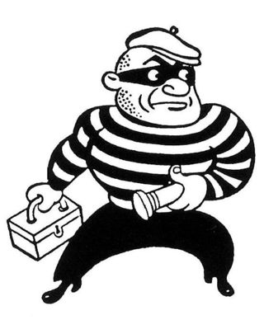
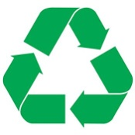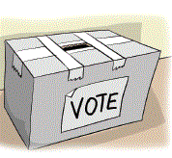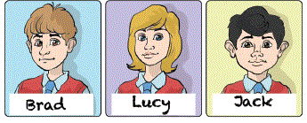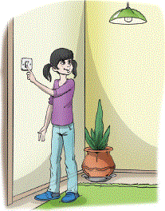

A. ................... B. ...................... C. .................... D. ................... E. ...................

B. Match the years with their pronunciation. (2x5=10 Pts)
 | 1455 |  |  | Sixteen seventy-one |  | ,,,,,,
 | 1846 |  |  | Two thousand eighteen |  | ,,,,,,,
 | 1904 |  |  | Fourteen fifty- five |  | ,,,,,,,
 | 1671 |  |  | Nineteen oh four |  | ,,,,,,
 | 2018 |  |  | Eighteen forty- six |  | ,,,,,,

C. Fill in the blanks with the occupations. (2x5= 10 Pts)
teacher doctor mechanic engineer tailor

- Jack is a ………………… He repairs cars.
- Jim is a ……………………… He likes teaching new things at school.
- Sue is a …………………………… She helps sick people. She works at a hospital.
- James is an …………………………He builds houses.

- Shelia is a ……………………She makes clothes and sew dresses.

D. Boşlukları ‘’ SHOULD “ veya “ SHOULDN’T ‘’ ile doldurun (2x5=10)

- We ________________ plant more trees.
- We ________________ cut down trees.
- We ________________ recycle paper, glass and plastic.
- We _________________ unplug the electrical devices when we do not use.
- We _____________________waste water and electricity.

E. Complete the text with the past forms of the verbs in parenthesis. (2x5=10 Pts)
a) Children _______ (drink) milk at the breakfast yesterday morning.
b) I _______(go) to Paris last summer.
c) Hakan __________(play)the guitar.
d) A thief _______ (steal) my bag two days ago.
e) I __________________ (swim) with my friends yesterday morning.

F. 1-3. soruları metne göre cevaplayınız. (3x3=9 Pts)
Dear David,
Hi! I am Ahmet from Kars. My mother is a teacher and she teaches Maths. My father is a doctor. He works at a hospital. My sister is older than me. She is a nurse and she also works at a hospital. My uncle and my aunt stay with us. My uncle is an engineer and he builds houses. We live together happily. What about you? What do you and your parents do?

- What does Ahmet's uncle do?
- He is a teacher.
- He is a lawyer.
- He is a doctor.
- He is an engineer.

2. Who works at a hospital?
- Ahmet.
- Ahmet's mother.
- Ahmet's father and sister
- Ahmet's aunt
3. Metne göre hangisi yanlıştır?
- Ahmet's uncle is an engineer.
- Ahmet is from Kars.
- Ahmet's father works at a hospital.
- Ahmet is older than his sister.

G. Choose the correct answer. (3x9=27 Pts)

- I’m a/an ………………….I can fly the plane.
a) pilot b) teacher
c) architect d) policeman

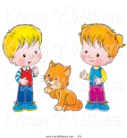
- The cat is .........the boy and girl.
a) in b) between
c) under d) on

- take / swim /run fiillerinin
2.hali hangi şıkta doğru verilmiştir?

a) taked /swam / run b) take /swim / run
c) took /swam / ran d) taked /swim / ran

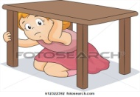
- The girl is ……………… the table.
a) on b) behind
c) under d) opposite

- I ______ in Gaziantep yesterday
a) was b) were c) are d) is

6- 1.000.000 – 100.000 – 10.000 – 1.000 –………..
Sıralamayı dikkate alırsak noktalı yere hangi rakam gelmelidir?
a)a hundred b)ten
c)a million d) a thousand

7-“250.000” yazılışı hangisidir?
a) sixty-eight thousand and five hundred
b) two hundred and fifteen thousand
c) twenty-five thousand
d) two hundred and fifty thousand

8- We __________ breakfast yesterday morning.
a) have b) had c) has d) having

9-A good candidate should _________
- be rude
- be respectful
- not ask other's opinions
- not be fair.

H-Kelimelerin Türkçe anlamlarını yazınız. (14 Pts)
- rubbish__________________
- planet___________________
- save____________________
- paper____________________
- air pollution_______________
- burglar___________________
- break into_________________
- steal_____________________
- binoculars_________________
- vote__________________
- unplug________________
- election_________________
- fair_____________________
- recycle____________________
Fatma BEYAZ
English Teacher

