……………. ACADEMIC YEAR ŞH. YAVUZ ULUTAŞ ÇELİKOĞLU ORTAOKULU
6TH GRADE 2ND TERM 2ND EXAM
NAME SURNAME: ………………………………. CLASS: …….. / NO:
A) Write the words under the pictures. (Kelimeleri resimlerin altına yazın) (5x2=10 pts)
pick up – throw away – unplug – remote control – rubbish

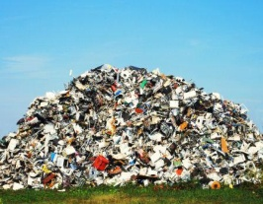
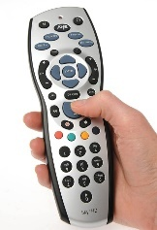
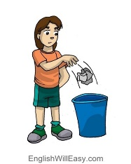
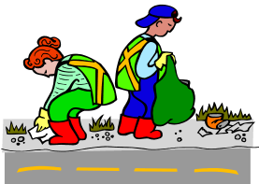
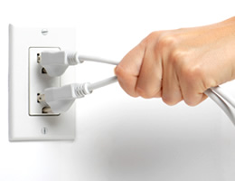

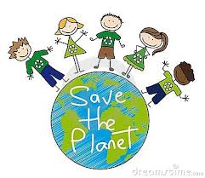
B. Fill in the blanks with “SHOULD” or “SHOULDN’T”. (Boşlukları SHOULD ya da SHOULDN’T ile doldurun) (5x2=10pts.)
- We _____________________keep the environment clean
- We _____________________cut down the trees
- We _____________________recycle paper, glass and plastic
- We _____________________make a fire in the forests.
- We _____________________turn off the taps when we are brushing our teeth

C. Write the numbers under the correct pictures. (Numaraları doğru resmin altına yazın) (6x3=18pts.)
1) Turn off the taps 2) Recycle 3) Don’t make a fire 4) Keep off the grass
5) Don’t feed the animals 6) Swimming not allowed

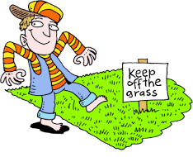
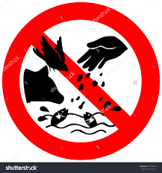
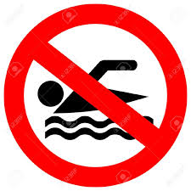
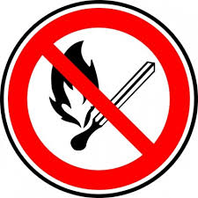
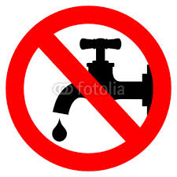
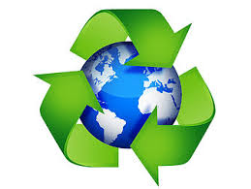

D. Match the sentences with the pictures. (Cümleleri resimlerle sayıları yazarak eşleştirin) (5x=10 p)
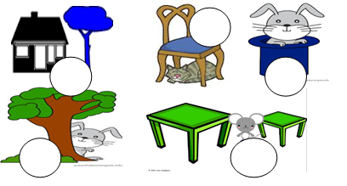
1) The rabbit is in the hat. 2) The cat is under the chair. 3) The tree is near the house. 4) The mouse is between the tables. 5) The rabbit is behind the tree.

E. Match the numbers with the words. (Sayıları okunuşlarıyla harfleri yazarak eşleştirin) (5x3=15 pts.)
a. | Ten million
b. | Seventeen thousand nine hundred and thirty two
c. | Eight hundred sixty five
d. | Twenty thousand
e. | Two hundred and eighty thousand
 |  | 1. | 280.000
 |  | 2. | 17.932
 |  | 3. | 10.000.000
 |  | 4. | 865
 |  | 5. | 20.000

F. Circle the correct one. (Doğru şıkkı işaretleyin) (9x4=36 pts.)
5. “I'm a/an __________ . I cut, dye and design hair.”
Yukarıdaki boşluğa hangi meslek gelmelidir?
a) Hairdresser b) Doctor c) Teacher d) Pilot

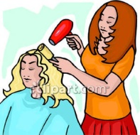
1. Görseli anlatan seçeneği işaretleyiniz.
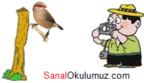
A) magnifier
B) fingerprint
C) footprint
D) robber
6. Görseli anlatan seçeneği işaretleyiniz.
A) take photographs
B) eat sandwiches
C) throw rubbish around
D) go hiking

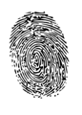
2. Görseli anlatan seçeneği işaretleyiniz.
A) prison
B) fingerprint
C) jewelry
D) detective
7. 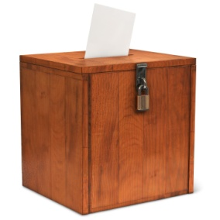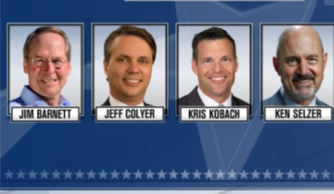 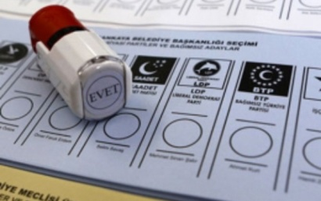
a) ballot box – president- vote c) equal- vote- candidates
b)vote- fair- ballot box d) ballot box- candidates- vote

8.Kemal: Were you ill last week? Kamil: ________.
a) Yes, I am b) Yes, I do c) Yes, I did d) Yes, I was

9. Beyza: What did you do on your last summer holiday?
Ali: …………………………………………..
a) I had a boat tour 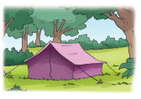
b) I stayed in a tent
c) I took a lot of photos
d) I climbed mountains


3. What does he do?
A) hairdresser
B) architect
C) lawyer
D) police
4. Cümledeki boşluğa hangi seçenek getirilemez?
I like ............. when I’m on the beach.
a) swimming b) learning ice skating
c) listening to the sea d) sunbathing

5. Aşağıdaki kişilerden hangisinin mesleğiyle ilgili verdiği bilgi doğrudur?
A)
I’m a lawyer. I draw the plans of buildings.


I’m a waiter. I wait for the bus.
B)


C)
I’m an actor. I act in films and plays.

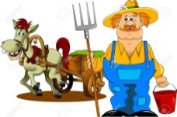
I’m a farmer. I grow vegetables and fruits.

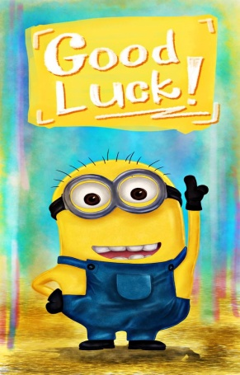

D)
Nihan ALTAN
Teacher of English

