…… EDUCATIONAL YEAR ÇARIKLAR SECONDARY SCHOOL
ENGLISH LESSON 2nd TERM 2ND EXAM for 6th (A) GRADES

Name-Surname: ……………………………………. Class:……….. Number:………..

- Match the occupations with the workplaces. B) Choose and circle the right option below.
- He is a waiter. He serves / cooks foods.
- Fatmagül is a nurse; she Works at a hospital / lab.
- Cengizhan is an architect; he designs / repairs buildings.
- Fatmanur is an author; she always writes / reads boks.
- He is a doctor and he writes story / prescription.
- Halise Nur is a lawyer; she defends people / animals.
- My friend Ömer is a teacher. He Works at a clinic / school.
- Şaban is a pilot and he can drive / fly planes.
- M. Ali is a hairdresser. He cut and designs / paint hair.
- Sude Nur is a tailor and she can sew / clean fabrics and clothes.
- ……. Scientist a. Company
- ……. Soldier b. Lab
- ……. Waitress c. Police station
- ……. Teacher d. Hospital
- ……. Worker e. Spaceship
- ……. Manager f. Plane
- ……. Doctor g. Factory
- ……. Policeman h. School
- ……. Astronaut i. Restaurant
- ……. Pilot j. Army

- Write the years in sentences.

- 2006 ……………………………………………………….. 6. 2016 ………………………………………………………..
- 2017 ……………………………………………………….. 7. 1917 ………………………………………………………..
- 1963 ……………………………………………………….. 8. 1755 ………………………………………………………..
- 1884 ……………………………………………………….. 9. 1923 ………………………………………………………..
- 2010 ……………………………………………………….. 10. 2019 ………………………………………………………..

- Circle the incorrect word for each phrase. (Yanlış olan seçeneği yuvarlak içerisine alınız.)
Do
Try
Play
forest
karate
yoga
skiing
scuba-diving
seaside
Snowball
Rafting
Handball
plane
school bus
truck
Drive
in the sea
water
in the pool
Swim
at a hotel
at a resort
in a tree
Stay
Films
Relatives
Parents
Visit
on holiday
playing golf
ice-skating
Go
Flowers
Apples
Museums
Pick

- Choose the correct answers.

- I had a great time with my friends on holiday last month.
______________________________________________
- It wasn’t very good. B) It was great. C) It was boring. D) It was horrible.

- A: …………………………………………?
B: It was really bad. We stayed at an UN-comfortable hotel and the foods were very bad.
- Who was with you? B) Where were you? C) Where was the hotel? D) How was your holiday?

- A: Where did you learn skiing?
B: ………………………………………… I was on holiday last winter and I took skiing lessons there.
- It is my sister. B) With my cousins. C) In Uludağ. D) No, I didn’t.

- Look at the pictures. Which one is false?



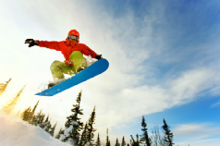
- . B) C) D)

DONNA LAURA CAROL SARAH

- Carol went sightseeing two years ago. C) Laura went to the mall to do some shopping.
- Donna learned snowboarding and she is good at it. D) Sarah went swimming on her last summer holiday.
- Write the 1st forms of the verbs in the text above.
- ……………………. – came 6. ……………………. – went 11. ……………………. – swam
- ……………………. – watched 7. ……………………. – bought 12. ……………………. – played
- ……………………. – stayed 8. ……………………. – visited 13. ……………………. – ate
- ……………………. – had 9. ……………………. – made 14. ……………………. – learned
- ……………………. – saw 10. ……………………. – did 15. ……………………. – drove
- Circle the correct word. (Doğru olanı yuvarlak içine alınız.)

1. I usually take the public bus to work because I want to save / protect air pollution.
2. You should plug / recycle plastic bags and newspapers.
3. We shouldn’t harm / use animals in our planet.
4. You shouldn’t throw rubbish / energy out on to the grass.

5. We should pollute / protect the environment.
6. You shouldn’t use deodorants much. They save / damage the ozone layer.
7. You shouldn’t cut down / plant trees in the forests.
8. You should / shouldn’t use eco-friendly bags.
G) Look at the pictures and match them with the slogans below.

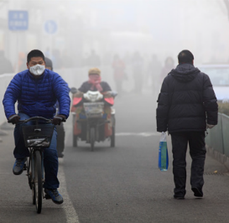
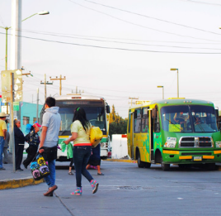
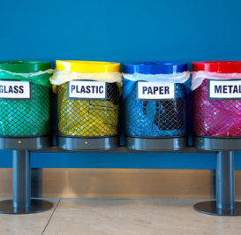
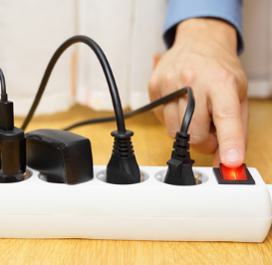
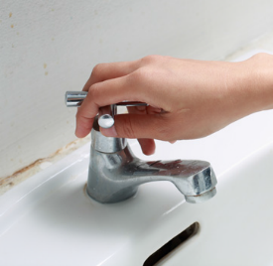
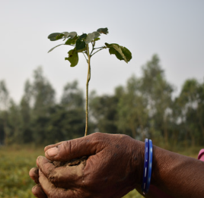
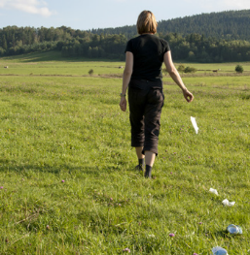
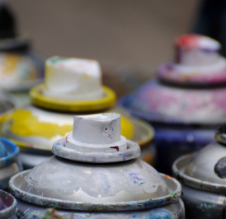
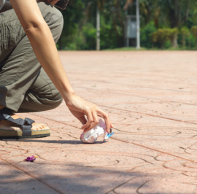
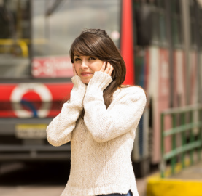
6
7
8
9
10
5
4
3
2
1

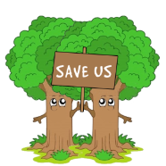
…… Use public transportation. …… Recycle paper, plastic, metal and glass.
…… Reduce noise pollution. …… Turn off the taps; don’t waste water.
…… Save our forests; don’t cut down trees. …… Turn off the electrical devices.
…… Keep the environment clean. …… Protect the environment; don’t throw rubbish around.
…… Don’t use deodorants ; stop damaging the ozone layer. …… Don’t pollute the air; stop air pollution.

- Choose the correct answer.
- Factories should use filters to ... . 2. Don’t waste water. ... .
A) Use your bicycle while going to school
A) pollute the air B) keep it clean B) Turn off the tap while brushing your teeth
C) recycle more glass D) reduce air pollution C) Go bird watching and take photos of the birds
D) Unplug the TV when you don’t watch it
- Which sentence is incorrect about protecting nature?

A) We should plant more trees to get more oxygen.
B) We should buy recyclable products.
C) We shouldn’t turn off the lights when we leave the room.
D) We shouldn’t waste electricity and water.

- A: What are you doing?
B: ..............................
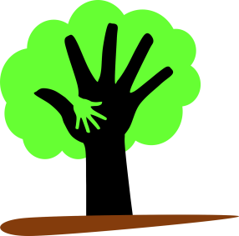
A: I see, but you should turn off the tap when you don’t use it. Don’t waste water.
B: Oh, I am sorry. I am turning it off now.

A) I am brushing my teeth B) I am walking on the grass
C) I am unplugging the TV D) I am playing video games

- Match the words with the pictures.

MAGAZINE NEWSPAPER DICTIONARY E-BOO LIBRARY ENCYLOPEDIA BOOKSHELF NOVEL
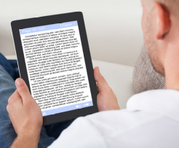

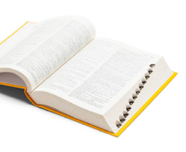

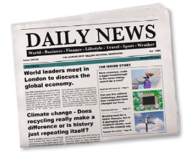

…………………………… …………………………… …………………………… …………………………… ……………………………

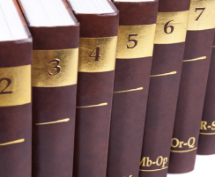
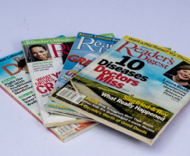

…………………………… …………………………… ……………………………
- Choose the correct answer fort he dialogs below.

- A: ..... ? 3. A: ..... ?
B: There were fifty magazines. B: I read the newspaper and drink tea.

a) Where did you see the magazines? a) What do you do after you get up?
b) How many magazines were there on the shelf? b) What did you watch on TV?


- A: ..... ? 4. A: ..... ?
B: Melis and Danial. B: Yes, I was. I had a great time.

a) Who were at the reading club? a) How was your holiday last summer?
b) Where were you yesterday? b) Were you at school on Thursday?

- A: ..... ?
B: It is behind the sofa on the desk.

- What time do you read a book?
- Where is my new book?
PUAN TABLOSU
A BÖLÜMÜ: 20 P D BÖLÜMÜ: 8 P G BÖLÜMÜ: 8 P
B BÖLMÜ: 10 P E BÖLÜMÜ: 15 P H BÖLÜMÜ: 8 P
C BÖLÜMÜ: 9 P F BÖLÜMÜ: 8 P İ BÖLÜMÜ: 10 P
J BÖLÜMÜ: 20 P



Samet SAYGI ENGLISH TEACHER

