- Aşağıdaki spor türlerini resimleri ile eşleştiriniz. (12x2=24 puan)
Horse riding Flying a kite Climbing Playing table tennis Cycling Weigh lifting Skateboarding Playing football Fishing Playing basketball Playing baseball Swimming

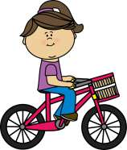 | 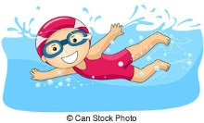 | 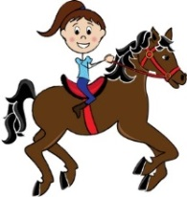 | 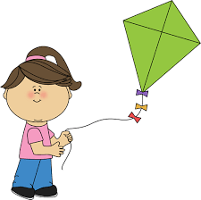 | 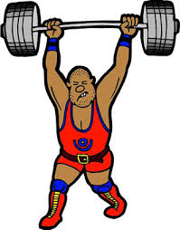 | 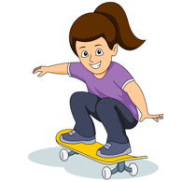
---------------- | -------------------- | -------------------- | -------------------- | -------------------- | --------------------
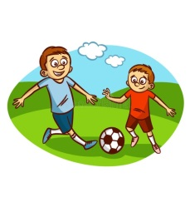 | 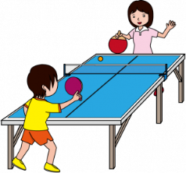 | 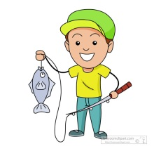 | 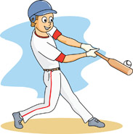 | 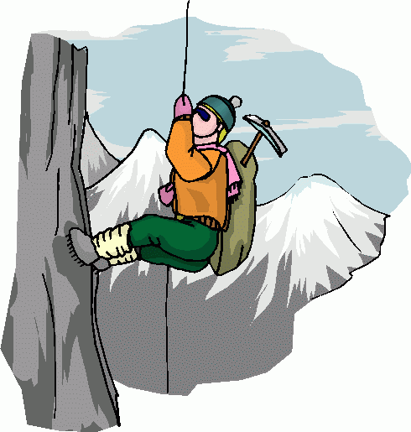 | 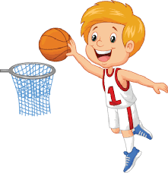
---------------- | -------------------- | ------------------ | -------------------- | ---------------- | ----------------

- Aşağıdaki hayvan türlerini resimleri ile eşleştiriniz. (12x2=24 puan)

Frog Donkey Dog Bee Lion Duck Horse Monkey Cow Elephant Goat Butterfly

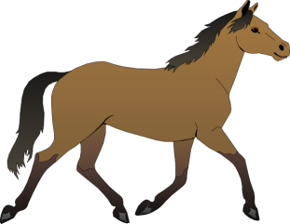 | 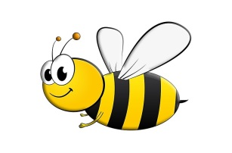 | 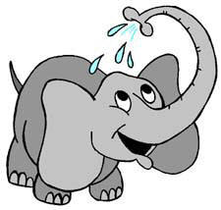 | 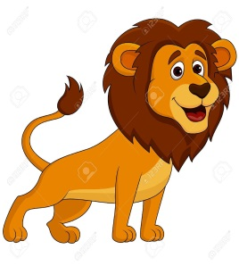 | 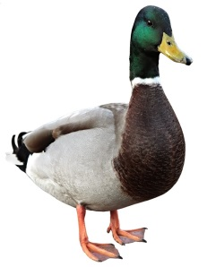 | 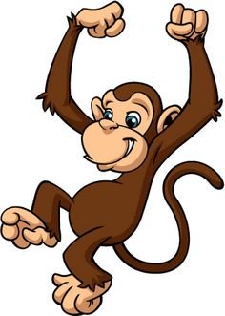
----------------------- | -------------------- | ------------------ | -------------------- | ---------------- | ----------------
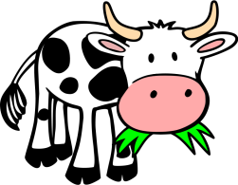 | 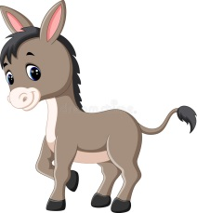 | 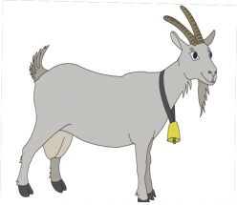 | 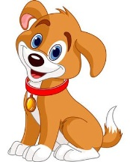 | 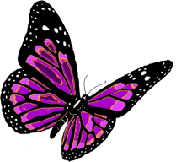 | 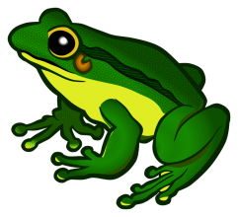
----------------------- | -------------------- | ------------------ | -------------------- | ---------------- | ----------------
- Farklı türden olanı yuvarlak için alınız. (7x2=12 puan)
1 | Camel | Cow | Frog | Fishing
2 | Jogging | Cycling | Barking | Trekking
3 | Sheep | Wing | Ant | Bee
4 | Chicken | Doing workout | Running | Walking
5 | Doing barbecue | Eating seed | Collecting eggs | Mosquito
6 | Crocodile | Camping | Flying a kite | Skateboarding

- Doğru cevabı işaretleyiniz. (10x4=40 puan)

- Resme göre hangisi doğrudur?
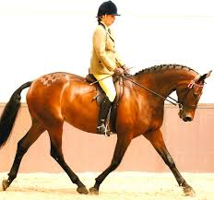
- riding a bike
- horse riding
- skating
- doing workout

- “Let’s go hiking” teklifini kabul etmiyorsanız, cevabınız ne olur?

- That sounds great.
- That’s a good idea.
- I’m sorry, I can’t.
- Sure
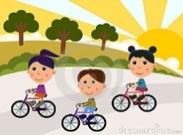
- They like …………
- cycling
- jogging
- hiking
- skating

- We need nine _______ for the birthday cake.


- Cookies
- Candles
- Gifts
- Balloons

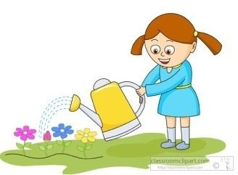
- Şenay is ___________.

- picking up the flowers
- cleaning the garden
- washing the flowers
- watering the flowers

6. ve 7. soruları resimlere göre cevaplayınız.
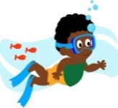
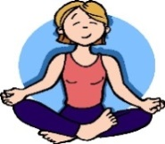

Mary John

- Mary likes__________.

- cycling b) doing workout c) swimming d) hiking

- John likes__________.

- cycling b) doing workout c) swimming d) hiking

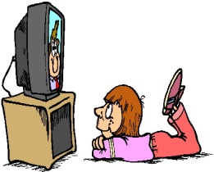
- What is he doing?

- He is watching TV.
- He is listening to music.
- He is doing puzzles.
- He is reading a book.

- I don’t like horror films because they are …………..

- frightening
- comic
- exciting
- enjoyable

- My tooth hurts a lot. I should see a ______ .
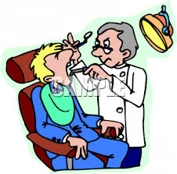
- dentist

- nurse
- patient
- teacher
Yağız TAPU
Keep up the good work!

