NAME SURNAME : NO: GRADE5/B

- WRITE THE CORRECT PHRASE UNDER THE PICTURES (10P)
Jogging | Skiing | Swimming | Skateboarding | Sailing

 | 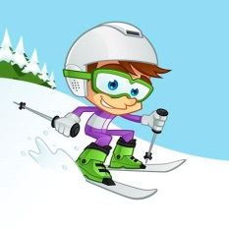 |  | 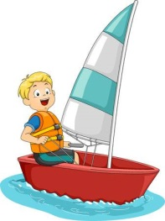 | 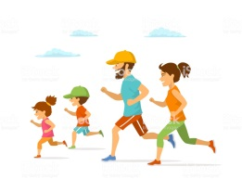
……………………… | ……………………… | ……………………… | ……………………… | ………………………

- WRITE THE COORECT NAME OF THE SPORT IN THE BLANKS (20P)
Soccer | Cycling | Volleyball | Swimming | Table Tennis

1. Hello! My name is Jack. I like doing sports in the nature. I go ………………………………. in the park. I need a bike and protective equipment for doing this sport. I can do it alone or with my friends.

2. Hi. My name is Lary. I like water sports. I go …………………………… at the weekends. I must go to the sea or pool to do this sport. I need to wear shorts or swimsuit for this sport.

3. Hello! I’m Sheila. I like many fitness and sports activities, my favourite is ………………………………….. . We need a ball and two teams with six players in each. We must hit the ball with our hands.

4.Hi. I’m Dave. My favourite sport is ……………………………. . We need a ball and two teams with eleven players in each. We must kick the ball with our feet.

5. Hi, I’m Ali. I love ………………………………….. . We play this game with two people. For this game, we need two rackets and a small ball. We must hit the ball with the rackets.

- COMPLETE THE DIALOGUE WITH THE GIVEN PHRASES (20P)
Shall we go wall climbing next Saturday? | Sorry! Can you repeat that please? | I’m sorry I can’t. | OK. I loveit.

1. MERT: Shall we go skiing next Sunday?
ARCHY: ……………………………………………………… . I like doing sport in the mountain.

2. BERRY: What about playing basketball together?
YAPRAK: ………………………………………………………. . I must do my English project.

3. ZEYNEP: Let’s play table tennis in the evening. (daaaaattttt)
MARY: …………………………………………………………
ZEYNEP: Sure. What about playing table tennis in the evening?
MARY: I’m afraid. I can’t. I need to do my English project this afternoon.

4. MARTIN: ………………………………………………….......
JOSEPH: I’m afraid. I can’t.

- ANSWER THE QUESTIONS ACCORDING TO THE PICTURES (15P)
Swim | Drink milk | Feed a dog | Play with a dog

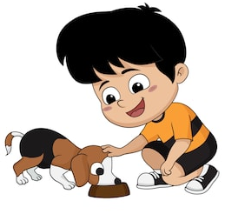  0. What is Steve doing?  He’s feeding a dog. | 1. What is the cat doing?    ………………………………………………
2.What is the girl doing?    …………………………….................. | 3. What are the ducks doing?  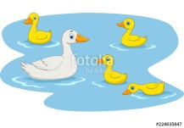  …………………………........................

- WRITE THE SENTENCES INTO THE CORRECT ORDER (15P)
0. NİSA : Can I adopt the rabbit, please?
MUM : (can / you / course / of) : Of course you can.
1. STUDENT: (window / open / can / I / the): ………………………………………………………………….. ?
TEACHER: I’m afraid. You can’t.
2. KADİR : Can we take the puppies home?
DAD : (you / can’t / sorry / I’m) ………………………………………………………… .
3. GIRL : (adopt / Can / shelter / we / an / the / animal / from)…………………………………………………………?
MUM: Sure. You can.

- WRITE THE CORRECT NAME OF THE ANIMAL UNDER THE PICTURES (10P)
Horse | Rabbit | Butterfly | Frog | Dolphin

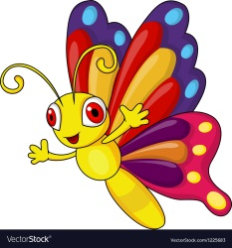 |  |  | 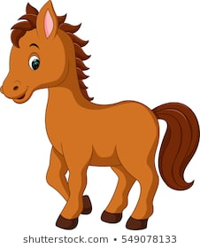 | 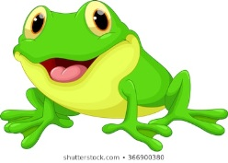
…………………………… | ……………………… | …………………………… | ………………… | ……………………………

- WRITE THE TURKSIH MEANINGS OF THE GIVEN PHRASES BELOW (10P)

Play with the kittens : …………………………………
Climb a tree : …………………………………
Give water to the dog : …………………………………
Baki ÖZEN
İngilizce Öğretmeni
Feed the ducks : …………………………………
Cleaning the shelter : …………………………………

