………… EDUCATIONAL YEAR ÇARIKLAR SECONDARY SCHOOL
ENGLISH LESSON 2nd TERM 2ND EXAM for 5th (A) GRADES

Name-Surname: ……………………………………. Class:……….. Number:………..

- Look at the pictures and fill in the blanks with the words in the box.

MILKING – CLIMBING – EXAMINING – FEEDING - WATERING
CLEANING – SWIMMING – WORKING – COLLECTING - SLEEPING

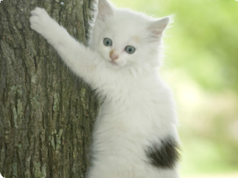


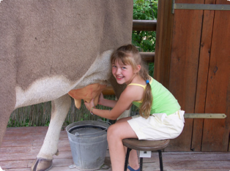
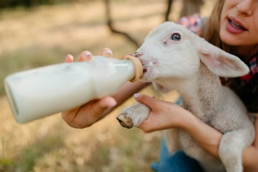

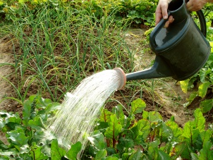
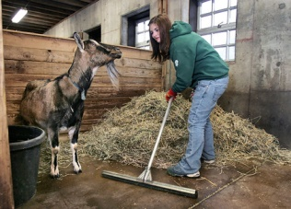
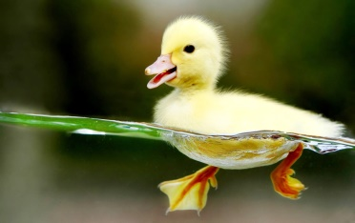
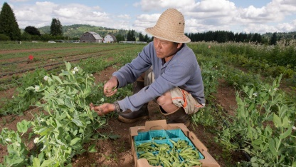
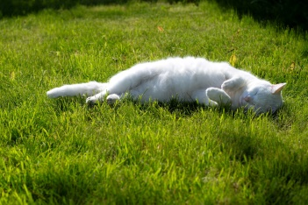
…………………………………. …………………………………. …………………………………. …………………………………. ……………………………………..

…………………………………. …………………………………. …………………………………. …………………………………. ……………………………………..
- Fill in the blanks with the words below.
SLEEPING
COURSE
IDEA
FEEDING
DONATE

- M.Ali : Mummy, Can I adopt a cat?
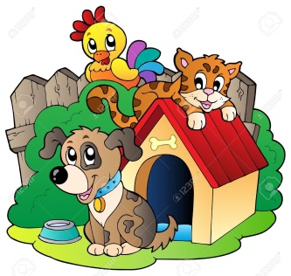
Mukaddes : Of ……………….. , you can.

- M. Berk : Can we …………………………… some Money fort he shelter ?
Ravza Nur : Yes, that’s a good ……………

- Selman “Sshh! Be quiet. The kittens are ……………”
- Sıddıka : What are you doing Sude?
Sude Irmak : I am ……………. my dog now. It is very hungry.

- Circle the odd option below.
- A) SHEEP B) COW C) VEGETABLE D) HORSE

- A) CLIMB B) JUMP C) RUN D) SNAKE
- A) TURTLE B) PARROT C) DUCK D) EXAMINE
- A) VET B) EXAMINE C) NOW D) CLINIC
- A) MILK THE COW B) CLIMB TREE C) COLLECT EGG D) WATER VEGETABLE
- Order the words to make meaningful sentences.
- don’t / I / playing / like / tennis /. 3. your / sport / What’s / favorite / ?
................................................................................. .................................................................................
- bother / play / soccer / Can / your / ? 4. like / to go / Would / you / cycling / ?
................................................................................. .................................................................................


- ride / Shall / horse / we / a / ?
.................................................................................

- Match the suggestions with the responses.

1. Let’s go to cycling together. A. It’s a good idea. I love nature.

- Shall we play basketboll today? B. That sounds great. I like ball games.
- How about jogging in the park? C. I am afraid I can’t. I don’t like music or dance.
- Shall we go dancing after school? D. I’m sorry I can’t. I don’t like riding bicyle.
- Why don’t we go camping this weekEND? E. Hmm sorry but I am very tired to jog.




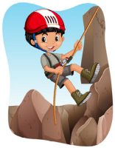



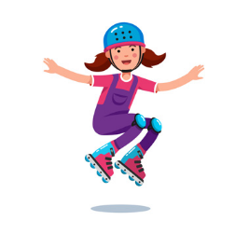

- Match the words with the pictures.
1. ROLLER-SKATING 2. SKATEBOARDING 3. GOLF 4. FISHING 5. CLIMBING 6. MOUNTAIN 7. JOGGING 8. BOWLING BASEBOLL

- Fill in the blanks with the given words given.
party
cake
guests
cards
shopping
CDs
house
list

- Throw / give a ……………………. 5. Go …………………….
- Decorate the ……………………. 6. Make a …………………….
- Make a guest ……………………. 7. Buy some music …………………….
- Write invitation ……………………. 8. Invite …………………….

- Fill in the blanks with “MUST” or “MUSN’T”.

- It’s Ümmünur’s birthday next Saturday. I ………………….. buy her a present/gift.

- I ………………….. clean the house after party.
- You ………………….. eat fast food. Because it is NOT healthy.
- You ………………….. go out. You must do your homework.
- I ………………….. call (aramak) my friends. The party is on Sunday.

1. How old is Medine ?
…………………………………………………………………....
Medine Ravza is turning 13. years old. Please come and join her birthday party.

MUSIC & FOODs & CLOWN AND FUNNY GAMEs

Place : Our garden.
Date : 2nd of May, Thursday.
Time : 14.00
2. When is the party?
…………………………………………………………………....
3. Where is the party?
…………………………………………………………………....
4. What time is the party?
…………………………………………………………………....
5. What type of party isi this?
…………………………………………………………………....

