
………… EDUCATIONAL YEAR ……………. SECONDARY SCHOOL
ENGLISH LESSON 2nd TERM 2nd EXAM for 5th GRADES

Name/Surname: ……………………………………. Number:……….. Class: 5/F

A) WRITE THE NAMES OF THE ACTIVITIES UNDER THE PICTURES (10x3=30)
MILKING – CLIMBING – EXAMINING – FEEDING - WATERING
CLEANING – SWIMMING – WORKING – COLLECTING - SLEEPING

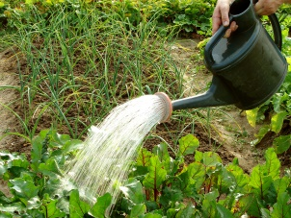
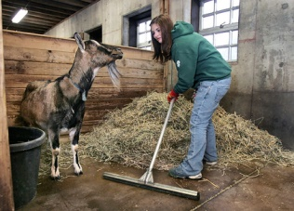
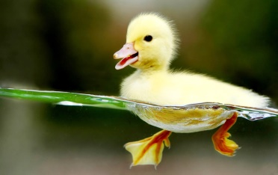



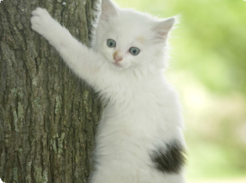


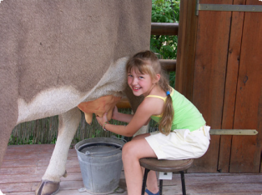
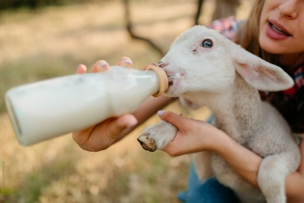
…………………………………. …………………………………. …………………………………. …………………………………. ……………………………………..

…………………………………. …………………………………. …………………………………. …………………………………. ……………………………………..

B) COMPLETE THE DIALOQUES WITH THE WORDS BELOW. ( 5x3=15 pts)
Donate
Idea
Course
Feeding
Sleeping

1.Ekrem:: Mummy, Can I adopt a cat?

Mom : Of ……………….. , you can.

2.Berk: Dad,can we …………………………… some money for the shelter ?
Dad : Yes, that’s a good ……………

3.Seçil : “Sshh! Be quiet. The kittens are ……………”
4.Nazlı: What are you doing Sude?
Sude : I am ……………. my dog now. It is very hungry.

C) MATCHING (5x4=20 pts)


1. Let’s go to cycling together. A. It’s a good idea. I love nature.
- Shall we play basketboll today? B. That sounds great. I like ball games.
- How about jogging in the park? C. I am afraid I can’t. I don’t like music or dance.
- Shall we go dancing after school? D. I’m sorry I can’t. I don’t like riding bicyle.
- Why don’t we go camping this weekend? E. Hmm, sorry but I am very tired to jog.

D) WRITE THE CORRECT WORDS UNDER THE PICTURES (8x3=24 pts
1. ROLLER-SKATING 2.SKATEBOARDING 3.GOLF 4. FISHING




5.JOGGING 6. BOWLING 7.CLIMBING MOUNTAIN 8.BASEBALL


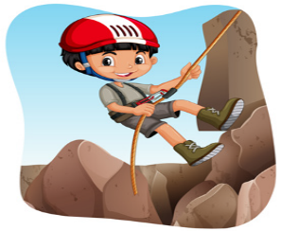




E) FILL IN THE BLANKS WITH “must/mustn’t ” (5x3=15 pts)

- It’s my friend’s birthday next Saturday. I ………………….. buy her a present/gift.

- I ………………….. clean the house after party.
- You ………………….. eat fast food. Because it is not healthy.
- You ………………….. go out. First,finish your homework
GOOD LUCK!
- I ………………….. call my friends. The party is on Sunday.


