ÇAMKÖY SECONDARY SCHOOL ………. ENGLISH LESSON 2nd TERM 2nd WRITTEN EXAM FOR 5th GRADERS
NAME &SURNAME:_______________________________ NUMBER:_______ CLASS:5/___
A. CIRCLE THE CORRECT ANSWER.

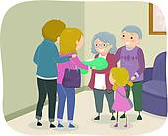
1) We _________ in Ramadan feast.
- clean our houses
- read poems
- play folk dances
- visit our relatives

2) Hello! I am Selenay from Turkey. We celebrate __________ on 23rd April. Children from different countries come and stay at our homes.
- new year
- children’s day
- Ramadan feast
- Republic day
3) Teacher: What is your school number Esra?
Esra: “two hundred and thirteen”
Konuşmaya gore Esra’nın okul numarası kaçtır?

a) 213 b) 233 c) 200 d) 230

4) There are 5000 books in our library.
a) five
b) fifty
c) five hundred
d) five thousand

5) “I live on a farm. I am milking cow.” diyen kişi kimdir?

a) 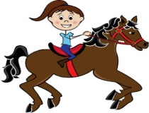 b) 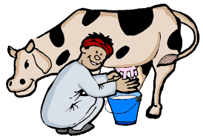

c) 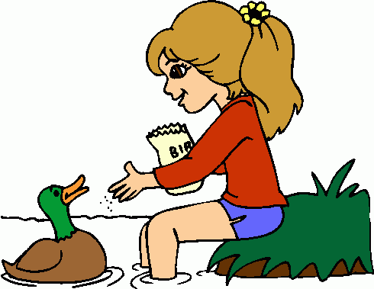 d)

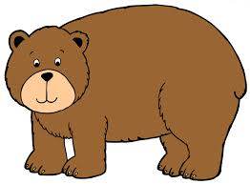
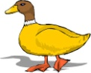
6)

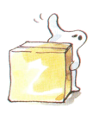
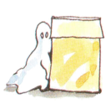
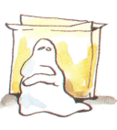
a) bear - elephant - cow - duck
b) duck - cow - bear - elephant
c) cow - duck - elephant - bear
d) elephant - bear - duck - cow

7) The vet is ________ the dog.

a) climbing c) examing
b) riding d) swimming
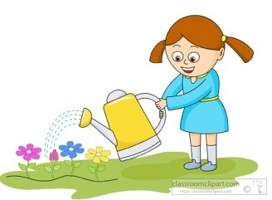
8) Şenay is ___________.

- picking up the flowers
- cleaning the garden
- washing the flowers
- watering the flowers

9) Let’s go ___________. 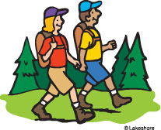
a)hiking c)swimming
b)camping d)fishing
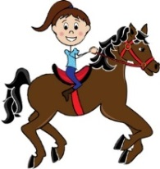
10)
………

Hangisini söylemiş olamaz?
a) My favorite activity is riding a horse
b) I enjoy riding a horse
c) I hate riding a horse
d) I am interested in riding a horse

11) A:Would you like to go fishing?
B:_____________.I like fishing.

a)Sure,Let’s go c) That is a bad idea
b)That sounds boring d) I am sorry. I can’t.

12) June , ………… and August are Summer months.

a) January b) May
c) July d) December

13) Tomorrow is my birthday an I throw a birhtday Party. My mother make a____________ for the party.
a)gift c)birthday cake
b)balloons d)clown

14) Dabbe is a / an __________ film.
a) adventure
b) romance
d) cartoon
d) horror

15) I don’t like Recep İvedik.
I think he is ______and ______.
a) lovely / clever
b) beautiful / honest
c) brave / friendly
d) ugly / rude

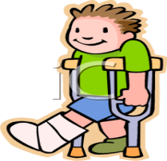
16) A:What is the matter with him?
B:He has a _____________.
a)broken leg c)sore throat
b)fever d)pain in his back

17) Kadir has got a runny nose. He needs some...................
a) tissues b) painkillers
c) fruits d) flowers
18) Mert and his friend like ........................

a) hide and seek b) playing tag
c) playing marbles d) skipping a rope

19) -) I ..................... up at …………….
a) go to school / half past eight
b) get up / seven o’clock
c) get back home / quarter to seven
d) get up / quarter to seven

20) Hello! My name is Mark. I am from the USA. I am American. I’m 16 years old. I can speak English and German. I like Maths and Science.
Where is Mark from?
a) He is sixteen years old.
b) He is from America.
c) He likes Maths and Science.
d) He speaks English and German.

