GÖNÜLLÜ HİZMET VAKFI AYSEL / ABDULLAH ÖĞÜCÜ SECONDARY SCHOOL

………… EDUCATION&INSTRUCTION YEAR 5th GRADES
NAME:
SURNAME:
CLASS:
NUMBER:

The questions of the 2nd Elective English examination for the 2nd semester.

1. Children like watching __________ .

A) romantic movies
B) cartoon movies
C) war movies
D) horror movies

2. - _________ you like action movies?

- No, I _______ .

A) Do / do
B) Does / doesn't
C) Do / don't
D) Does / does

3. Dabbe is a / an __________ film.

A) adventure
B) romance
C) cartoon
D) horror

4. - What __________ of film is it?
- It is a horror film.

A) colour B) old C) class D) type

5. Sam : Let’s do yoga.
Bob : …………….. I must do my homework.
A) It is a good idea B) OK.
C) That sounds great D) No, I can’t

6. Kader : …………………… ?
Bilgi : It’s on 9th December.

A) What type of party is it?
B) When is your birthday?
C) Where is the party?
D) What time is it?

7. Snow White is ………….. and…………..

- ugly / honest
- beautiful/ friendly
- evil/ brave
- handsome/ interesting
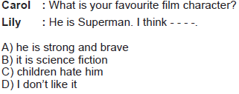
8.

9. Görsele uygun cümleyi seçiniz.
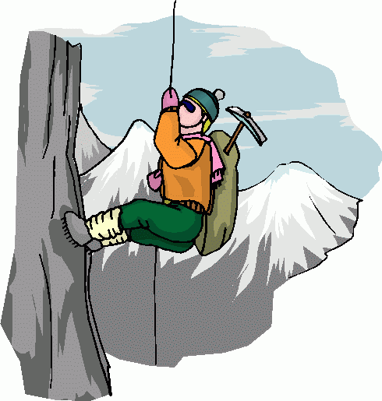
A) He hates doing exercises.
B) He loves playing golf.
C) He doesn’t like diving.
D) He likes climbing mountains.

10. Mustafa likes cycling.
Cümle ile uyumlu seçeneği işaretleyin.
A) 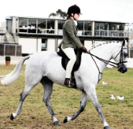 B) 
C) 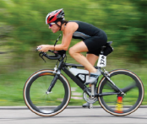 D) 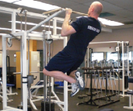
11. A: What is your favourite exercise?
B: ………………………………… .
Boşluğa uygun düşen ifadeyi seçin.
A) I can do jogging.
B) She likes swimming.
C) I like rafting but I don’t like running.
D) My favourite exercise is yoga.

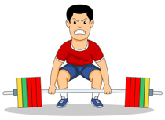
12. He likes ……………………..
A) skateboarding
B) push ups
C) weight-lifting
D) windsurfing

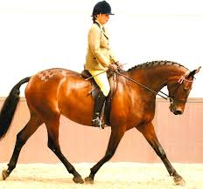
13. Resme göre hangisi doğrudur?
A) riding a bike
B) horse riding
C) skating
D) doing yoga

14. Aşağıdaki görsel hangi bayram ile ilgilidir?
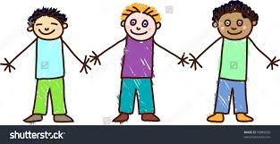
a) Easter b) Halloween
c) Diwali d) Children’s Day

15. Görseli anlatan cümleyi işaretleyiniz.
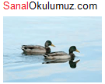
A) The ducks are swimming in the lake.
B) The fish are swimming in the sea.
C) The dogs are eating fish.
D) The cats are flying.
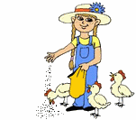
16. She is ................. the chickens.
A) adopting
B) playing
C) climbing
D) feeding
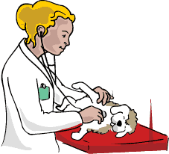
17. The .............. is examining the animals.
A) teacher
B) doctor
C) vet
D) police
18. ve 19. soruları aşağıda verilen parçaya göre cevaplayınız.
This is Mark’s home. Mark and his big family are at home now. He is studying lesson. His father is doing shopping. His mother is preparing dinner in the kitchen and his sister is tidying up her room. Grandmom is feeding the birds and grandpa is carrying the fruit basket. Everybody at home is doing something now.

18. Mark’s mother is - - - - .
A) studying lesson
B) doing shopping
C) cooking the meals
D) carrying the fruit basket

19. - - - - is giving food to the birds now.
A) Mark’s grandmother
B) Mark’s mother
C) Mark’s father
D) Mark

20. A fish ............ swim, but it .......... fly.
A) can / can’t B) can / can
C) can’t / can’t D) can’t / can
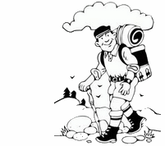
21. Let's go..............
A) hiking
B) swimming
C) cycling
D) jogging

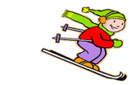
22. Jennifer goes ................. in winter.
A) flying
B) horse riding
C) sailing
D) skiing

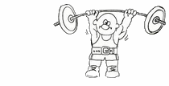
23. Terry can ................ weight.
A) lift
B) run
C) walk
D) climb

24. Hangisi DOĞRU eşleştirilmiştir?
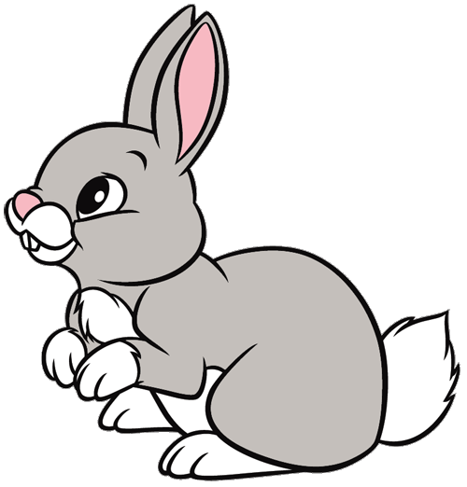
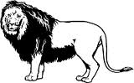
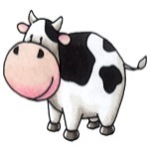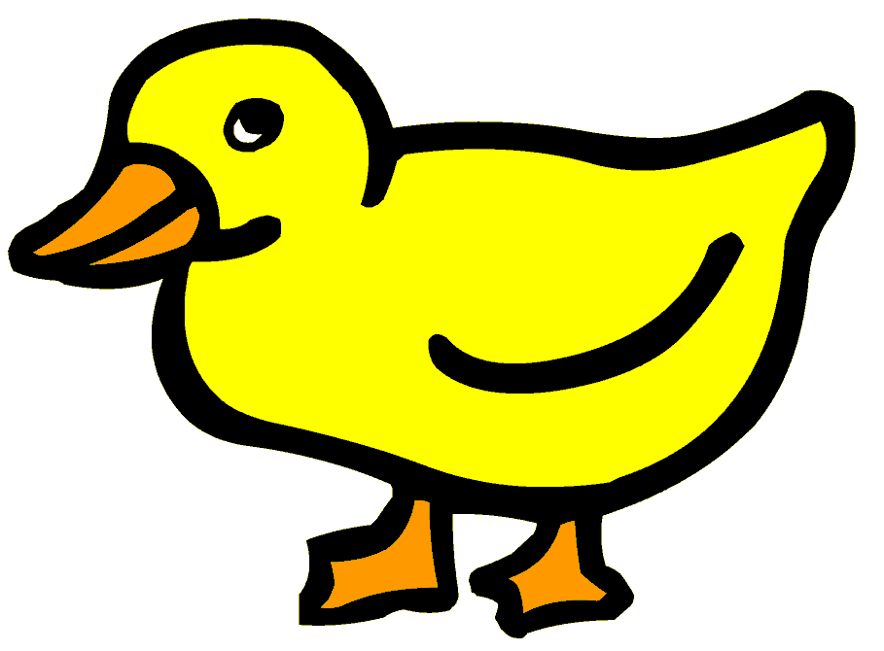
a) cat b) dog c) lion d) zebra

25. Aşağıdaki göreselde yapılan iş nedir?
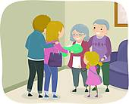
a) have a big family dinner
b) carve pumpkins
c) paint eggs
d) visit relatives

You have 40 minutes
NEJLA YIĞİT
English Language Teacher

