…….. EDUCATION YEAR ……………………………………………… PRIMARY SCHOOL
2ND TERM 2ND ENGLISH EXAM FOR 4TH GRADES
NAME-SURNAME: YAZILI REHBERİM CLASS:
A) Görselleri verilen kıyafetlerin isimlerini uygun şekilde altlarına yazınız. (7*2=14 points)

jeans / shoes / skirt / sunglasses / umbrella/ coat / socks

 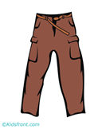 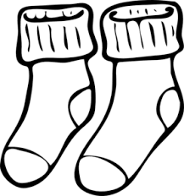 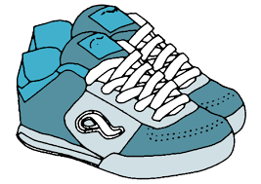 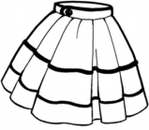  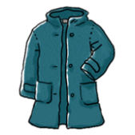……………………. …………………… ……..………… …………….………. …..…….………… ..……………….. ..………………..

B) Aşağıda verilen cümleleri, görsellere uygun hava durumları ile tamamlayınız. (6*2=12 points)

Sunny / windy / hot /rainy / snowy / cold

- What is the weather like?
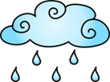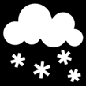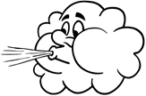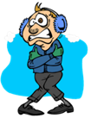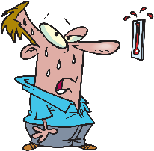

1.It’s……………... 2.It’s………………..…. 3.It’s…….………….. 4.It’s…………………… 5.It’s…………………….. 6.It’s……………….…
C) Write correct words. (Uygun kelimelerle doldurunuz.) (7*2=14 points)
Policeman – Farm – Teacher – Police station – Farmer – School – Pilot – Chef – Fire station – Doctor Restaurant – Hospital – Fireman – Airport



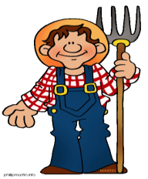

2
1
3
4

I am a …………………………… I am a ………………………….. I am a ……………………… I am a ………………………


I work at …………………… I work on a ………………………. I work at …………………. I work at …………………….
5

7
6
5

I am a ………………………………… I am a ………………………………… I am a ………………………………….
5
I work at …………………………… I work in a ………………………….. I work at ………………………………
D) Aşağıdaki cümlelerde anlatılmak istenen meslekleri numaralandırarak eşleştirin. (6*2=12 points)
1. I like helping animals. ( ) DOCTOR 2. I like planting vegetables. ( ) PILOT 3. I like helping people. ( ) FARMER
4. I like cooking. ( ) TEACHER
5. I like teaching students. ( ) VET
6. I work at Airport. ( ) CHEF

E) Aşağıdaki boşlukları tabloda verilen kelimelerle doldurunuz. (4*2=8 points)
Summer - Spring - Autumn - Winter
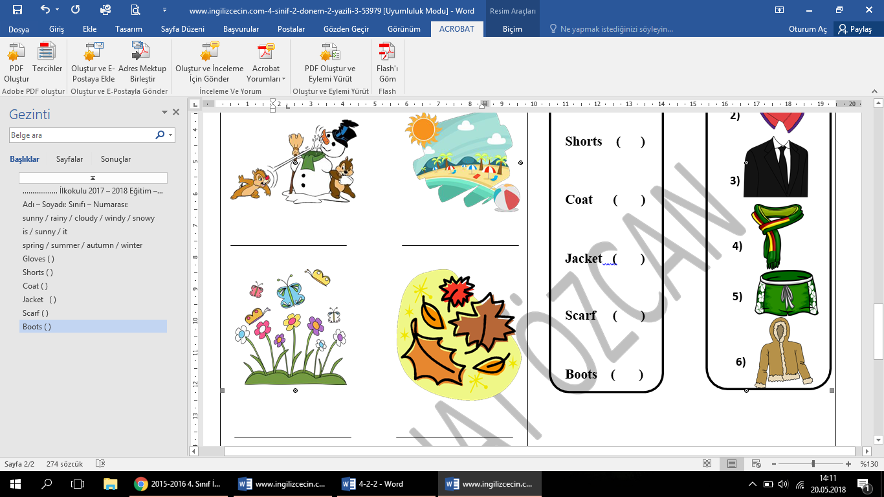
F) Görsellerin altlarına ilgili ifadeleri yazınız. (5*2=10 points)
Cut it — Brush it — Don’t cut it —Water it — Fill with water

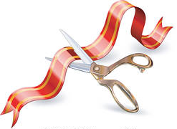

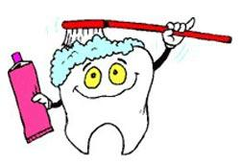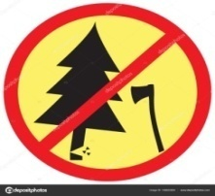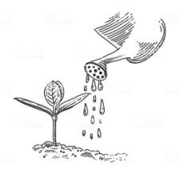

………………… …………………….. .………………….. …………………… …………………...

G) Answer the questions. (10*3=30 points)
1) Pelin: Where does Serhan work?
Oya : …………………………………….
A) I am a businessman.
B) I work in an Office.
C) He Works in an Office.
D) He is a businessman

2) Görseli doğru ifade eden seçenek hangisidir?
A) Plant a tree !
B) Line up three glasses !
C) Cut the paper !
D) Water it !

3) Aşağıda haftanın günlerinden hangisi yanlış eşleştirilmiştir?
A) Sunday- Salı B) Monday-Pazartesi
C)Thursday - Perşembe D) Friday-Cuma

4) It’s rainy today. Take your ................
A) hat B) sunglasses
C) umbrella D) skirt
5) Selena: ........................................
Hades : It is cold and snowy.
A) What do you do?
B) What do you like?
C) What is the time?
D) What is the weather like?

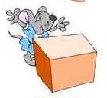6) Where is the mouse?
A) It is in front of the box. B) It’s behind the box.
C) It’s under the box. D) It’s in the box.

7) I wear my ................... in summer.
Boşluğa seçeneklerden hangisi getirelemez?
A) hat B) sunglasses

C) shorts D) scarf
8)
It’s sunny. Wear your …………..
A)boots B) sunglasses
C) coat D) sweater
9)It’s snowy................................
A) wear your sunglasses B) wear your T-shirt
C) Wear your coat D) wear your dress

10) Mustafa: What do you do?
Kemal: ……………………………………..
A) He works at a restaurant.
B) I am a chef.
C) I work at a restaurant.
D) He is a chef.



