Name: ………. ACADEMIC YEAR ……….. PRIMARY SCHOOL 2nd TERM
Surname: 2nd ENGLISH EXAM FOR 4th GRADES

Class: Number:

A)Testi cevaplayınız.(25x4=100p)


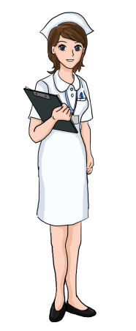
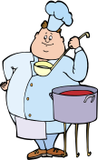
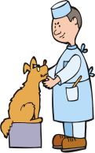
1) Verilen resimlere göre hangi seçenek yanlıştır?

Bill Tim Sue Jason
A) Jason is a plumber. B) Tim is a chef.
C) Sue is a nurse. D) Bill is a dentist.

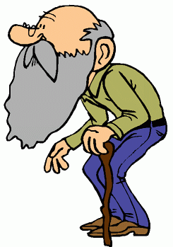
2) Resme göre uygun olmayan ifade hangisidir?
a) He is old.
b) He is young.
c) He has a beard.
d) He has a moustache.

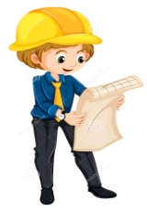
3) Resme gore soruyu cevaplayınız.

Ceren:What is his job?
Yağız: He is an ..................

A)pilot B)engineer C)lawyer D)farmer

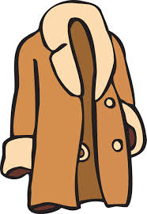
4)Cümleyi tamamlayan seçeneği işaretleyiniz.

“It is hot and sunny. Wear your _____.”
A) dress and sunglasses B) scarf and gloves
C) boots and coat. D) raincoat and boats.

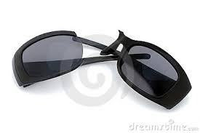
5)Resme gore soruyu cevaplayınız.

Sena: It is sunny. May I borrow your sunglasses?
Melike: ...................................... .
A) I’m sorry. I don’t know.
B) Sorry. It’s broken.
C) Sure. Here you are.
D) Yes, of course.

6)Resme göre soruyu cevaplayınız.
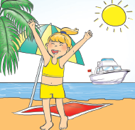
“What is the season?”
A)winter B)autumn
C)warm D)summer

7.8.9. soruları tabloya göre cevaplayınız.
Antalya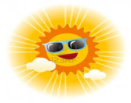 | Rize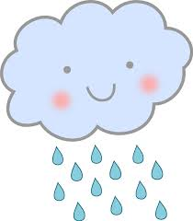
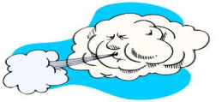  İzmir | Ankara 

7)Rize is ………………… .
A)sunny B)cloudy C)rainy D)windy

8)İzmir is ……………….. .
A)snowy B)cloudy C)sunny D)windy

9)It is …………….. in Ankara.
A)cloudy B)stormy C)rainy D)windy

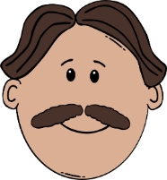
10) Resme gore soruyu cevaplayınız.

Arda: What does your father look like?
Hasan: He has a ............................ .
A) short and slim B) moustache
C) friendly D) beard

11) Zıt anlamlısı verilen eşleştirmelerden hangisi yanlıştır?
A) Fat x slim
B) Tall x short
c) Beautiful x ugly
d) Young x pretty


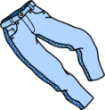
12) Aşağıda resimleri verilen kıyafetlerin isimlerinin bulunduğu seçeneği işaretleyiniz.
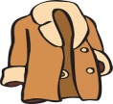


A)jeans-hat-gloves-jacket
B)jeans-gloves-hat-coat
C)shoes-gloves-hat-coat
D)shirt-hat-gloves-coat

13)Resme gore soruyu cevaplayınız.

Ali: Where does a postman work?
Can: He works…………….

A)at a post office B)at school
C)at a hospital D)at a restaurant

14)Meslek iş yeri eşleştirmelerinden hangisi yanlıştır?

A)fireman - fire station B)teacher – school
C)nurse – factory D)chef – reataurant

15)Boşlığa uygun düşen cümleyi işaretleyiniz

It’s rainy. ................................
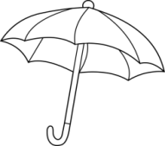
A) Wear your sunglasses.
B) Put on your T-shirt.
C) Wear your skirt.
D) Take your umbrella.

16) Resme gore soruyu cevaplayınız.

Aysun: What does a pilot like?
Tuana:………………………………….
- He like driving a car.
- He likes flying a plane.
- He likes helping patiens.
- He like animals.


17)Resimdeki hava durumuna gore soruyu cevaplayınız.
”What’s the weather like?”
A) It’s sunny. B) It’s snowy.
C) It’s foggy. D) It’s stormy.

18) Konuşma balonunda verilen cümleyi tamamlayan ifade hangisidir?
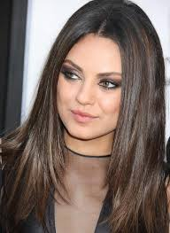
I have………. hair.
a) long b) short c) curly d) fat

19) Aşağıda eksik kalan ay hangisidir?

- March –April – ………. -June

A)May B)October
C)January D)July

.

20) Resme gore soruyu cevaplayınız.
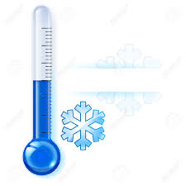
What is the weather like in winter?
A)It’s hot. B) It’s cold.
C)It’s warm. D) It’s sunny.

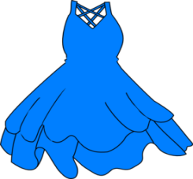
21) Sorunun cevabı nedir?

”What is that?”
A)They are socks. B)It’s a shirt..
C)It’s a dress. D)It is a scarf.

22) Aşağıda verilen aylar hangi mevsime aittir?
September
October
November

A)Spring B)Summer
C)Autumn D)Winter

23) Aşağıdaki cümlenin Türkçe anlamı hangisidir?

“Benim kız kardeşim mavi gözlere ve sarı saçlara sahip.”

A)My sister has blue eyes and blonde hair.
B)My sister is tall and she has big ears.
C)My sister has green eyes and brown hair.
D)My sister has brown hair and short hair.

24) Resme göre diyaloğu tamamlayınız.
Emir:What is the weather like in Spring ?
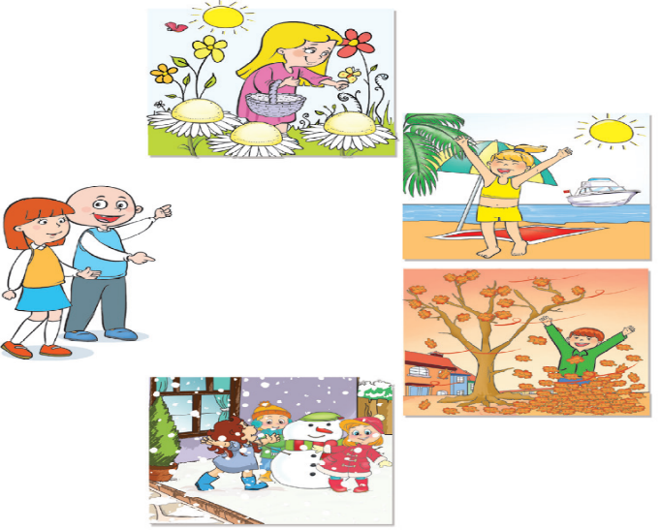
Büşra: It is .......................
A) cool and rainy
B) hot and snowy
C) cold and cloudy
D) warm and sunny
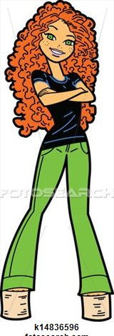
25)Resme göre YANLIŞ olan seçeneği
işaretleyiniz
A)She has long curly hair.
B)She has young and pretty.
C)She is fat and short.
D)She is thin and tall.

English Language Teacher
Burcu Çam

GOOD LUCK

