……….EDUCATIONAL YEAR İSMAİL KAYA ANATOLIAN IMAM HATIP HIGH SCHOOL SECOND TERM SECOND EXAM FOR THE 10TH GRADES

- A- Used to ,Didn’t use to or Did … use to ? KULLANARAK CÜMLELERİ OLUŞTURUNUZ (4x3=12 pts)
- 1. we / wear / school uniforms / (+) …………………………………………………………………………………………………….
- 2. I / not like /history / much / (-) ………………………………………………………………………………………………………..
- 3. they/eat/garlic and onions for good health.(+)…………………………………………………………………………………
- 4. you / have lunch / at school / (?) …………………………………………………………………………………………………….

- B- BOŞLUKLARA WHEN / WHILE GETİRİNİZ ( 5*2=10 pts)
- 1.My father hurt his leg …………… he was carrying the luggage.
- 2. The police arrived there …………………. he was sitting on the sofa.
- 3. We were watching a match on TV ………….. the fire broke out
- 4. ……………. the rain started, I was flying over the Amazon
- 5. .…………… we were visiting an open air museum, we saw the ruins of an ancient castle.
ANCIENT CHINA
ANCIENT GREECE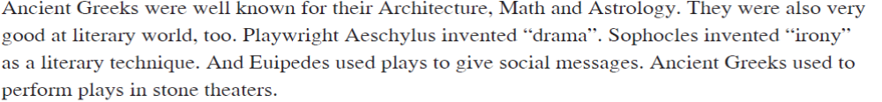
C-AŞAĞIDAKİ SORULARI YUKARIDAKİ PARÇAYA GÖRE CEVAPLAYINIZ ( 4*3=12 pts)
1- Where did Ancient Greeks use to perform plays?................................................................................
2-How did they use to learn the time? ………………………………………………………………………………………………..
3- What were the great inventions of Ancient China?..........................................................................
4- Who invented drama ? …………………………………………………………………………………………………………………….
D- TRUE /FALSE ( 4*2=8 pts)
( …….) 1- Writers used to give social messages with theatre plays in Ancient Greece.
(………) 2-Ancient Greeks were interested in Asrology, Maths and Architecture.
( ………) 3- Ancient Chinese learned the time from digital clocks.
( ………) 4- Ancient Greek inventors invented gunpowder and compass.

E-FİLLERİ BOŞLUKLARA YAZINIZ.( 9*2=18 pts )
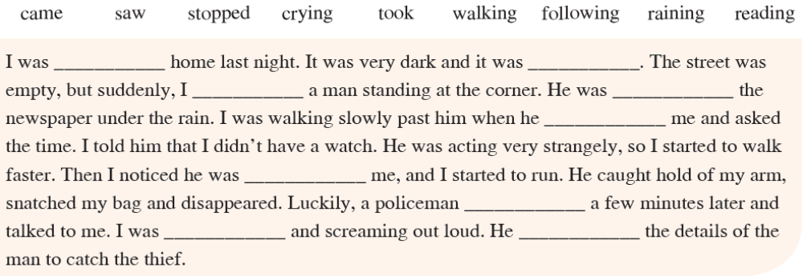
F-SORULARI CEVAPLAYINIZ : (4*3=12 pts )
1- Have you ever eaten shark? ………………………………………………………………………………………………………
2- Have you ever been to a foreign country? ……………………………………………………………………………….
3- Has your mother ever cooked fish soup? ……………………………………………………………………………
4- Have you ever ridden a horse? ………………………………………………………………………………………..
G-SORULARLA CEVAPLARI EŞLEŞTİRİNİZ.(8*2= 16 pts )
1 | 2 | 3 | 4 | 5 | 6 | 7 | 8 | 9
e

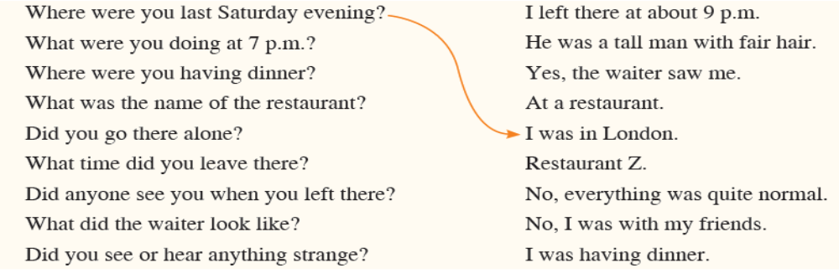
H-CÜMLELERİ SIRAYA KOYUNUZ ( 6*2=12 pts)
