B
………………. EDUCATION YEAR ŞIRNAK-CİZRE MİTHAT PAŞA VOCATIONAL AND TECHNICAL ANATOLIAN HIGH SCHOOL ENGLISH LESSON 2nd TERM 1ST WRITTEN EXAM PAPER FOR 9TH GRADE
NAME-SURNAME: CLASS: NO: SCORE:
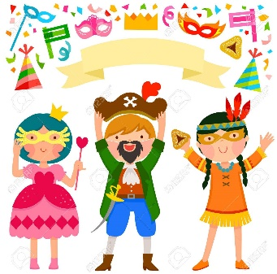
2. fancy dress party _______
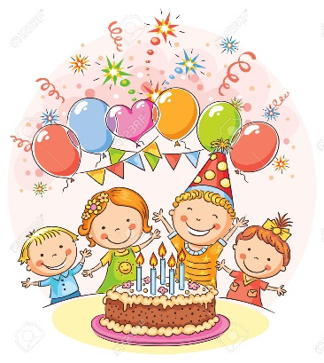
I. Görselleri verilen partileri eşleştiriniz. (2x5 pts)
1. birthday party _______

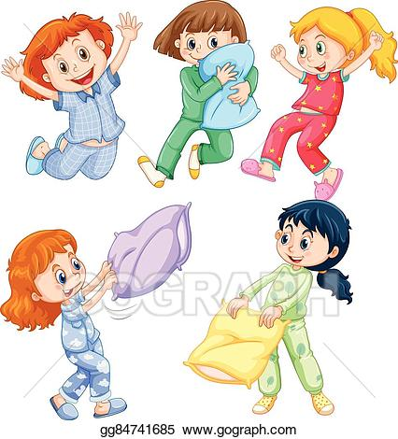
4. slumber party _______
a. slumber party
b. graduation party
c. birthday party
d. fancy dress party
e. farewell party

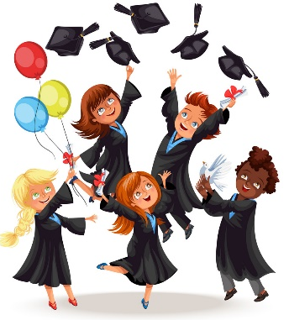

5. farewell party
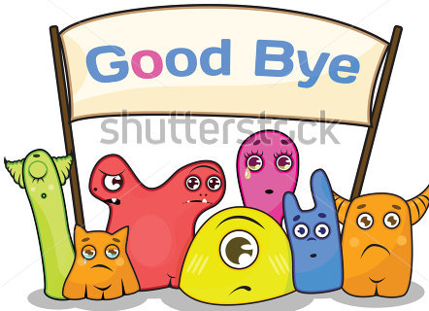
3. graduation party

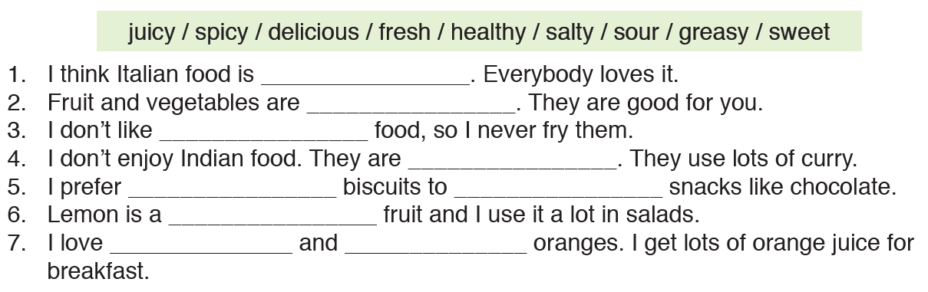
II. Boşlukları verilen kelimelerle doldurunuz. (4x7 pts)
delicious
healty
greasy
spicy
sweet
salty
sour
jujcy
fresh

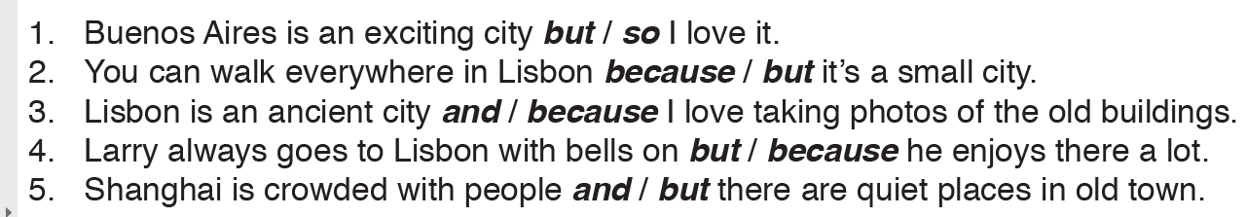
III. Doğru seçeneği yuvarlak içine alınız. (3x5 pts)

- So 2) because 3) because 4) because 5) but
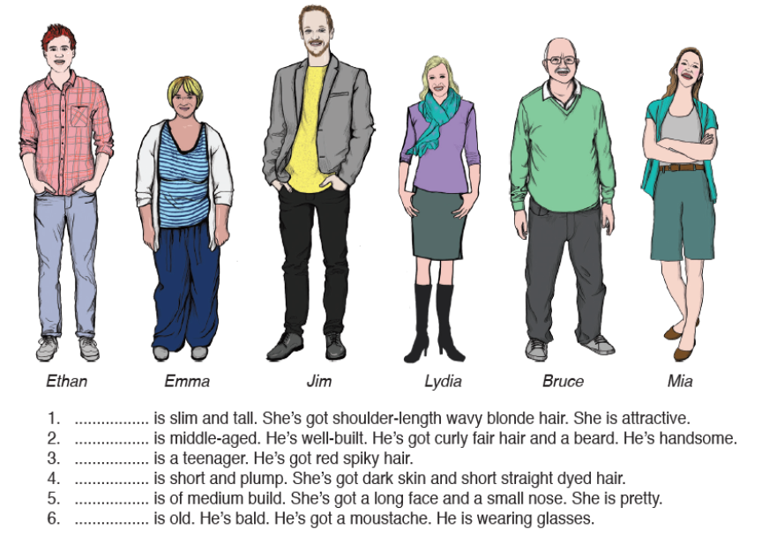
IV. Verilen tarife göre kişileri uygun boşluklara yerleştiriniz. (3x6 pts)

1Ethan . . . . . . . . . . . . . is slim and tall. She’s got shoulder-length wavy hair. She is attractive.
2.Jim. . . . . . . . . . . . . . is middle-aged. He’s well-built. He’s got curly hair and a beard. He’s handsome.
3.Mia . . . . . . . . . . . . . is a teenager. He’s got red spiky hair.
4.Emma . . . . . . . . . . . . . is short and plump. She’s got dark skin and short straight dyed hair.
5.Lydia . . . . . . . . . . . . . is of medium build. She’s got a long face and a small nose. She is pretty.
6.Bruce . . . . . . . . . . . . . is old. He’s bald. He’s got a moustache. He is wearing glasses.

V. Verilen hastalıkları resimlerin altına yazınız. (2x5 pts)
fever - headache - sorethroat - sprain ankle – stomachache

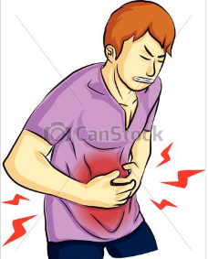
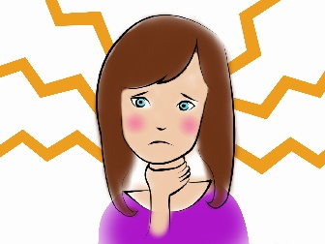
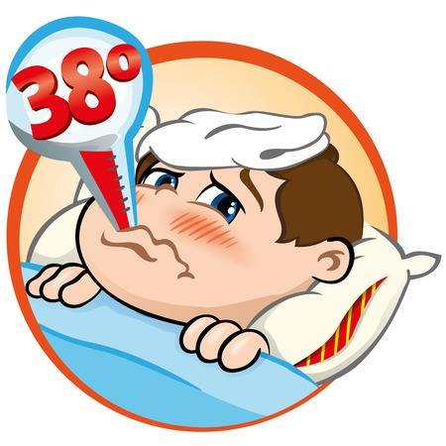
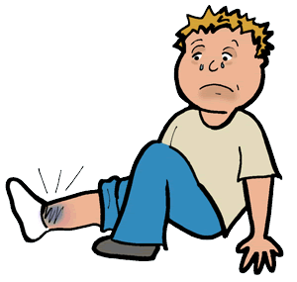
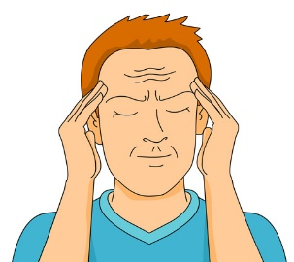

1. ___________________ 2. __________________ 3. __________________ 4. __________________ 5. _________________

VII. Kelimelerin Türkçe anlamlarını yazınız. (1x9 pts)
1. baker: fırıncı
2. toy shop: oyuncakçı
3. butcher: kasap
4. bookshop: kitapçı
5. greengrocer: manav
6. clothes shop: kıyafet mağazası
7. newsagent: gazete bayii
8. cinema: sinema
9. school: okul

VI. Kutuda verilen ekleri doğru boşluklara yerleştirinz. (2x5 pts)

1. Stay _ with_ touch with
with
to
up
for
in

2. Search __ for_ information
3. Fill _ for_ spare time
4. Contact _ to_ a celebrity
5. Stay up-__ up___-date

