Name: Surname: Number: Class: Point:
……………….. Educational Year ………………….. Vocational and Technical Anatolian High School
Second Term First English Written Exam for 9th Classes
A. Complete the sentences using the suitable word below. One word is extra. (Aşağıda verilen kelimeleri, uygun şekilde boşluklara yerleştiriniz. Bir kelime fazladan verilmiştir.) 3x6=18p.
baggage / check-in desk / aisle seat / passport / pilot / departs / seat belt
1. .... Pilot…. is the person who flies the plane.
2. You can not travel abroad if you don’t have a ...... passport............. It is an official document to travel abroad.
3. Baggage………………… is all the suitcases and bags you take when you travel.
4. The officer gave me my boarding pass in .. check-in desk........................
5. I want to sit on ...... seat belt.................. because I don’t want to look out from the window.
6. The plane ..... departs..................... from İstanbul at 08:00 p.m.
B. Match Ancient World Seven Wonders name with the pictures correctly. (Eski Yedi Harika isimleri ile, fotoğrafları uygun şekilde eşleştiriniz, fotoğrafların altına yazınız.) 3x4=12p.
a- Hanging Gardens of Babylon b- Great Pyramid of Giza c- the Statue of Zeus d- the Lighthouse of Alexandria
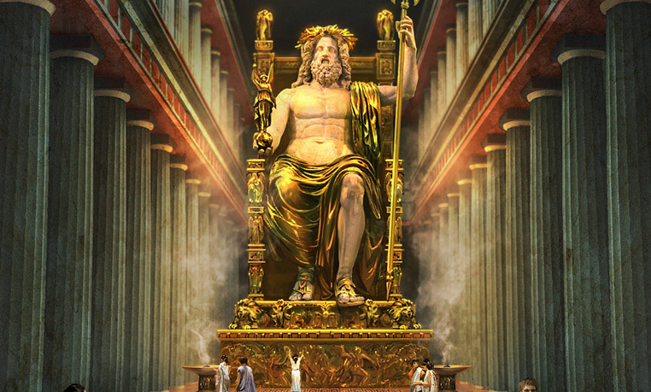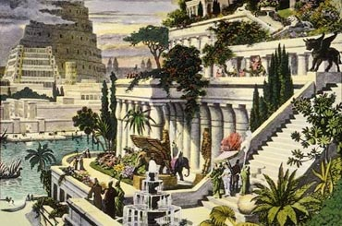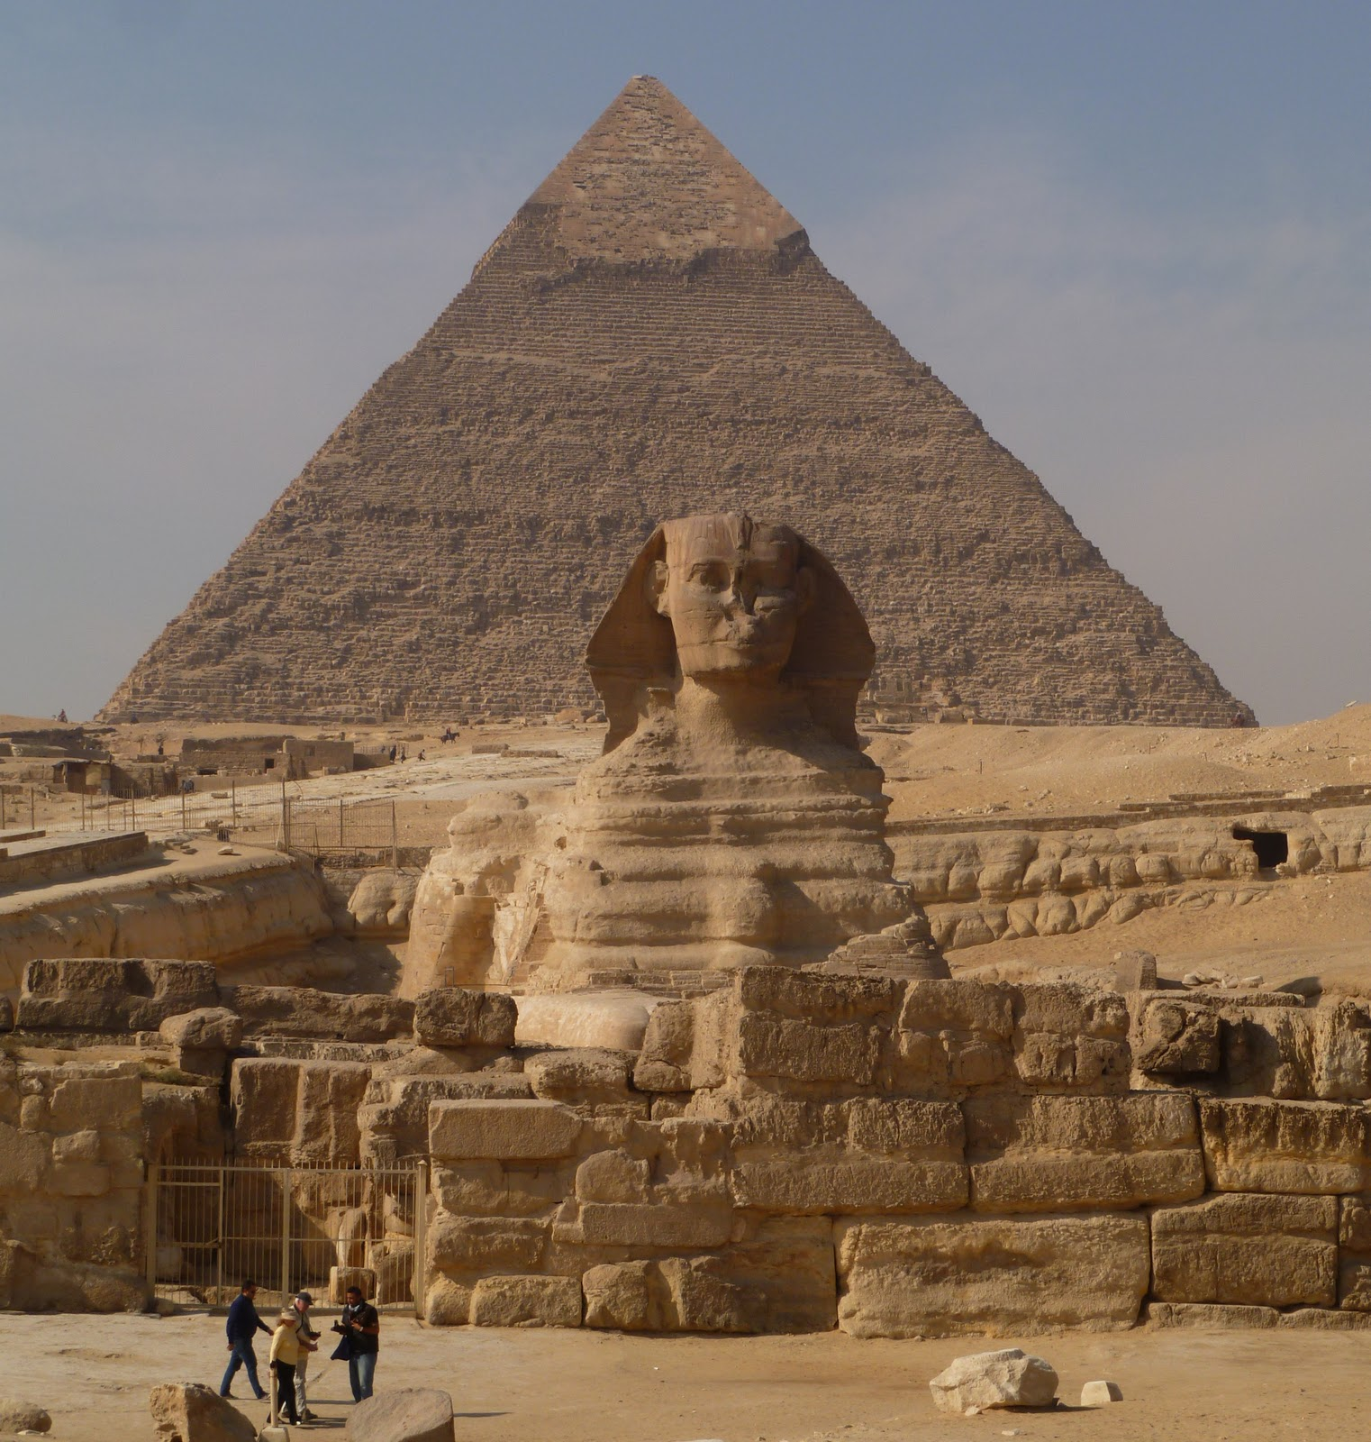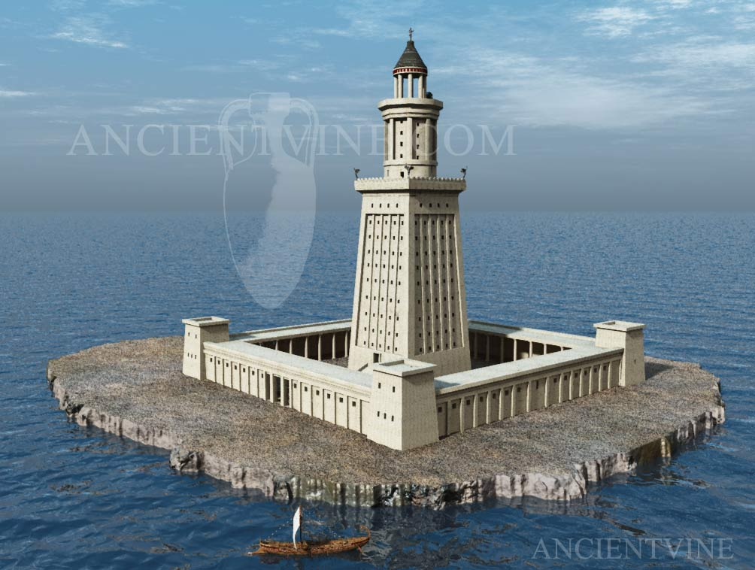

1- The Statue of Zeus 2- Hanging Gardens of Babylon 3- Great Pyramid of Giza 4- The Lighthouse of
Alexandria

C. Fill in the blanks with Simple Past Tense by using the verbs in brackets in correct form. (Aşağıdaki boşlukları, parantezde verilen fiillerin uygun hallerini kullanarak Simple Past Tense’e göre doldurunuz.) 3x5=15p.
1. They .....went.......................................... (go) to school on Monday. (+)
2. Did.................................. you ....clean............................. (clean) your room a few hours ago? (?)
3. I ..didn’t listen........................... (listen) to music yesterday. (-)
4. The students .....saw......................... (see) their new teacher last week. (+)
5. What ....did............................. Ayşe ........have........................... (have) for the breakfast? (?)

D. Fill in the blanks with “was, were” correctly. (Boşlukları uygun şekilde “was, were” ile doldurunuz.) 3x5=15p.
1. The weather ......was............................. very hot last Saturday.
2. Gizem and Hande .....were.................................... ill yesterday.
3. The students .......were.................................. at the theatre last night.
4. Your son ......was................................ five years old last year.
5. I .....was................................. in Germany in 2001.

E. Choose the correct option. (Doğru olan seçeneği işaretleyiniz.) 2x6=12p.
1. The doctor …………… (work) in the local hospital now. 4. Michael ……………… (go) shopping with his father on Saturdays.
a) works b)is working a) goes b) is going
2. Look! Roberto ……………. (catch) the bus. 5. Chinese use very little oil to cook the food ………….. Chinese food is rarely greasy.
a) catches b)is catching a) but b) so
3.The girl often ……….. (drink) milk for breakfast. 6. I have got book ………… ruler in my bag.
a) drinks b)is drinking a) and b)but

F. Answer the question below and make 4 sentences using the verbs below. (Aşağıdaki soruyu yanıtlayınız, verilen fiilleri kullarak 4 adet cümle kurunuz.) 4x4=16p.
visit my friends / walk to school / study for the exam / eat a hamburger / watch TV / call my friend / drink tea / clean my room / listen to music / play football / help my parents / go to cinema
What did you do last weekend?
1.) I visited my friend…………………………………………………….
2.) I ate a hamburger……………………………………………………..
3.) I went to cinema………………………………………………………..
4.) I helped my parents……………………………………..……………..
5) I studied fort he exam…………………………………………………

G. Read the texts and answer the questions according to them correctly. (Aşağıdaki metinleri okuyunuz ve soruları metinlere göre doğru şekilde yanıtlayınız.) 2x6=12p.
1. The Brazilians eat lentils on New Year’s Day because ...............
a) they like lentils b) lentils bring luck c) lentils symbolise coins

2) They make .................... from meat and beans.
a) pork b) beef c) fejioda

3) When something is all Greek to you, you don’t ................ it.
a) understand b) like c) speak

4) Chinese people don’t add salt to their food because ...............
a) they don’t like salt
b) soy sauce is salty enough
c) salt is dangerous.

5. The Chinese eat their meal with ....................
a) chopsticks b) forks c) spoons

6. Chinese people eat noddles on their birthdays to have ............
a) a lot of money
b) a long lifetime
c) a healthy body

Camilla’s Blog
Hi, My name is Camilla. I’m from Brazil. We usually have ham or cheese sandwiches at breakfast. We love eating tropical fruit, too. They are always fresh and juicy. Lunch is normally the biggest meal of the day. We come together with our family at dinner. We usually have dinner late. Our national food is “fejioda”. We make it from black beans, pork and beef and we often serve it with some rice. In many restaurants , they only serve fejioda on Saturdays. It is delicious. People drink coffee all day; morning, noon and night because it is cheap and healthy. In my county, I guess it is all Greek to you, it is so rude to walk away with your food in your hand. First, you should finish it and then go. Many Brazilians include lentils in a New Year’s menu because they believe it increases one’s good luck.
Huang’s Blog
Hello, I’m Huang from China. Chinese dishes are always very popular in the world, aren’t they? For breakfast, lunch and dinner we usually have almost the same kind of food. Rice, dumplings and noddles are always on our menu. We use very little oil to cook the food so Chinese food is rarely greasy. We often use soy sauce, and it’s quite salty, so we never add salt to our meals. In some part of China, spicy food is quite popular and they usually eat “Hunan fish head” with hot red peppers there. We love meat and seafood with sweet and sour sauce. We use chopsticks to eat our food. Everyone knows that China is a tea country and we always drink it a lot. On our birthdays, we eat noddles. They are the symbol of a long life.

