………………… EĞİTİM-ÖĞRETİM YILI İDİL KIZ ANADOLU IMAM HATIP LİSESİ 9. SINIF 2. DÖNEM 1. İNGİLİZCE SINAVI
PAPER -A

Name and Surname: Number: Class: Point:

A. Fill in the Blanks Using the Words from the Box (8x2=16 pts)
earthquakes / ocean / mountain /desert / drought / tsunami / avalanche / beach
1. Tsunami_______ are large waves after earthquakes.
2. There is almost no water in the __desert____ . You can find it hard.
3. Nemrut __mountain________ is in Adıyaman.
4. I like swimming and sun. When the summer comes, I always enjoy going to the __beach___ .
5. Many people die when an __earthquakes____ happens.
6. I can’t dive into the ___ocean_______ , because it is very dangerous for me.
7. Farmers don’t get any crops during a __ drought____ . They can’t grow up anything.
8. When there are a lot of snow, sometimes there can be __avalanche____ in the winter.
B. Write the sentences in correct order (5x2=10 pts)
1. never/she/cooks/ . She never cooks._____________________
2. you/ every night / read /Do / a book /? Do you read a book every night?_______
3. your mother /always / Does / clean /the house/? Does your mother clean the house always?
4. travel/ How/ do /often /you/? How often do you travel?______________
5. never / Her sister / dances/. Her sister never dances._________________
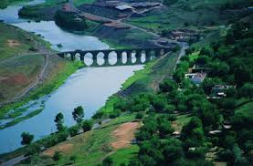
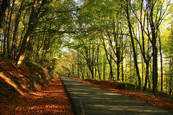
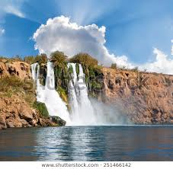
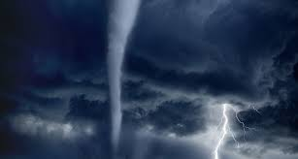
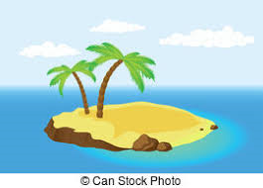
C. Match the Words from the box with the Pictures, Two are EXTRA (5x2=10 pts)
a. hurricane | b. hill | c.waterfall | d. forest | e. desert | f. river | g. island
c
d
a
f
g

D. Put the Adjectives into the correct form of Superlatives (5x2=10 pts)
1. Kızılırmak is _the longest_____ (long) river in Turkey.
2. Antalya is _hottest____ (hot) city in summer in Turkey.
3. Ali is __thinnest_______ (thin) boy in the class.
4. Murat Boz is _the most handsome____ (handsome) singer that I know.
5. İsmet Özel is _the best____ (good) writer in our country.
D. Look at the table and Write True (T) or False (F) (5x3=15 pts)
 | 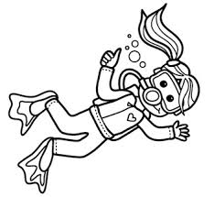 | 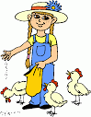 | 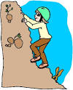 | 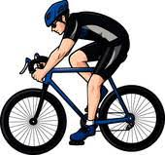 | 
Lucy | × | × | √ | × | √
Max | √ | √ | × | √ | ×
Naz | × | × | √ | × | √
Ali | × | √ | √ | × | ×
…T… 1. Lucy can’t feed animals. …F…... 4. Lucy can dive into the oceans.
…T… 2. Max can dive into the ocean. …T…… 5. Max and Ali can feed animals.
…F… 3. Ali and Naz can’t jump.
E. Look at the Table in “D” and Answer the Questions (5x3=15 pts)
1. Ali _____ to the mountains.
a. can’t climb b. can climb c. can climbing d. can jump
2. Naz _____ into the oceans easily.
a. can dive b. can swim c. can’t dive d. can cycle
3. Max and Ali _____ well.
a. can’t jump b. can dive c. can’t feed d. can jumping
4. Lucy _____ to the mountains but she _____ well.
a. can’t climb/ can’t cycle b. can climb/can cycle c. can climb/can’t cycle d. climbing/can’t cycle


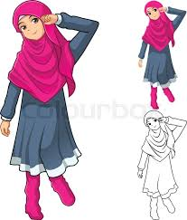



F. Look at the pictures and write their names (6x4=24 pts)
Luke

1. …Ayşe……………... is wearing a headscarf and dress. She has got boots.
2. …Pamela…... is wearing high-heeled shoes and dress. She has got long wavy hair, she is beautiful.
3. …Luke……………... is wearing glasses, flip-flops and short. She has got straight dark hair.
4. …Sam……………... is wearing suit and tie. He has got a clutch. He is middle-aged.
5. …Bob……………... is wearing suit. He has got beard and moustache, he is well-built.
6. …Taylor……………... has got short curly hair. She is wearing a T-shirt and jeans.
Elif KOÇAK
Taylor
Ayşe
Bob
Sam
Pamela

