…………………… EDUCATION YEAR FATİH SULTAN MEHMET SECONDARY SCHOOL
2nd TERM 1st ENGLISH EXAM FOR THE 8TH GRADES

Name/ Surname: Class/ Number:

- Fill in the blanks with comparative forms of given adjectives. (5x3=15 pts.)
(Boşlukları verilen sıfatın uygun halleriyle doldurunuz.)
- Taking photos of animals is __easier__________ than scuba diving. (easy)
- Rafting is _more entertaining________________than caving. (entertaining)
- Riding an elephant is __more dangerous_______ than climbing a mountain. (dangerous)
- Going on a jeep safari is ___better__________ than joining a motorcycle tour. (good)
- Climbing is __worse_________ than swimming. (bad)

- Fill in the blanks with “prefer” or “ would rather”. (5x2=10 pts.)
( Boşlukları prefer ya da would rather ile doldurunuz.)
1. I ___ would rather ___________ travelling by bus to travelling by train.
2. Aslı ___ prefer ______________walking to running.
3. They___ would rather _______ visit historic sites than modern cities.
4. Ali ___ prefer _____________ watching TV to going out.
5. She__ would rather ________ go to the cinema than sit at home.
- Categorize the given words and write them under correct titles. (12x2=24 pts.)
(Verilen kelimelerin numaralarını uygun kategoriye yazınız.)

1.South – 2.wickerwork basket – 3.bed & breakfast hotel – 4.east –5. hardaliye – 6.warm –
7.Selimiye Mosque –8.guest house – 9.hot – 10. fried liver – 11.Taj Mahal 12. Fragnant soaps

Location | Climate | Accommodation | Souvenirs | Local Food  (Cuisine) | Tourist Attractions
South | warm | bed & breakfast hotel | wickerwork basket | Fragnant soaps | Selimiye Mosque
east | hot | guest house | hardaliye | fried liver | Taj Mahal

- Answer the questions according to the text. (5x3=15 pts.)
( Soruları parçaya göre cevaplayınız.)
1) What are some tourist attractions?
Muğla is a city on the Southwest coast of Turkey. The growing city has lots of alternatives such as shopping mall, sports activities, historic sites. Bodrum castle, Kaunos historic site and Ölüdeniz beach are some of the most important places to visit. You can also try paragliding in Ölüdeniz. Approximately nine hundred thousand people live there and it has a coast to Aegean. It has a warm temperature over the year. You should taste the delicious foods. You can choose sour fish, Keşkek and Bodrum dessert Lokma for your dinner.

Bodrum castle, Kaunos historic site and Ölüdeniz beach are some of the most important places.
2) What is the weather like there?
It has a warm temperature over the year.______
3) What is the population in Muğla?
Approximately nine hundred thousand people live there._______________________________
4) What is the location of the city?
Muğla is a city on the Southwest coast of Turkey.
5) What are traditional dishes?
Sour fish, Keşkek and Bodrum dessert Lokma. _____________________________________________

- Complete the dialogue with the questions.(Diyaloğu verilen sorularla tamamlayınız. (6x2: 12 pts)
Suzan : Hey, Leyla! It’s nice to see you. 1) . How was your holiday?..................
• Fantastic! • Did you take lots of photos? • What was the weather like?
• Where did you go? • How was your holiday? • Where did you stay?
Leyla : It was 2) . Fantastic!.................. I had a great time.
Suzan : 3 . Where did you go?.......................................
Leyla : I went to İstanbul, Turkey.
Suzan : Wow! 4) . Where did you stay?...........................
Leyla : I stayed at a five-star hotel in the centre of the city.
Suzan : That’s great. 5) ... What was the weather like?................
Leyla : The weather was good. It wasn’t too hot, and it wasn’t too cold.
Suzan : Lucky you! 6) .. Did you take lots of photos?.......................
Leyla : Yes, I did. Would you like to come over later to see them?
Suzan : Sure, that sounds great. See you later.

- Fill in the blanks. (Boşlukları doldurunuz.) (8*1=8 points)
Mom Darren Set Sarah Loading Dad Cooking Vacuum

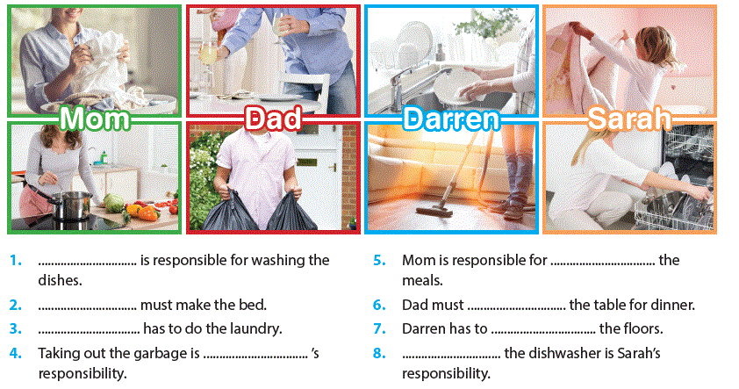

G. Write the numbers. (Sporların numaralarını uygun kutucuğun içine yazınız. (10*1=10 Pts)
1. kayaking 2. wind surfing 3. hang gliding 4. paragliding 5. skiing 6. ice climbing 7. rafting 8. bungee jumping 9. under water hockey 10. heli skiing
Water Sports | Air Sports | Winter Sports
Kayaking  rafting  under water hockey | wind surfing  hang gliding  paragliding  bungee jumping | ice climbing  skiing  heli skiing

G.Verilen cümleleri Türkçeye çeviriniz. (2*3=6 Pts)
- I would rather visit Venice in Italy because I love ancient cities.
İtalya-Venice’i ziyaret etmeyi tercih ederim. Çünkü antik şehirleri seviyorum._________________________________________________ GOOD LUCK
- Have you ever ridden an elephant? Nihan ALTAN
Hiç file bindin mi?_________________________________________________ ELT

