2. Match the words with
…………… EDUCATION YEAR ATATÜRK SECONDARY SCHOOL
8th GRADE 2nd TERM 1st ENGLISH EXAMINATION

NAME: CLASS:
1. Match the words with the pictures. (8*3=24)
- Read the text and write True and False. (7*3=21)
John : There are lots of things to do in Cairo. I think you should start with visiting the citadel and exploring the Pyramids of Giza. Then, you should go shopping at Khan Al-Khalili, go for a walk in Zamalek, and spend time in Islamic Cairo.
Mike: Sydney is an excellent place to have an enjoyable holiday, because you spend a lot of time on the beach. You can go on a boat trip, sail under the Harbour Bridge, visit the Opera House and see a lot of kangaroos.
Doris: Antalya is a marvellous place to see the sun, sand and history together. You can see Aspendos Theatre there and stay at a five-star all-inclusive hotel by the sea. It is really relaxing and fun.
- Mike prefers going shopping. _F_
- Mike prefers spending time on the beach. _T_
- John has visited the citadel in Cairo. _T_
- John has stayed at an all-inclusive hotel. _F_
- Doris had a relaxing holiday. _T_
- Doris visited the Opera House _F_
- Doris explored the Pyramids of Giza. _F_
- Mike experienced water sports. _T_

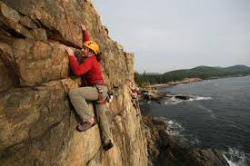
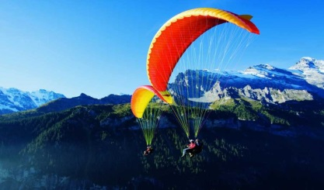
Rock climbing –caving- – skiing–paragliding-hiking– mountain biking- motor racing-parkour running

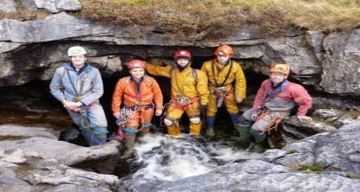
____ skiing _________________________caving __________________
___ paragliding __________________ Rock climbing _____________________
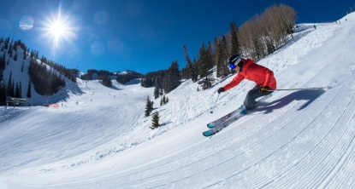
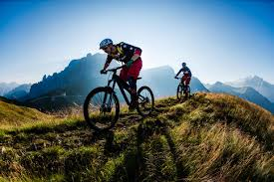
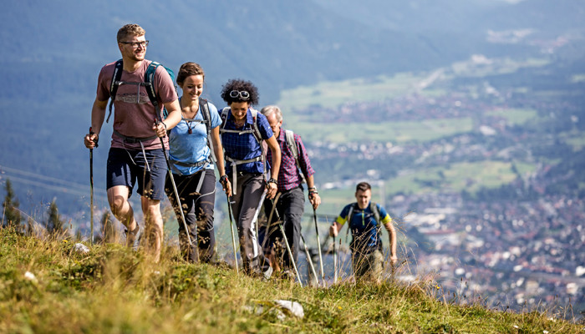

___ hiking _____________________mountain biking ______________________
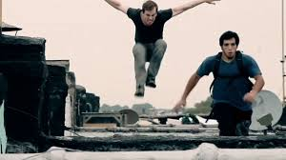
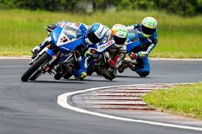

__ motor racing parkour running _______________________________________________

4. Fill in the blanks with the comparative form of the Adjectives (5*2=10)
1. İstanbul is –more crowded than-- ------- İzmir. ( crowded ),
2. Mr. Smith is---smarter than------------Mr. Taylor. ( smart )
3. Hang gliding is –more challenging than-- caving. ( challenging)
4. Everest mount is –higher than-------Nemrut mount.( high )
5. The Sahara is ----larger than------- ---------The Gobi.( large )

3. Fill in the blanks with “prefer” “would rather”. (5*2=10)
1. I ____ prefer ____ travelling by bus to travelling by train.
2. John ____ prefer _______________ walking to running.
3. They __ would rather __ visit historic sites than modern cities.
4. Jack __ would rather ________ watch TV than going out.
5. She __prefer___ going to the cinema to sitting at home.

5. MATCH THE WORDS WITH THEIR MEANINGS. (10*1=10)

1. ancient 6. province a. köy e. el sanatları
bbA
2. architecture 7. village b. başkent f. gidilecek yer
3. capital 8. handcrafts c. köfte g. antik
4. destination 9. trade route d. hediye h. mimari
5. gift 10. meatball e. il i. ticaret yolu

6. MATCH THE WORDS WITH THE PICTURES. (5*2=10)
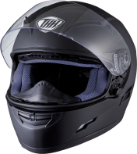
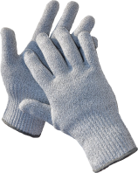


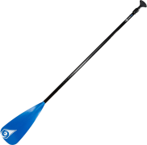
1. HELMET 2. PADDLES 3. GLOVES 4. DROWN
5. COAL MINERS

7. MATCH THE WORDS WITH THE PHRASES? (15*1:15)
Vacuum wash mow load set/ lay sweep clean
take wash mop do Take do take out hang out

_ clean ______ the house
_wash______ the dishes
__mop_____ the floor
__do_____ the grocery shopping
_ take out ______the garbage
_clean______ the bathroom
_ vacuum ______ the leaves
_ hang out ______ the clothes

__do_____ the laundry
__wash_____ the car
__ mow _____ the lawn
__ load _____ the dishwasher
__set_____the table
_take out______ the dog for a walk
__take_____ the care of the cat

English Teacher Meryem Çelebi

