…………… EducationalYear Sason İmam Hatip Secondary School 7th Grades 2nd Term 1st Exam

Name / Surname: Number:

A.Match the names of the TV programmes with the pictures.( TVprogramlarınıuygunresimlerleeşleştiriniz .)(3X8=24)
1 .News 2.Documentary 3.Quiz Show 4.Soap opera 5.Sports programme 6.Cookery programme 7.Reality Show 8.Cartoon

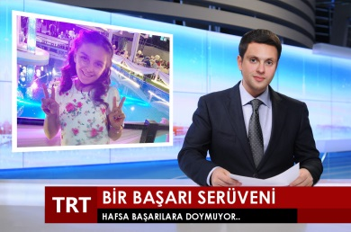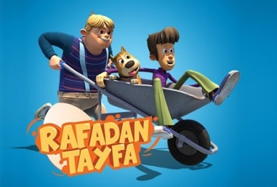

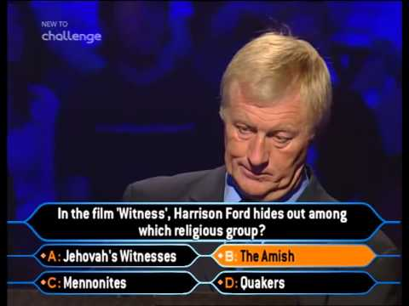

B.Complete the sentences with “ Future Tense ( will)”. (Cümlelerigelecekzamanınuygunyapısıylatamamlayınız) (4X5=20)
1 .Robert…won’t watch………………………a football match next month.(not / watch)
2 .I think it …won’t rain……………….. …………….. tomorrow. (not / rain)
3 .Will…………………. Ayşegül …decorate……………………… the house tomorrow?(decorate)
4.I …will watch…………………………… a quiz next week. (watch)
5 .In the future,I …will live………………. …………..in a big city. I want to live in a small city.(live)

C.Match the phrases.(Fiilleriuygunsözcükgruplarınayerleştiriniz) (2X8=16)
eat / organise / wear / light / invite / send / visit / refuse
1. .… wear………………… funny clothes 2..…… send……………invitation card

3.… light……… candles 4 .…… visit…………… relatives
.5 .… eat………………… a cake 6 .… organise……………… a birthday party
7.… invite………………… guests 8. … refuse …………………… invitation
D.Fill in the boxes with phrases. (Kutularauygunkelimeleriyazınız) (2X15=30)

A.Would you like some coffee? / B. No, thanks. / C. That sounds good. / D. What about a sandwich?E. Let’shave a party tonigh. /F. I’d love to. / G. I’d rather not. / H. Shall we go together?
I. Do you fancy watching a documentary?/ J. I don’t really like it. / K. Why don’t you join us?L. Yes, please. / M. Sure, why not? / N. Great idea. / O. Not really, thanks.

Offering/Suggesting/Inviting
Would you like some coffee?
What about a sandwich?
Let’s have a party tonigh.
Shall we go together?
Do you fancy watching a documentary?
Why don’t you join us?
Accepting Refusing
That sounds good. I’d rather not.
I’d love to. No,thanks.
Yes, please. I don’t really like it.
Sure, why not? Not really, thanks.
Great idea.

E)Write the corrects words under the pictures. (Resimlerin altına uygun kelimeleri yazınız) ( 5X2=10 pts)
A. Halloween Party | B. Graduation Party | C. PyjamaParty | D. Birthday party | E. Wedding Party


_____________ ______________ ______________ _____________ ___________

