………….. EDUCATIONAL YEAR AŞKALE IMKB ANATOLIAN HIGH SCHOOL ENGLISH LESSON 11TH GRADE
2nd TERM 1ST EXAM

POINTS
NAME:
SURNAME:
CLASS: 11/…... NO:…… NO:...........
PUANI:

DATE: 27/03/2020
- Read the text and answer the questions (7x2=14)
Story of a mobile phone  I had been saving money to buy the latest brand cellphone for two years. Yesterday was the day! I had saved enough to afford one! In the morning, I rushed to the shopping center to buy it(1). I asked for that brand, but the sales person told that it wasn’t available. He (2)promised to bring it to the market next week. A week later, I went to the market again, and bought the one that they brought for me. I fell in love with it. I carried it with me wherever I went. Believe me! Even to the toilet! Then I fell my phone into the toilet. immediately, I tried to take it from there! That went from bad to worse! I shouldn’t have tried to take it back because my hand got stuck in the toilet! I don’t want to tell the rest. My brother helped me to take my hand and my phone too! | Read and Mark the sentences as TRUE (T) or FALSE (F)  1.Elena was waiting for the phone for a long time. T  2.Elena couldn’t buy the mobile phone on her first trial T  3.Elena forgot her mobile phone in the toilet. _F  4.Elena’s brother helped her. T  Find what the underlined words in bold refers to.  5. it ( 1): .........phone................  6.he (2):……the sales person………  Choose the correct option  7.What is the meaning of ‘afford’?  a) to be able to bring something  b)to be able to buy something
- Fill in the blanks with the words from the box. There is ONE EXTRA word in the box. (5x2=10)

- Many teenagers are into……trekking.............. and feeling the nature. They enjoy walking in the forest.
- I am bored this ………dull routine…………… because I have the same schedule everyday.
- A dog is a …faithful………………………… animal. It always comes to sit by your side.
- The wood cutter didn’t ………get by……… without his axe.
- I can’t stand living in Amsterdam . My life here is unbearable……………….
- Choose the correct answer (10x2=20)
- I’m sure he didn’t come from the pool. He must have been at home all day.
- We took a lot of luggage for our holiday. I think we should have had less bags to carry.
- All the lights at home were on last night. The Simons must have been/ at home.
- Sally went out without waiting me.I went home on foot. She must have waited for me!
- The lock on the door looks loose. Somebody should have tried to enter the house.
- There was no table for us in the restaurant yesterday. We /should have booked a table for us!
- Marta looked pale all the night yesterday. Marta must have been ill.
- The team didn’t score an early goal, so they couldn’t win. The team should have scored/ a goal early.
- I didn’t study, so I failed. I should have studied/ more.
- Before leaving the class, you could have asked me to go together.

000000000000000000000000000000000000000000000000000000000000000000000000000000000000000000000n
- faithful- get by- dull routine- unbearable - servant - trekking

- Match the sentences. (8x2=16) 1e 2h 3g 4f 5c 6b 7a 8d
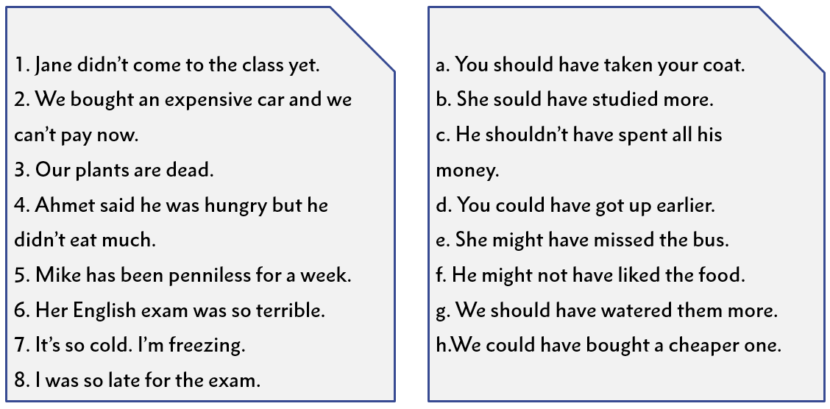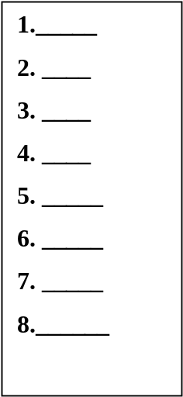
Fill in the blanks below with must have V3, might have V3, can’t have, should- shouldn’t have V3. (5x3=15 )
- Marta looks upset. She probably heard about the bad news.
Marta ............must has heard............................. about the bad news.
- Don’t complain about the trafic accident. You drove too fast
You ………………shouldn’t have driven……………….. too fast.
- Samantha has many mistakes in her report. She didn’t check it before the meeting.
Samantha ...................should have checked.................. her report before the meeting.
- I am quite sure that I left my purse in my bag. Somebody took it.
Somebody ............must have taken.................................. my purse from my bag.
- Alexandra probably didn’t see my message. She would have answered otherwise.
Alexandra …………………can’t have seen…………. my message.
Match the idioms with the definitions (5x2=10p.)
____c__ 1) Give someone credit for something
____b__ 2) When a habit begins to cost money it is called a hobby.
____e__ 3) In vain
____d__ 4) Haste makes waste
____a__ 5) Blood, sweat and tears
- Something that requires a lot of effort and hard work
- When you pay some money for a regular activity, it becomes a hobby
- Believe that someone is good at something or has a special quality
- Hurrying will cause you to makes mistakes
- Without success
G. Write about your hobbies (at least 5 sentences )You can use;good at,bad at, gifted in, prefer (5x3=15)
- I am good at riding horse…………………………………………………………………….
- I am gifted in playing tennis………………………………………………………………..
- I prefer reading book…………………………………………………………………………….
- I am bad at dancing…………………………………………………………..
- I am gifted in singing………………………………………………………………….

Abdullah KALKAN Esra ÖZTÜRK Kader KOÇ
Müdür Başyardımcısı İngilizce Öğretmeni İngilizce Öğretmeni
Başarılar Dilerim……
Abdullah KALKAN
Din Kültürü ve Ahlak Bilgisi Öğrt.

