…………….. ACADEMIC YEAR
ANATOLIAN HIGH SCHOOL
2nd TERM - 1st WRITTEN ENGLISH EXAM FOR THE 11TH GRADES

Name & Surname : ____________________
Class : ______ Number : _____ MARK: _____

- Use the words below to complete the sentences. ( 15p. )
* cybersecurity *cyberbully *cyberlaw *cybercriminal *cyberattack

1. A ............................ commits various crimes and steals precious information.
2. ................................ is really important to protect companies’ important data.
3. A ............................ gives harm especially to the kids via Internet.
4. ................................ can be prevented with special virus programmes.
5. ............................... organises the rules and regulations in the techno-world.

- Put the verbs in brackets into the correct tense. ( if clause type 3 ) (20p. )

1. If I ………………………... ( work ) harder, I would have passed the exam.
2. I would have been happy if you …………….………. ( call ) me on my birthday.
3. If Emily hadn’t driven the car carefully, the accident …………………………..( happen )
4. If I had had a smartphone, I .......................................... (check) my emails.
5. We would …………….…. ( go ) out if Tom hadn’t been watching TV.

- Match the sentences. ( 16p. )

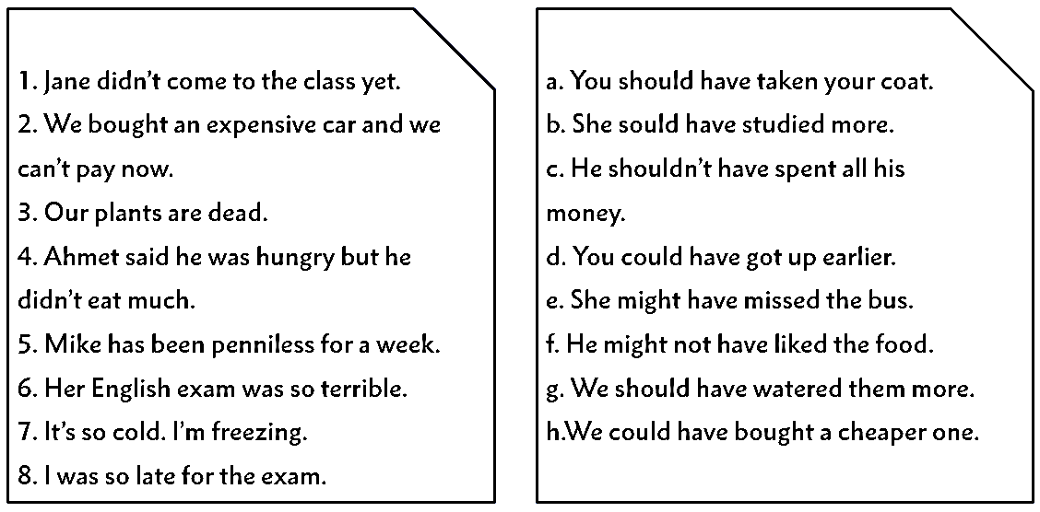
- Rewrite the sentences with “should have”. ( 15p. )

1. Sally left home angrily. ________________________________________________
2. He didn’t ask my opinion. _______________________________________________
3. George didn’t tell the truth____ __________________________________________
4. He made me upset. ____________________________________________________
5. They didn’t listen to my advice. _________________________________________

- Match the words with their meanings. ( 14p. )

1. stick the knife in | a) a feeling of liking or caring about someone
2. sneak into | b) not taking much effort
3.all that glitters is not gold | c) a single fortunate event doesn’t mean that what follows will also be good
4.being as easy as falling of a log | d) not having much light
5.one swallow does not make a summer | e) give harm to somebody by criticizing
6. dim | f) enter there secretly
7. affection | g) someone who seems to be good physically might not be good inside
*ANSWERS: 1. 2. 3. 4. 5. 6. 7.

- Read the advice coloumn and answer the questions. ( 20p. )

Dear Advice Guru,
Something really bad happened. We moved to another city because my mother changed her job! I still feel terrible about this.
In my hometown, I had a lot of good friends. We used to study and spend time together all the time. My best friends were there, too. Whenever I was in trouble, I had best friends to talk about it and they were always able to sort out that problem. My mother never told me about her plans, so I was shocked! We moved here three months ago and I haven’t had a new friend, yet. My life here seems unbearable . I can’t stand living in this city. This city is smaller and it lacks social activities. There are only three big shopping malls! Although it is by the sea and there are a lot of cafés to go, I have no friends, so they are useless. My mother keeps telling me that I will get used to living here, but I don’t think so.
People here are really communicative and talk too much. They try to interact with me all the time, asking many questions. I don’t like to be inquired! I don’t answer their questions most of the time and my parents get mad at me! What should I do? Please help me.
Best,
Desperately Lonely

1. Why did they have to move to another city?

2. How was her life in her hometown?

3. What makes life unbearable in the new city?

4. What kind of people live in the new city?

