2018 – 2019 ACADEMIC YEAR ASHGABAT TURKISH ANATOLIAN HIGH SCHOOL
2nd TERM 1st WRITTEN ENGLISH EXAM FOR 1Oth GRADES 05/03/2019

NAME-SURNAME :
CLASS / NUMBER :

- Put A QUESTION TAG at the end of each sentence

1. Switch on the light for me, …………………………… ? 6. There’s plenty of time, ……………………………….. ?
2. Don’t forget to lock the door, ………………………… ? 7. Pass me that magazine, ………………………………. ?
3. Nobody was watching the TV, ……………………….. ? 8. Let’s have a cup of tea, ………………………………. ?
4. Everyone will be here soon, ………………………….. ? 9. It’s a good restaurant, ………………………………… ?
5. Nothing terrible has happened, ………………………. ? 10. You haven’t seen my keys, …………………………… ?

- Complete the sentences ACCORDING TO YOU by using IF CONDITIONALS

1. If you write me from England, ………………………………………………………………………………………..
2. She can learn English if ……………………………………………………………………………………………………
3. We can catch the bus if ……………………………………………………………………………………………………………….
4. If it doesn’t rain this afternoon, ……………………………………………………………………………………………………
5. His family will be hungry if ……………………………………………………………………………………………………………
6. Your room will become untidy if ……………………………………………………………………………………………………
7. A baby cries if …………………………………………………………………………………………………………………………………
8. If my girlfriend comes early, ……………………………………………………………………………………………………………
9. If he doesn’t smoke, ………………………………………………………………………………………………………………………
10. You can’t sleep well if ……………………………………………………………………………………………………………………..

C . Write The True Household Chores Under The Correct Pictures

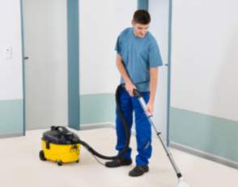
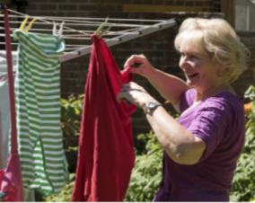

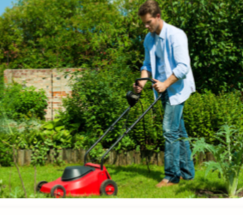
..………………………………. ……………………………. ……………………………. ………………………….. …………………………..
……………………………….. …………………………… ………………………….. ………………………… ………………………….

- Complete tTe Sentences by Using The Words Correctly Below.
rely on | referee | wrinkles | vital | cooperation
Count me in | departure | regulations | distraction | threats

- “ I can’t remove the ……………………………… of this shirt. What should I do ? “
- There is a close …………………………………..in the household chores in our family.
- Higher Carbon footprints are …………………………………… to the planet and our choices play a …………………………. role in lowering carbon footprints.
- “I chnaged my mind and I’m coming to the concert tonight, don’t forget to …………………………………………………”.
- The ……………………………… must show red card for accidental fouls.
- “ In a World with billions of people , we cannot …………………………………….. jungle laws. “
- Today modern societies have created their own rules and …………………………………. for a powerful state.
- One of the most important youth problems at schools is ………………………………………
- “ Your …………………………… time is 7 pm and your arrival time for Istanbul is 9.45 pm. “

- Rewrite the sentences using USED TO
1. When she was a child, she lived in a small village.
……….. …………………………………………………………………………….. …………………………………….
2. When he was a young man, he enjoyed playing basketball.
…………………………………………………………………………………………………………………………………
3. In ancient Rome, wall paintings were a popular form of advertising.
…………………………………………………………………………………………………………………………………..
4. Before she learned to read, her parents read stories to her.
…………………………………………………………………………………………………………………………………….
5. Before he came to Ankara, life was cheap in Turkey.
……………………………………………………………………………………………………………………………………
6. Jim spoke German ar school, but he has now forgotten.
……………………………………………………………………………………………………………………………………..
7. Susan was a nurse before she got married and raised a family.
……………………………………………………………………………………………………………………………….
8. Sally played tennis when abroad, but she prefers swimming now.
……………………………………………………………………………………………………………………………….
9. Before they bought their house, they lived in an apartment.
…………………………………………………………………………………………………………………………..
10. While she was going to university, she worked in a doctor’s office.
…………………………………………………………………………………………………………………………
- Categorize the Words In the Correct Boxes

dance festivals Statue of Liberty hostel pizza Ephesus Ancient City
foggy food and cookery festival guest house by ferry Fairy chimneys
Big Ben kebap warm spaghetti Sumela Monastery
Maiden’s Tower dry flat by subway camping tent
Landmarks | Transportation | Accommodation | Cultural Events
Cuisine | Climate | Sightseeing Spots

- Make sentences with should or shouldn't.
1. He can't speak English well. ________________________________
2. He coughs a lot. ________________________________
3. You are always late. ________________________________
4. He works all the time. ________________________________
5. Hasan makes a tot of mistakes. ________________________________
6. The children are making a lot of noise. _________________________
7. He spends a lot of money. ________________________________
8. She always daydreams in class. ______________________________
9. They go out every evening. ________________________________
10. Your father comes home very late. _____________________________
HABİP ÖZÇAKIR GOOD LUCK
ELT TEACHER of ATAL

