………………… EĞİTİM-ÖĞRETİM YILI İDİL KIZ ANADOLU IMAM HATIP LİSESİ 9. SINIF 2. DÖNEM 1. İNGİLİZCE SINAVI
PAPER -A

Name and Surname: Number: Class: Point:

A. Fill in the Blanks Using the Words from the Box (8x2=16 pts)
earthquakes / ocean / mountain /desert / drought / tsunami / avalanche / beach
1. ______________ are large waves after earthquakes.
2. There is almost no water in the ______________ . You can find it hard.
3. Nemrut ______________ is in Adıyaman.
4. I like swimming and sun. When the summer comes, I always enjoy going to the ______________ .
5. Many people die when an ______________ happens.
6. I can’t dive into the ______________ , because it is very dangerous for me.
7. Farmers don’t get any crops during a ______________ . They can’t grow up anything.
8. When there are a lot of snow, sometimes there can be ______________ in the winter.
B. Write the sentences in correct order (5x2=10 pts)
1. never/she/cooks/ . ___________________________________
2. you/ every night / read /Do / a book /? ___________________________________
3. your mother /always / Does / clean /the house/? ___________________________________
4. travel/ How/ do /often /you/? ___________________________________
5. never / Her sister / dances/. ___________________________________
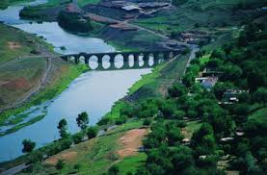
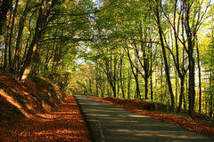
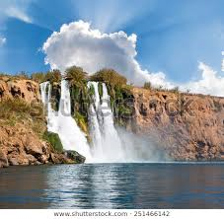
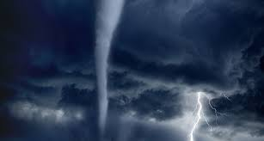
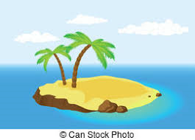
C. Match the Words from the box with the Pictures, Two are EXTRA (5x2=10 pts)
a. hurricane | b. hill | c.waterfall | d. forest | e. desert | f. river | g. island

D. Put the Adjectives into the correct form of Superlatives (5x2=10 pts)
1. Kızılırmak is ___________ (long) river in Turkey.
2. Antalya is ___________ (hot) city in summer in Turkey.
3. Ali is ___________ (thin) boy in the class.
4. Murat Boz is ___________ (handsome) singer that I know.
5. İsmet Özel is ___________ (good) writer in our country.
D. Look at the table and Write True (T) or False (F) (5x3=15 pts)
 | 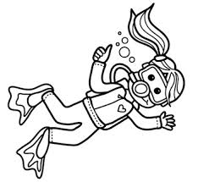 | 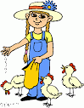 | 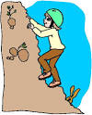 | 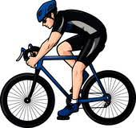 | 
Lucy | × | × | √ | × | √
Max | √ | √ | × | √ | ×
Naz | × | × | √ | × | √
Ali | × | √ | √ | × | ×
…… 1. Lucy can’t feed animals. ……... 4. Lucy can dive into the oceans.
…… 2. Max can dive into the ocean. ……… 5. Max and Ali can feed animals.
…… 3. Ali and Naz can’t jump.
E. Look at the Table in “D” and Answer the Questions (5x3=15 pts)
1. Ali _____ to the mountains.
a. can’t climb b. can climb c. can climbing d. can jump
2. Naz _____ into the oceans easily.
a. can dive b. can swim c. can’t dive d. can cycle
3. Max and Ali _____ well.
a. can’t jump b. can dive c. can’t feed d. can jumping
4. Lucy _____ to the mountains but she _____ well.
a. can’t climb/ can’t cycle b. can climb/can cycle c. can climb/can’t cycle d. climbing/can’t cycle


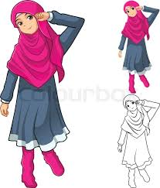



F. Look at the pictures and write their names (6x4=24 pts)
Luke

Elif KOÇAK
1. ………………... is wearing a headscarf and dress. She has got boots.
2. ………………... is wearing high-heeled shoes and dress. She has got long wavy hair, she is beautiful.
3. ………………... is wearing glasses, flip-flops and short. She has got straight dark hair.
4. ………………... is wearing suit and tie. He has got a clutch. He is middle-aged.
5. ………………... is wearing suit. He has got beard and moustache, he is well-built.
6. ………………... has got short curly hair. She is wearing a T-shirt and jeans.
Taylor
Ayşe
Bob
Sam
Pamela

