……………….. EDUCATION YEAR MİLLİ HAKİMİYET MIDDLE SCHOOL
1ST TERM 2ND ENGLISH EXAM FOR 8TH GRADE

NAME SURNAME: ……………………………….………………………….Class:…………Mark:…………

Read the text and answer 1.2.and 3. questions
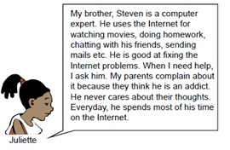

- According to text,which one is true ?

- Steven always needs help.
- His parents like Steven’s habit.
- Steve uses the internet for many things.
- Juliette uses the Net for homework.

- Steve……………………….

- spends his time playing with Juliette.
- never cares about his sister,Juliette.
- gets on well with his parents.
- is good at using computer.

- Juliette’s parents………………………….

- are happy with Steven’s habit.
- think that Steve is an addict.
- spends most of time with their son.
- often use the internet.

4. Eray : I’m hungry. Let’s eat something.
Hasan : - - - - ?
Eray : I’m not sure. How about pizza?
Hasan : OK. It is fine for me.

A) Where can we have a good pizza
B) How often do you eat healthy food
C) What do you want to eat
D) How can we make pizza

5. Taha : What do you usually have for ……………….breakfast?
Mustafa : ………………………….

A) I never have coffee after dinner
B) It is easy to prepare a tasty lunch
C) A glass of warm milk with some FFFFF honey is my favorite
D) We often use warm milk and some FFFFF butter to make a cake

6. Rümeysa : …………………………………………?
Emine : Several times a week.
- How often do you chat online
- How do you do your homework
- What time do you meet your friends
- How do you contact with your relatives

7. Yunus : ……………………………?
Soner : No,I don’t.I prefer making phone calls or …………….texting.
- Do you usually send emails to your friends
- What do you usually do in the evenings
- Do you have a smart phone
- Would you like to buy a new phone

8. Batuhan : Hello,it’s Batuhan speaking.Can I speak to ………………Yasin,please ?
Jabbar : Hi,Batuhan.I’m sorry,he is not available ………………now. ……………?
Batuhan : No,thanks.I’ll call back later.

- What about calling later
- Pardon ? Could you please repeat that
- May I ask who’s calling
- Would you like to leave a message

9. Leyla : What is this ?
Özlem : It’s a vegetable soup.
Leyla : ………………..?
Özlem : Mushrooms,carrots and potatoes.

- Do you like it B. What is in it
C. Is it healthy D. How do you cook it

10. Habibe : Do you have any plans tomorrow?
Asude : Yes,I do.My grandfather is at the hospital ……………..now.I have to visit him.
Habibe : ……………I hope he will get well soon.
- Ohh,it is so nice
- I’m happy to hear that.
- Huh ! It is so bad.
- Hang on,please.
11. Sebahattin :Would you like to go out and have a ………………….drink tomorrow evening?
Hamza : …………..Will you come and pick me up?

- No, I’m really busy B. Yes,I’d like to
C. I hope you enjoy it D. I’m sorry I can’t

12. Yaren : Hello,Yaren calling.Can I talk to Nisanur ?
Züleyha : Hi,Yaren.I’m sorry………………………
Can I take your message ?
Yaren : No,thanks.I will call back her later.

- She is out at the moment.
- Can you hold on please ?
- One moment,please !
- Could you repeat that,please ?

13. Esra : How should we cook the vegetables?
Bahar : You………………………

A. should have all the ingredients
B. must serve them immediately
C. should steam them
D. must wash them

14. I. Hello, I’m Sarah.
II. Oh, sorry Sarah. This is Jim’s father.
III. Could I ask who is calling?
IV. Hi, Sarah. Could I speak to Jim?

Put the conversation in correct order.

A. I, IV, III, II B. IV, II, III, I
C. I, II, IV, III D. IV, III, I, II
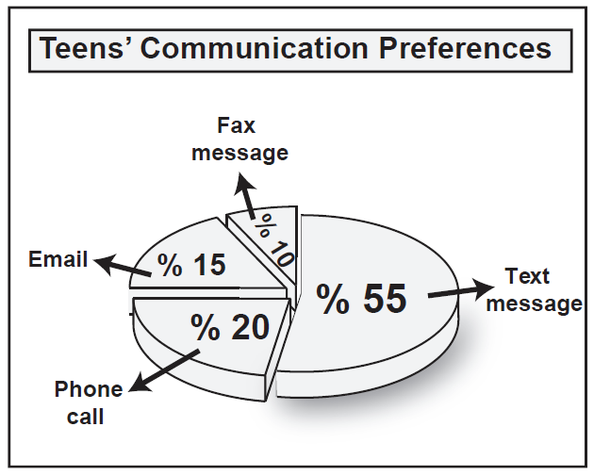

15.Teens…………………………

A. make phone calls most.
Fikri ÇEKİÇ
English Language Teacher
B. never prefer sending fax messages.
C. enjoy sending text messages at least.
D. send text messages more than emails.

16. Mom : What would you like to have for ………………. breakfast?
Daughter : - - - -.
Mom : Boiled or fried?
Daughter : Boiled please.

A. I want to eat some eggs
B. I never boil or fry potatoes
C. I prefer eating dessert after dinner
D. We need to buy some cheese and olive

17. You invite your best friend to your tea party.
She says that she is ill and refuses your
invitation politely.What would you say to
express your feelings about her illness?

A. I am sure you can come with us.
B. I hope you feel better soon.
C. I am happy to hear that.
D. I will call her later, then.

18. Ahmet:…………………………….?
Veysel: Nearly 50 in a day. I like exchanging
messages with my buddies.

A. How many text messages do you send in a day?
B. Why do you send text messages to your friends?
C. Do you usually text messages?
D. Who do you leave a message note for?

19. Tuğba: I don’t like technological devices
so I prefer………….communication
with my friends.

A. face-to-face B. e-mail

C. mobile phone D. social network

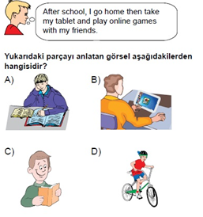
20.

