……………… ACADEMIC YEAR ……………………….. SECONDARY SCHOOL 1ST TERM 2ND ENGLISH EXAM FOR 7TH GRADES
Name- Surname: Class-Number:
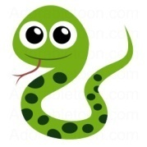
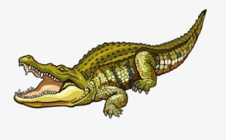
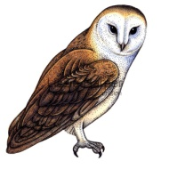
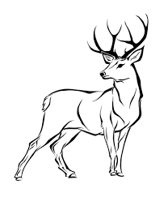
A. Write names of the animals under the pictures (15x2:30 pts.)
a) Shark b) Dolphin c) Octopus d) Cheetah e) Deer f) Bear g) Owl h) Eagle i) Seal j) Lizard k) Snake l) Tiger m) Crocodile n) Rhino o) Squirrel
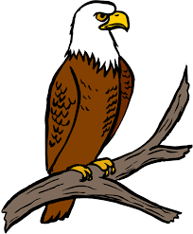
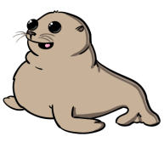
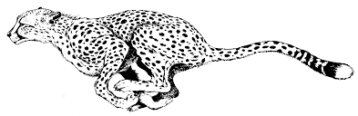

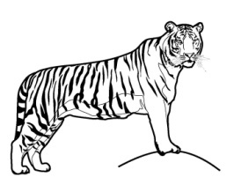
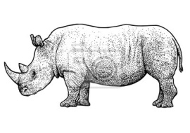
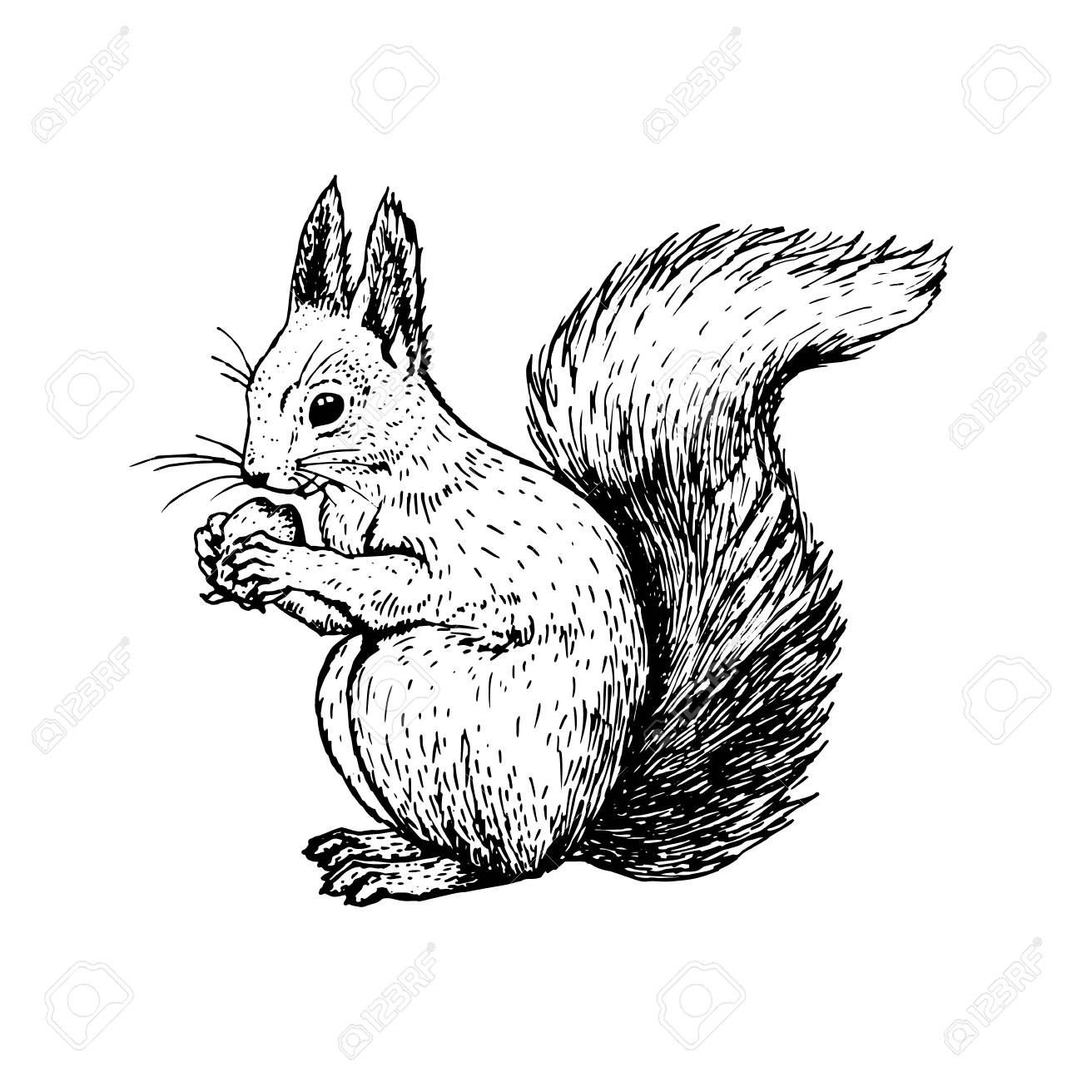



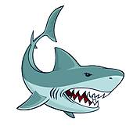
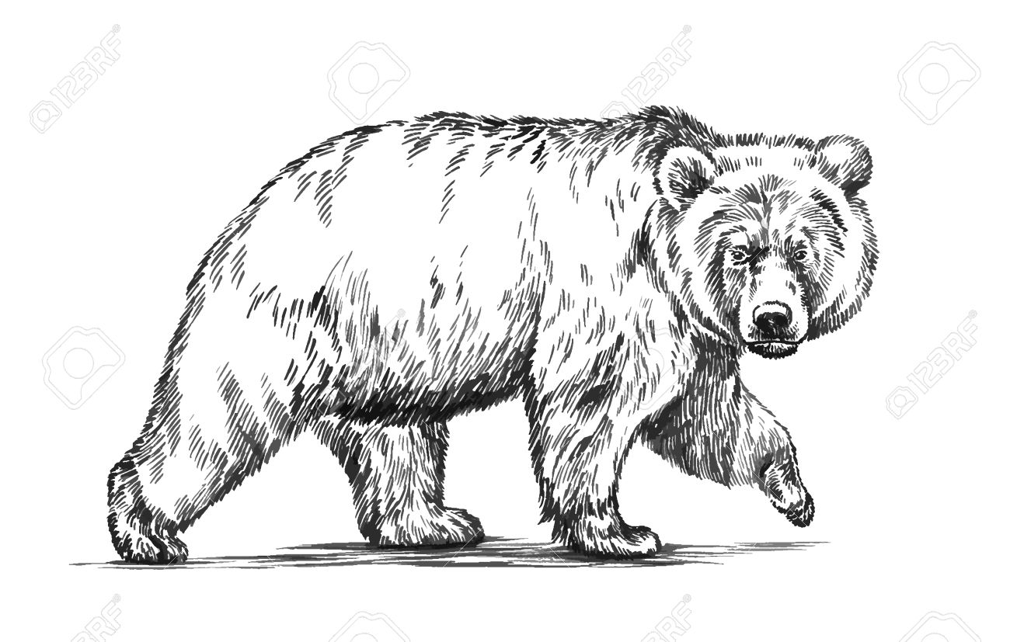
1._ Eagle__ 2. Cheetah 3.__ Deer___ 4.__Owl __ 5. __ Seal___ 6.__ Crocodile____ 7.__Snake___

8._ Tiger___ 9._ Shark__ 10.__Bear_____ 11. _ Lizard_ 12. Dolphin 13._Octopus_ 14._ Squirrel_ 15._Rhino_
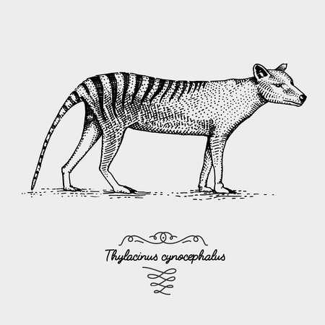
B. Read the text and write T (True), F (False) for the following statements. (5X2: 10 pts.)
Tasmanian tigers became extinct 82 years ago. They were carnivores and they mostly hunted kangroos, wallabies and birds. They lived in forests and grasslands in Australia and Tasmania Island. They could weigh up to 30 kg and measured up to 130 cm. They became extinct because people overhunted them and destroyed their natural habitat.
- Tasmanian tigers lived in Australia. _T__
- They weren’t herbivores. _T__
- They were 30 kg and 1.30 cm. _T__
- They became extinct 82 years ago. _T__
- They became extinct because of a meteor. _F__
C. Fill in the blanks by “should” or “shouldn’t”. (8x2: 16 pts.)

- We …should…….. keep the seas clean.
- We … shouldn’t….. overhunt fish.
- We… shouldn’t……… wear fur.
- We … shouldn’t…….. cut down trees.
- We …should…….. plant more trees.
- We … should….. protect wild life
- We …should….. save natural habitat.
- We … shouldn’t….. pollute our world.

D. Match the years. (4x2:8 pts)

1. 2010 (d) a) Nineteen oh eight
2.1908 (a) b) Seventeen Hundred
3. 1700 (b) c) Eighteen eighty one
4. 1881 (c) d) Two thousand ten

E. Match the questions with the answers.(5x2:10 pts)
1. What was his job? ..e... a. Yes, he did.
2. Where was Chomsky born? …d... b. He was born in 1928
3. Was he successful? …c... c. Yes, he won a lot of awards.
4. Did he write books? …a... d. He was born in Philedelphia, USA.
5. When was he born? …b... e. He was a writer and professor.

G. Write the past form of the given verbs. (10x1:10 pts)

1. Go __went___________
2. Cry __cried_____________
3. Watch __wached_____________
4. Be __was/were_____________
5. Eat __ate_____________
6. Die __died_____________
7. Take __took_____________
8. Win __won_____________
9. Fly __flew_____________
10. Have __had_____________

F. Choose the correct option.(8x2:16 pts)
1. Dodo birds are _______ animals.
a. extinct b. endangered
c. poisonous d. domestic
2. Hangisi yanlıştır?
a. Reptiles: Snakes and lizards.
b. Herbivores: Whales and dolphins.
c. Birds: Parrots and eagles.
d. Mammals: Bears and monkeys.
3. A:_________ was he born?
B: in 1938.
a. Where b. When c. What time d. Which
4. A:___________ you win a Nobel Prize?
B: Yes, I did.
a. Did b. Do c. Are d. Does
5. .Gökçen:What is your sister like?
Eylül:…………………………………
a. She is kind and helpful. b. She has got long hair.
c. She is beautiful. d. She is tall and slim.
6. They ………. at the library yesterday.
a. are b. were c. is d. was
7. A:…………. do you go to cinema?
B: Once a month.
a. How often b. When c. Where d. Why
8. They went to Antalya four days …….
a. before b. last c. ago d. yesterday



