…………….. EDUCATIONAL YEAR
AHMET AZMİ MAKBULE ELBERK SECONDARY SCHOOL
1ST TERM 3RD ENGLISH WRITTEN EXAM OF 7TH GRADES
Name-Surname : ______________________________ Class-Number: 7/___ & ______

A) Complete the sentences with “SHOULD” / “SHOULDN’T’’
- We ...shouldn’t...............................wear fur.
- We ....should...................................... protect nature reserves and our environment.
- We..... should.....................................stop cut down the forests.
- We...... shouldn’t................................... hunt animals.
- We....... shouldn’t................................... pollute the rivers and the seas.
- We........ should................................... stop overhunting.
- We........ should.................................. plant trees.
- We......... should................................. recycle.
B) Hayvanların isimlerini yazınız.
lion – elephant – bear – shark – giraffe – crocodile
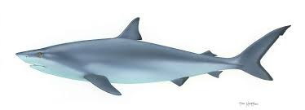
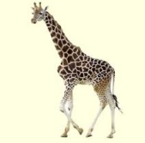
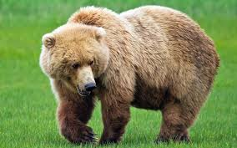
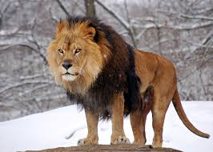
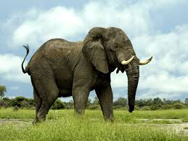
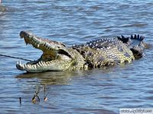

_ shark______ __crocodile____ _ elephant_____ __ giraffe_____ __ lion______ __ bear___
C)Write past forms of these words.
1) Meet -_met_______ 5) See___ - Saw 9) Lose - _lost______
2)Have - _had_______ 6) Write -_wrote____ 10) Come - _came____
3)Say__ - Said 7) Drive - _drove_____ 11) Go -_went_______
4)Break_- Broke 8 )Make - _made_____ 12) Win - won______

D) Choose the correct answer.
1) Today _____ Friday. Yesterday _____ Thursday.
a) was / is b) was /were c) is /was d) is / are

2) I was at cinema ________.
a) last week b) today c) this week d) now

3) I ________ in Ordu yesterday, now I ______ in Giresun.
a) was / am b) was /was c) am / was d) was /were

4) Ali and Ayşe ______ in Germany ten years ago , now they ______ in Turkey.
a) are / were b) was /is c) is / were d) were/are

5) I was ill __________ ,but I am fine _________,
a) today / yesterday b) yesterday / today c) now / today d) yesterday / last night

E) Choose the correct one
1) I saw / seed my friend last week.
2) We didn’t live / lived in İstanbul.
3) Did you went / go to the cinema ?
4)We played / plays football last Saturday .

1. Which one is wrong?
A)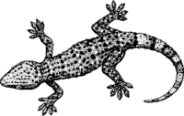B) 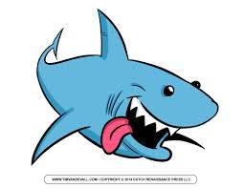
Lizard Ostrich

C) 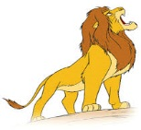 D) 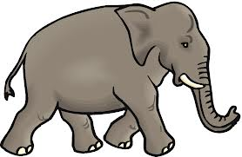
Lion Elephant
2. Superman is................. Ben10.
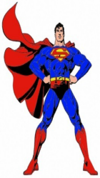
a)more crowded than
b)stronger than
c)lazier than
d)weaker than

3. 1972 (……………………..)
A) one thousand and seventy two
B) nineteen seventeen two
C) nineteen seventy two
D )nineteen seventy twelve

4.Which one is TRUE?
A) We should protect the endangered animals.
B) We should overkill the animals.
C) We shouldn’t protect forests.
D) We should overhunt the animals.

5)They are very big animals. They live in savannah.
They have two tusks, big ears and a trunk.

a) crocodiles b)lions c)elephants d)penguins

INDOOR | OUTDOOR
1) chess  2) table tennis  3) gymnastics  4)…………….. | 1)archery  2)horse-riding  3)soccer  4)………………………
6. Football is ………… tennis in Turkey.
A)popular more than B) the more popular
C)popular then D)more popular than

7.Görseli en iyi ifade eden seçeneği işaretleyiniz?
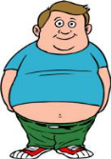
a)He is tall and well built with short curly hair
b)He is short and fat with short straight hair
c)He is short and slim with long hair
d)He is short and thin with long wavy hair

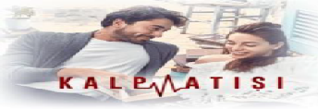

8) I like watching……………………… and ………………………
A)sitcom / documentary C) cartoon / TV series
B)news / quiz show D)talk show / TV series
9. I didn’t go to school .................... .
A. yesterday B. tomorrow C. at the moment D. everyday

10) Complete the table.
Appearance | Personality
attractive | generous
1 ………….. | 2……………

A) punctual/ well-built C) stubborn/ forgetful
B) overweight/ stubborn D) tall/ slim

11 )Caretta Caretta turtles are in danger.
We should ………………………
A)go hunting  B)sell them as pets  C)protect their habitats  D)plant more trees | 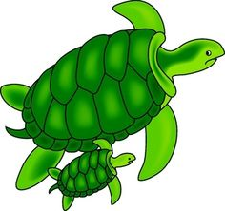
12.Aşağıdaki cümlelerde hangi hayvandan bahsedilmemiştir?
- It is a carnivores. It is king of the jungle.
- It has got a tusk. It is very big.
- It is a carnivores and reptile. It has sharp teeth.
A) b)
c)d) 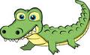
13) Boşluğa uygun olanlar hangi seçemektedir?

A) football / karate C) running / swimming
B) bowling / skiing D) scuba-diving / boxing
14)What kind of TV programme is it ?

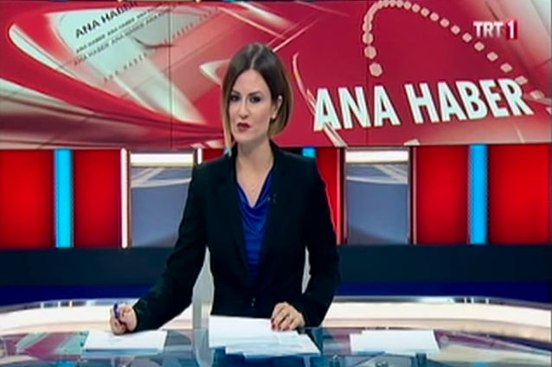
a) reality show
b) news
c) discussion
d) cookery show

