……………….. Secondary School 8th Grades 1st Term 2nd Written Exam
Name – Surname:__________________________ Class:_______ Number:_______
A) Match the questions and the answers. (5x2=10)
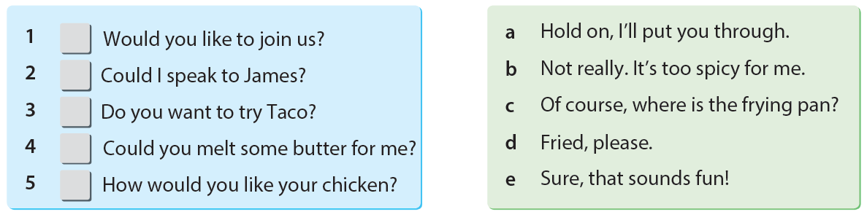

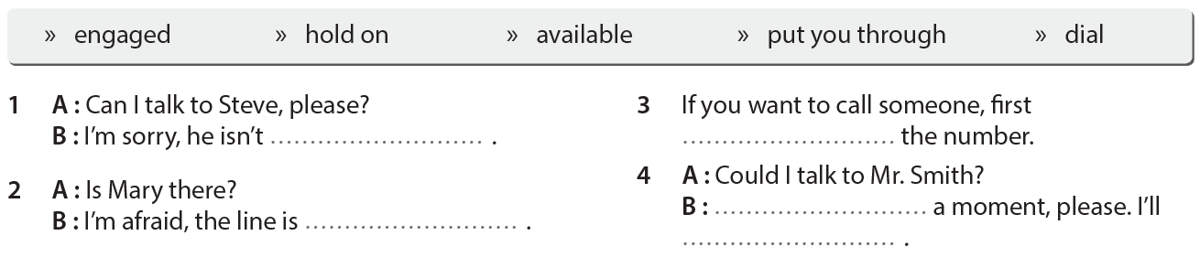
B) Put the words into the correct places. (5x3=15)

C) Choose the correct option. (5x3=15)
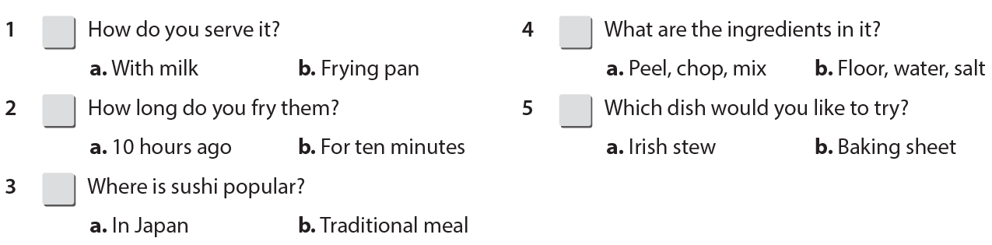

D) Match the words/phrases with the icons. (10x2=20)

Choose the best options. (10x4=40)

1. Sam: I always have breakfast.
Kyle: Really! I don’t have it all the time. - - - -?
Sam: Butter, some olives and some jam.

A) What time do you have your breakfast?
B) What do you usually have for breakfast?
C) When do you usually make it?
D) What would you like to drink?

2. John: Jane and I are going to have lunch. ………?
Tim: I’d love to, but I’m full. Thanks.

A) Where is the restaurant
B) Are you doing anything
C) Do you often eat out
D) How about joining us

3. Mike: Why do you like jazz music?
Jane: Because - - - - .

A) it’s really relaxing
B) it’s unbearable
C) I hate listening to music
D) I am not into jazz

4. Jenny: - - - - ?
Elizabeth: It’s very easy. Put some flour, yeast, salt
and warm water into a large bowl. Mix the ingredients and knead the dough. Then, bake it.

A) Why do you like pizza
B) How can I make bread
C) What do you need for a chicken soup
D) Which country is sushi from

5. Alan: - - - - , please?
Emma: All right. This is Emma Twain. My Number is 256 58 18.

A) Could I call back half an hour later
B) Could you tell me your address
C) Could I take your name and phone number
D) Could you wait a minute

6. You get some news on the phone. Your friend has got the flu and can’t join your slumber party. What do you say to your friend?

A) I’m sorry to hear that.
B) I hope you can make it.
C) I’m afraid, I can’t join you.
D) I think that is awesome.
7. I’m afraid she is not at home now, but ……..
A) wait for the response.
B) don’t hang up the phone, please.
C) you can call her on her mobile phone.
D) I’ll try to connect you.

8. TEENAGERS and Favorite Activities
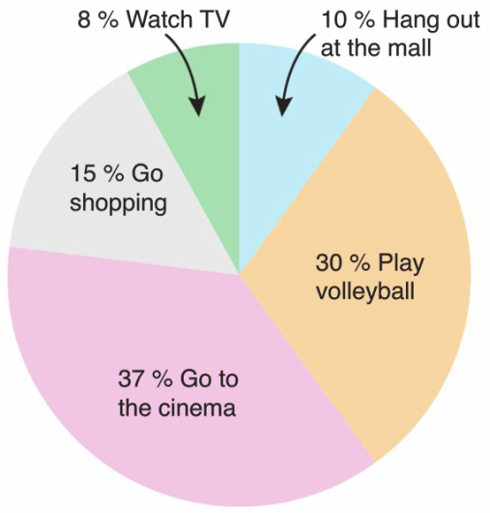

Teens……

A) hang out at the mall more than shopping
B) prefer going to the cinema most
C) don’t play volleyball
D) often watch TV

Answer the questions (9-10) according to the texts below.
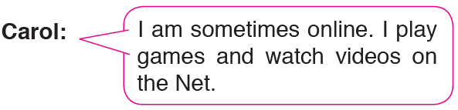

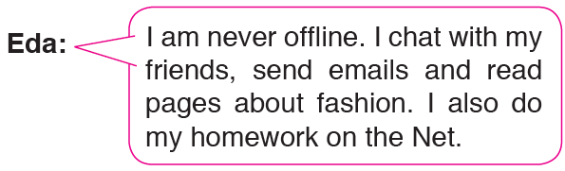

9. - - - - uses the Net for fun.

A) Carol B) Bruce C) Eda D) John

10. - - - - is an Internet addict.

A) Carol B) Bruce C) Eda D) John
