…………………………………………………. SECONDARY SCHOOL
………….. EDUCATIONAL YEAR 8th GRADE 1st TERM 2nd ENGLISH WRITTEN EXAM
Name-Surname: Class: Number: MARK:

A) FILL IN THE BLANKS WITH THE CORRECT WORDS. (16 pts)

slice crack peel sprinkle chop whisk dice spread

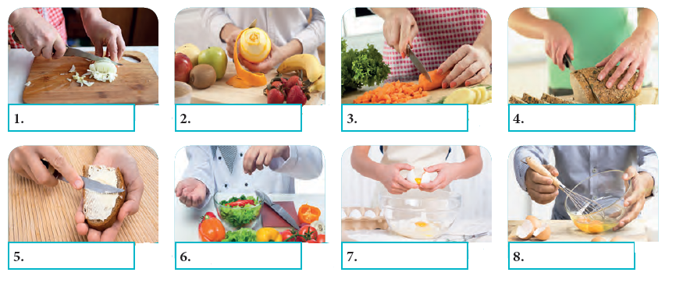

B) FILL IN THE BLANKS WITH THE CORRECT WORDS. (20 pts)
possible reserve addiction spell extension

stranger sorry useful polite emergency

1. If you know Mr. David’s ……extension……. number, please dial it, or the secretary will put you through to him.
2. I’m ……sorry………………………….to hear that you aren’t joining me tomorrow. We can meet up later then.
3. I think smartphones are …… useful ……………………. because they help us keep in touch with people easily.
4. Fiona called you today, and she asks you to get back to her as soon as ………………………………. .
5. Call center specialists should always be ……polite…………………………. to people and try to solve the problems.
6. I’d like to ……reserve…………………………. a room for three nights at your hotel.
7. One of the cons of smartphones is …… addiction ……………………. . Many people can’t live without them today.
8. Everybody should know the …emergency………. numbers so that they dial them immediately when there is a need.
9. Could you speak louder and ……spell…………………………. your name and surname, please?
10. Hello! A ……stranger…………………………. is sitting in my garden, and he is looking at my house. Please help!

C) MATCH THE WORDS WITH THEIR SYNONYMS. (14 pts)
1. engaged (…3.…) a. kind
2. hold on (….…) b. answer
3. polite (…4.…) c. say again
4. repeat (…6.…) d. communicate
5. pick up (…2.…) e. in use
6. keep in touch (….…) f. short tone
7. memo (…1.…) g. wait

D) PUT THE SENTENCES IN ORDER. (10 pts)
_3__ Secretary: I’m sorry, sir, but he is out at the moment. Would you like to leave a message?
_2__ Osman: Hi. Can I speak to Mr. Daniel, please? I’m his friend.
_1_ Secretary: This is Mr. Daniel’s Office. How may I help you?
_4__ Osman: That would be great. Can you please tell him to call me back as soon as he turns back? I’m Osman Eser.
_6__ Osman: E – S – E – R.
_5__ Secretary: How do you spell your surname?

E) MATCH THE WORDS WITH THE ICONS. (26 pts)
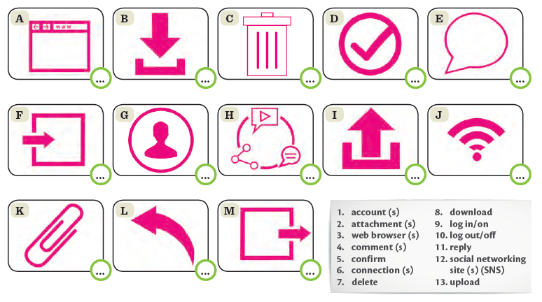
10
13
11
12
2
6
1
9
4
5
7
8
3

F) MATCH THE WORDS WITH THEIR DEFINITIONS. (14 pts)
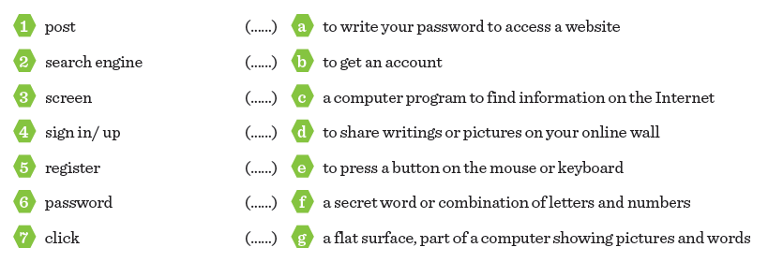
3
6
7
1
2
5
4

BONUS – ANSWER THE QUESTIONS. (10 pts)
How often do you use the Internet? I use the internet very often. I am an addict………………………………… .
Who uses the Internet in your family mostly? Definitely me …………………………………………………..……………………… .

Good Luck!

