…………….. ACADEMIC YEAR …………………. PAŞA SECONDARY SCHOOL 8th GRADES 1st TERM 2nd ENGLISH EXAM
Name & Surname: Number: Class: 8/
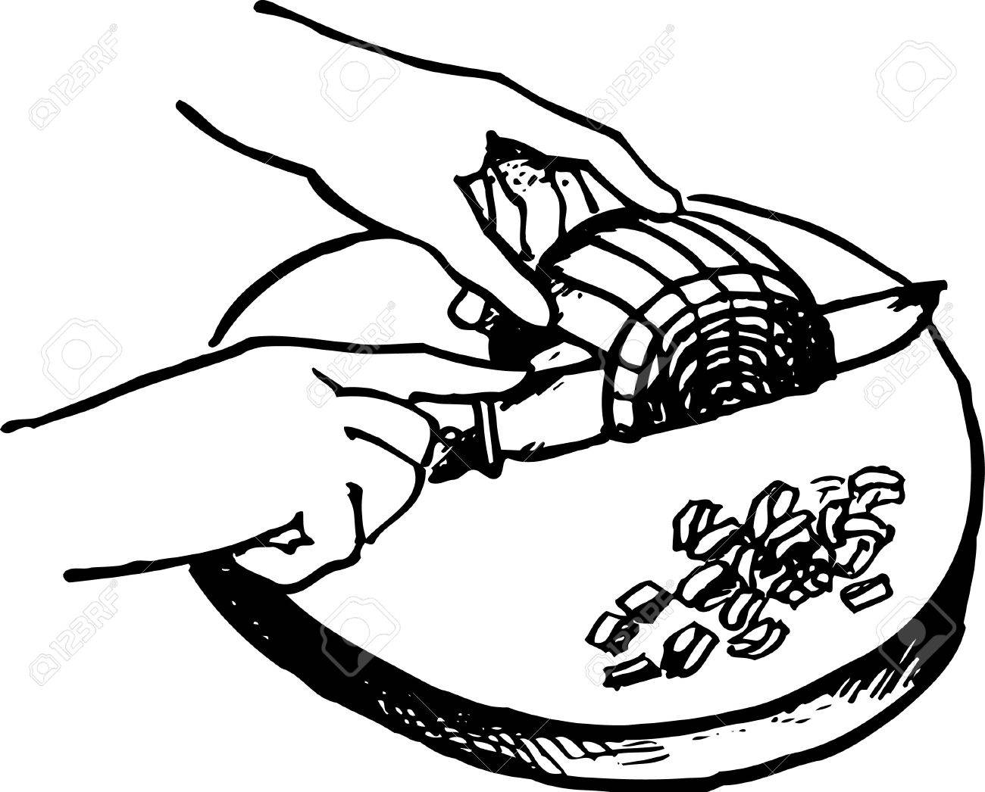
baking tray saucepan grater strainer knead mash dice peel spread slice fry grill pour crack whisk
A. Match the words with the pictures (15x2: 30 pts.)
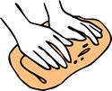
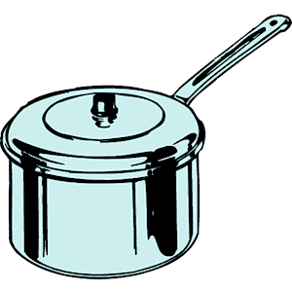

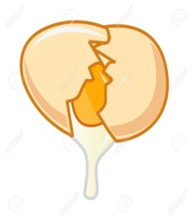
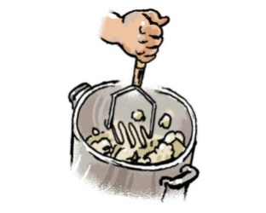
1.__________ 2.___________ 3.____________ 4._______________ 5.________ 6.________ 7._______

8.__________ 9.__________ 10.__________ 11._________ 12._______ 13._________ 14.________ 15.______
B. Fill in the table according to the invitation letter. (5x3: 15 pts.)
Hi Pınar,
We are organizing a birthday party on Saturday evening, 29th December. It is at 6 o’clock. It is at our house. Hope you can come.
Love,
Engin.
Sender | Receiver | Event | Date | Place

C. Find the od done. (5x3:15 pts.)
1. Detective / Fantasy / Jazz / Biographical
2. Trekking / Reading/ Cooking / Fascinating
3. Buddy /Map / Mate / Best friend
4. Salty / Sweet / Boil / Sour
5. Snob / Western / Comedy / Science fiction

D. Choose the correct option. (16x2: 32 pts.)

1. Jane is my buddy. She never tells my secret to anyone. I can always _____ her.
a) get on well with b) laid back
c) count on d) come along
2. A: Would you like to watch the film with us?
B: ________ because I have to do my homework.
a) Yeah, that would be great b) I’d love to but I can’t
c) It sounds great d) That sounds fun
3. Kate: ___________?
Meghan: I ‘m visiting my grandparents.
- What do you do after school
- What are you doing tomorrow
- What kind of movies do you like
- What would you like to drink
4. Harry: Do you ______ with you brother?
William: Yes, we have good relationship.
a) pick up b) come over c) tell lies d) get on well
5. Lily never worries about anything. She doesn’t care what other people think. She is ______.
a) loyal b) generous c) laid back d)snob
6. I prefer listening to heavy metal to pop music because I think it is _____.
a) unbearable b) terrific c) ridiculous d) boring
7. Tina: I’m going to a book fair tomorrow. Would you like to join me?
Mike: ______ I’m not fond of books.
a) Yeah, why not? b) to be honest
c) That sounds good. d) Sure.
8. Ann: ___________?
Mary : Mostly rock and jazz.
a) What kind of music do you like
b) Do you like rock and jazz
c) Which instrument can you play
d) Who is your favorite singer
9) Kate is fond of desserts. She _________.
a) has a sweet tooth b) likes salty food
c) has her own restaurant d) is a chief
10. I’m not keen on künefe because it is too _______.
a) salty b) sour c) bitter d) sweet
11. _______ the rice under running water before you add it into the pot.
a) mash b) slice c) rinse d) dice
12. Cathy: May I speak to Henry, please?
Anne: ___________________
Cathy: Oh, sorry. Good bye
a) I think you have got the wrong number
b) Who is calling?
c) Hold on a moment please
d) Would you like to leave a message
13, 14, 15ve 16. Soruları verilen telefon konuşmasına göre cevaplayınız.
Peggy: Hello, Arthur. _13_is Peggy. __14_
Arthur: __15_ a moment, please. I’ll __16__him.
13. a) He b) I c) Who d) This
14. a) Who is calling? b) It is a bad line
c) Is your brother in? d) That’s beter.
15. a) Get up b) Hold on c) Keep on d) Get back
16. a) watch b) kick c) hang d) get
E. Put the sentences into the correct order. (4x2: 8 pts.)
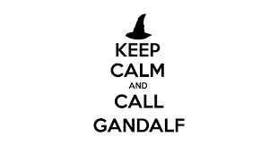
(….) I’m sorry he isn’t available now. Would you like to leave amessage?
(….) Hello, this is Frodo. Is Gandalf there?
(….)No, thanks. I’ll call him later.
(….)Don’t hang up the phone, please. I’ll check him.

