………… ACADEMIC YEAR BARDAS VAV SECONDARY SCHOOL 1st TERM 2nd ENGLISH EXAM FOR 8th GRADES
NAME-SURNAME:
- Berk : Hello.Is Can here?
Can’s mother: I am afraid. .....................................
a) Hang on a minute, please.
b) This is his friend.Berk
c) He is not available at the moment.
d) I’ll get him.
2. Aksel: Hello, Aksel speaking.
Ebru: Hello, can I speak to Esra, please?
Aksel: I can’t hear you well ................................. .
a) Would you like to leave a message?
b) He isn’t available at the moment
c) Could I ask who is calling?
d) It is a bad line.
Hi, Amanda
I am going to have a barbeque with my friend Jane and Tina on Saturday afternoon. We are going to have fun together. If you are not busy on Saturday afternoon, would you like to join us? We are going to go there with bus. We are going to meet at Green Park at half past twelve p.m.. I hope you will come.
Take care Sally
3.Who is the receiver of the e-mail?
a) Sally b) Amanda c) Tina d) Jane
4.What is the activity?
a) They are going to meet at Green Park.
b) They are going to have a barbeque.
c) They are going to meet at 12:30.
d) They are going to go by bus.
5.A : What’s your favourite dish ?
B : It’s Jacket Potato.
A : ……………………………….. ?
B :Potato, butter ,cheese and salt
A) How do you cook it ?
B) What are the ingredients ?
C) Do you like spicy things ?
D) Who cooks it for you?

6. A : Do you like rap music ?
B :No I don’t like rap music because it is …………………
A) unbearable B) awesome
C) fabulous D) great
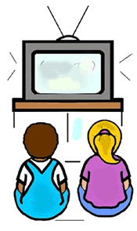

7.



- I don’t prefer reading books to watching tv
- I prefer watching tv to reading books
- I would rather watch tv than read books
- I prefer reading books to watching tv

8. )Yasemin is my true friend in the class. She - - - -
A) always tells me a lie. B) always backs me up.
C) never encourages me.D) eats alone

9. Which of the matchings is FALSE?

- 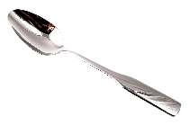- Knife
- - Bowl
- 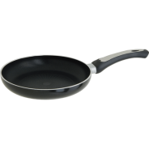- Frying pan
- 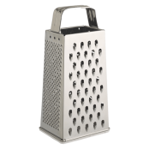 - Grater
10.Jane : I am bored.Let’s do something.
Tom:Ok.How about watching horror film?
Jane:I am sorry but I don’t like horror films.
Tom:_________________________?
Jane:I like comedy films.
A)What kind of films do you like?
B)How do you watch films?
C)How often do you watch films?
D)Where do you watch films?

11. a)First crack 2 eggs into a bowl.
b)Bake it for about 25 minutes.
c) Pour the mixture into a frying pan
d)Slice and serve it.
e)Add sugar,oil,milk and flour.
f)Stir the mixture.

A)c-d-f-a-b-e
B)a-f-e-b-d-c
C)a-e-f-d-b-c
D)a-e-f-c-b-d

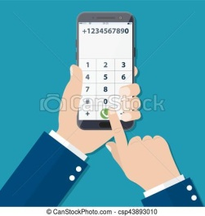
12.

A)hang on B)dial
C)put through D)take a memo

13.
Kylie:Mum! I am hungry.




Kylie’s mum:Ok honey.I _________prepare a sandwich for you.
Kylie:Thank you mum.

A)am going to B)will
C)are going to D)won’t



14.

A)match - rope - sleeping bag
B)torch - rope - compass
C)rope - compass - match
D)pocket knife – compass – match

15. Your friend invites you to a party but you won’t join and want to make an excuse. You say:
Yukarıda bir durum verilmiştir.Buna uygun ifadeyi işaretleyiniz.
A)Ok.Where is the party?


B)I like parties.Of course I will join.
C)That sounds great.
D)I am sorry but I have headache.

16. First, peel the bananas and kiwi fruit. Second, cut them into small pieces. Put them into a small

bowl, then add some grapes and cranberries.

Next, cut the strawberries into halves. After that,
squeeze the lemon. Finally, add the lemon juice
and honey.
This is the recipe of ___________.
A)meatball B)muffin
C)fruit salad D)cheesecake
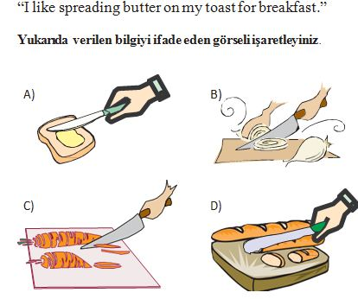
17.

18. While you are making pasta first you should ……….

A) Crack the eggs B) Boil the potatoes
C) Grate the cheese D) Boil the water

19. “Add some olive oil.”

- B) C) D)
20.
Jane : Hello, Jane speaking. Can I speak to Kenan please?
Rüzgar : Hi, Jane. I am sorry,he is out now._________________________?
Jane: No, thanks. I’ll call back later.

A) he is not available at the moment.
B) could you hold on a moment?
C) would you like to leave a message?
D) could you please repeat that?

Match the words with the icons.
Download – upload – account – delete –social media



__________ _________

____________

__________ __________

