Name & Surname:
A
1. Jason always ..................... when I have a probem. I’m lucky to have a friend like him.
A) meets up B) counts on me
C) backs me up D) picks me up

2. You want to invite your friend to the cinema. What do you say?
A) How often do you go to the cinema?
B) Why don’t you invite me to the cinema?
C) Are you going to the cinema on weekends?
D) What about going to the cinema?

3. Anna is a(n) ..................... person. She always helps other people.
A) self-centered B) caring
C) honest D) mean

4. 
I and my friend Camilla always go .....................
A) skating B) cycling
C) trekking D) bungee jumping

5. A: ..................... do you go shopping?
B: Three times a week.
A) What kind of B) When
C) How long D) How often

6. I really don’t love rock music. I can’t stand it. I think it is .....................
A) unbearable B) harmonic
C) impressive D) amazing

7. Our school football match is .......... March.
It is going to start .......... 17:30 .......... Saturday.
A) at / in / on B) in / at / on
C) in / on / at D) on / at / in

No:

8. 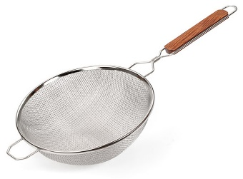 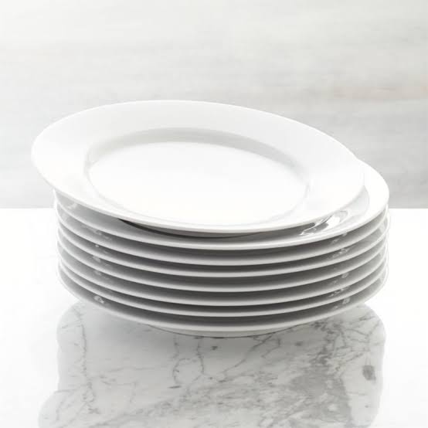
A) strainer - surface
B) saucepan - plate
C) strainer - plate
D) bowl – baking tray

9. My mother will cook my favourite ....................
A) cuisine B) mixture
C) dessert D) dish

10.
Ways of Cooking | Kitchen Tools
grill | .....................
..................... | cake pan
boil | teaspoon

A) knead / oven B) roast / frying pan
C) cake pan / steam D) slice / bowl

11. Girl : Mom, what sould I do?
Dad : First, ................... the potatoes. Second, ................... the potatoes and then ................... them.

A) grate - put - mash B) dice - peel - put
C) mash - peel - slice D) peel - dice - mash

12. ................... the oven and and put the cake in it.
A) Heat B) Raw
C) Crack D) Place

13. 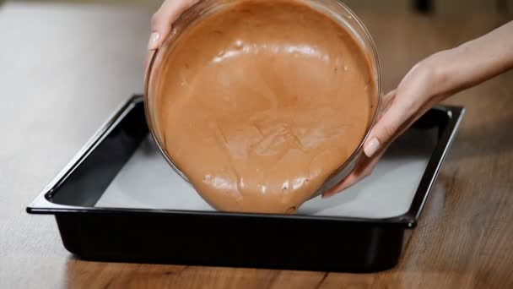

................... the mixture into a cake pan and ................... it for 30 minutes.
A) Pour / bake B) Roast / knead
C) Slice / fry D) Boil / steam

14. A: ...................................................?
B: I always prefer fried eggs. I think it is more delicious.
A) What do you want for dinner?
B) When do you prefer eggs?
C) How do you like your egg?
D) How often do you eat fried eggs?

15. Turkish people usually ..................... chicken with rice.
A) place B) serve
C) add D) grate

16. A: I’d like to make some chocolate sauce. ........................................................
B: Of course. It is very easy. First, chop some chocolate into pieces and mix them with some milk.
A) Do you prefer eating cake?
B) Do you know how to make it?
C) Would you like to have any dessert?
D) Do you like chocolate on your ice cream?

17. 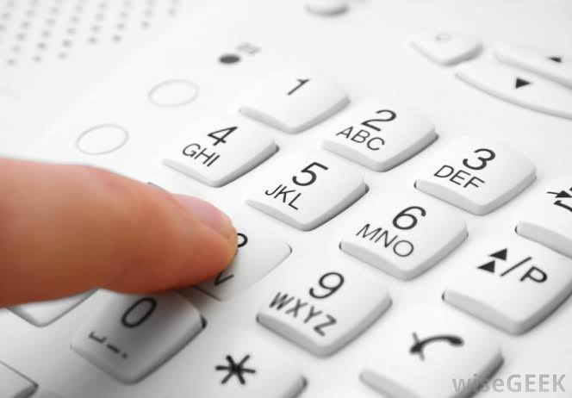
A) push B) line
C) text D) dial

18. A: Hello, can I speak to Mary?
B: I am sorry but she is not available now.
........................................................
A: No, thank you. I will call her later.
A) Could you ask her to call me?
B) Can you hold on a minute?
C) Would you like to leave a message?
D) Who is speaking?

19. A: Hello, Peter .................... Can I speak to Tom?
B: Hang on a minute please. I’ll get him.
A) speaking B) repeating
C) sending D) holding

20. Dad: How do you .................... with your friends?
Son: I usually use social networks.
A) hang up
B) keep in touch
C) use
D) put through

21. 
Betty is .......................... now.
A) translating a message
B) writing a letter
C) sending an e-mail
D) texting a message

22. Make a dialogue.
(I) Yes please, can you tell her that Daisy called?
(II) I am afraid she is not here. Can I take a message?
(III) Hello, this is Daisy. May I speak to Sue please?
(IV) Sure. I will give her the message when she comes.

A) III - II – IV - I
B) I - IV – III - II
C) III - II – I - IV
D) II - III – I - IV

23. A: Hi, I want to speak to Tom.
B: Hang on a minute. I’ll ..................... him
A) ring B) get
C) leave D) hang

24. Linda: Mom, your phone is ringing.
Mom: Oh no, I am busy. .....................
Linda: Okay.
A) Can I answer it?
B) Can you please hang it up?
C) Can I call back later?
D) Can you pick it up for me?

25. If I am not in the office, you can always call me on my .....................
A) smartphone
B) application
C) appointment
D) phone call

Good luck!

Erkan TOY
English Teacher

Name & Surname:
B
1. Anna is a(n) ..................... person. She always helps other people.
A) self-centered B) caring
C) honest D) mean

2. Jason always ..................... when I have a probem. I’m lucky to have a friend like him.
A) meets up B) counts on me
C) backs me up D) picks me up

3. You want to invite your friend to the cinema. What do you say?
A) How often do you go to the cinema?
B) Why don’t you invite me to the cinema?
C) Are you going to the cinema on weekends?
D) What about going to the cinema?

4. Our school football match is .......... March.
It is going to start .......... 17:30 .......... Saturday.
A) at / in / on B) in / at / on
C) in / on / at D) on / at / in

5. I really don’t love rock music. I can’t stand it. I think it is .....................
A) unbearable B) harmonic
C) impressive D) amazing

6.
I and my friend Camilla always go .....................
A) skating B) cycling
C) trekking D) bungee jumping

7. A: ..................... do you go shopping?
B: Three times a week.
A) What kind of B) When
C) How long D) How often

No:

8. A: ...................................................?
B: I always prefer fried eggs. I think it is more delicious.
A) What do you want for dinner?
B) When do you prefer eggs?
C) How do you like your egg?
D) How often do you eat fried eggs?

9. ................... the oven and and put the cake in it.
A) Heat B) Raw
C) Crack D) Place

10. A: I’d like to make some chocolate sauce. ........................................................
B: Of course. It is very easy. First, chop some chocolate into pieces and mix them with some milk.
A) Do you prefer eating cake?
B) Do you know how to make it?
C) Would you like to have any dessert?
D) Do you like chocolate on your ice cream?

11. Turkish people usually ..................... chicken with rice.
A) place B) serve
C) add D) grate

12. My mother will cook my favourite ....................
A) cuisine B) mixture
C) dessert D) dish

13.

................... the mixture into a cake pan and ................... it for 30 minutes.
A) Pour / bake B) Roast / knead
C) Slice / fry D) Boil / steam

14.
A) strainer - surface
B) saucepan - plate
C) strainer - plate
D) bowl – baking tray

15. Girl : Mom, what sould I do?
Dad : First, ................... the potatoes. Second, ................... the potatoes and then ................... them.

A) grate - put - mash B) dice - peel - put
C) mash - peel - slice D) peel - dice - mash

16.
Ways of Cooking | Kitchen Tools
grill | .....................
..................... | cake pan
boil | teaspoon

A) knead / oven B) roast / frying pan
C) cake pan / steam D) slice / bowl

17.
Betty is .......................... now.
A) translating a message
B) writing a letter
C) sending an e-mail
D) texting a message

18. If I am not in the office, you can always call me on my .....................
A) smartphone
B) application
C) appointment
D) phone call

19. A: Hello, Peter .................... Can I speak to Tom?
B: Hang on a minute please. I’ll get him.
A) speaking B) repeating
C) sending D) holding

20. A: Hi, I want to speak to Tom.
B: Hang on a minute. I’ll ..................... him
A) ring B) get
C) leave D) hang

21. Make a dialogue.
(I) Yes please, can you tell her that Daisy called?
(II) I am afraid she is not here. Can I take a message?
(III) Hello, this is Daisy. May I speak to Sue please?
(IV) Sure. I will give her the message when she comes.

A) III - II – IV - I
B) I - IV – III - II
C) III - II – I - IV
D) II - III – I - IV

22. A: Hello, can I speak to Mary?
B: I am sorry but she is not available now.
........................................................
A: No, thank you. I will call her later.
A) Could you ask her to call me?
B) Can you hold on a minute?
C) Would you like to leave a message?
D) Who is speaking?

23. Dad: How do you .................... with your friends?
Son: I usually use social networks.
A) hang up
B) keep in touch
C) use
D) put through

24. Linda: Mom, your phone is ringing.
Mom: Oh no, I am busy. .....................
Linda: Okay.
A) Can I answer it?
B) Can you please hang it up?
C) Can I call back later?
D) Can you pick it up for me?

25.
A) push B) line
C) text D) dial

Good luck!

Erkan TOY
English Teacher

