MEHMET AZMAN ÇAVUŞ SECONDARY SCHOOL ………….. ACADEMIC YEAR
7TH GRADES ELECTIVE ENGLISH LESSON I.TERM II.WRITTEN EXAM
Name&Surname: Number: Class: Point:

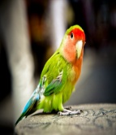
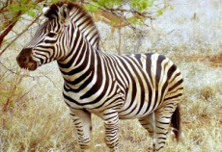
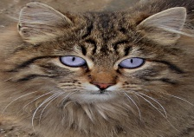
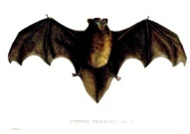
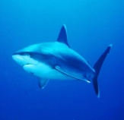
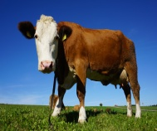
A. Match the sentences with the pictures.(7x2=14 p)


(H) (C) (D) (F) (G) (B) (E)
A. It lives in Australia. It can jump. It carries its baby in its pouch.
B. It is colorful. It can talk. It lives in tropical forests.
C. It is big and dangerous. It lives in the ocean. It has got sharp teeth.
D. It has got wings. It sleeps all day. It can fly.
E. It is white and black. It eats fish.
F. It is small and friendly. It has got whiskers. It doesn’t like dogs.
G. It has got stripes. It looks like a horse. It eats leaves and plants.
H. It is a farm animal. It gives milk. It’s not dangerous.

B.Complete the sentences with given words. One word is extra.(5x2=10 p.)
extinct / poisonous / deserts / pouch / polar bears / enormous

1. Camels live in … deserts ……….…………
2. A kangaroo carries its baby in its… pouch…………….
3. Elephants are … enormous…….... land animals.

4. Siberian tigers are becoming … extinct…….….. in the wild day by day
5. Some kinds of snakes are … poisonous…………..

C. Read the text and write TRUE or FALSE.(7x2=14p.)
Pandas are mammals. Pandas are black and white. They have black circles around their eyes. They can see very well. They like climbing trees. When babies are 7 months old, they can climb trees. They live in the bamboo forests of Western China. They are herbivores. They like eating bamboo leaves very much. They spend 12 hours a day on eating. They can live between 15-20 years in the wild. They are endangered animals because of the loss of habitat. People are cutting down the bamboo trees to do farming in this area.

1. Pandas have white circles around their eyes. …T…….
2. Pandas are good at seeing. …T…….
3. Pandas hate climbing trees. …..F…

4. Pandas like eating meat. ……F….
5. Panda’s favorite food is bamboo leaf. ……T….
6. They spend all the day on eating. …..T…..
7. Pandas are in danger of becoming extinct. ….T…..
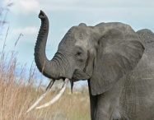
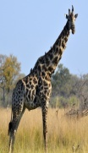
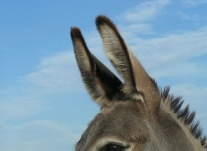
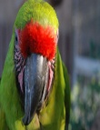

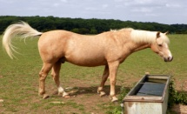
D. Match the pictures with the words.(10x2=20 p)
D
F
B
E
C
A

G
I
H
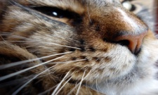
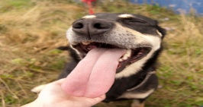

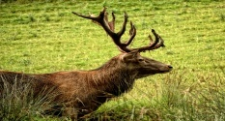
44
J

1. feather …B………. 2. whiskers …H……… 3. wing ……I….. 4. trunk …D………. 5. horns ……G………….
6. tongue ……J……….. 7. ears ……E…………. 8. neck ……F…………. 9. tail ……A………. 10. beak ……C………
E. Complete the sentences by using the verbs in bracelets in Simple Past Tense.(5x2=10 p)
1. Mike …forgot……….…….. (forget) to post the letters.
2. Jack ……spent……………….(spend) all her money on new t-shirts.
3. Patrick ……hid……………… (hide) behind the tree.
4. We …came………….……. (come) home at four o’clock in the afternoon.
5. A snake ……bit…………… (bite) him yesterday.

F. Look athe pictures and write “am”, “is”, “are,” “was” or “were”. (10x2=20 p.)


1. There …was…………….. a bird in the cage ten minutes ago but now it ……is………… empty.



2. I …am……………………… at work today but last weekend I …was…………. on a cruise holiday.

3. Mt. Stewart ……was………………….. a soldier twenty years ago but now he ………is………………. retired.


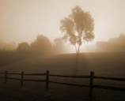

4. My sons ……was……… in primary school in ten years ago but now they ……are……….. university students.

5. Today it ……is…………… sunny but yesterday it …was………… foggy.

G. Choose the best option. (6x2=12 p.)
1. Martin ………………….. hazel eyes and black hair.
a) has got b) have got
c) is d) are
2. Natalie ………………….of medium height and thin.
a) am b) is
c) have got d) has got
3. Kate is never late for her appointments. She is……….
a) forgetful b) thoughtful
c) honest d) punctual

Complete the dialogues (4-6 questions).

Chris: Who won the match?
Lara: Nobody. It was a /an …………….
a) lose b) win
c) beat d) draw

5. Susan: Andrew is interested in outdoor sports.
Catherine: Really?
Susan: Yes, …………………………….
a) he goes hiking at the weekends.
b) he goes swimming in the sports center on weekdays.
c) he goes fencing at the weekends.
d) he plays handball on weekdays.
6. A: ………………………………………….
B: Greg is losing two to one.
a) How often does Greg have a match?
b) How old is Greg?
c) How is Greg doing in the match?
d) How many times did Greg have a match?

1- | 2- | 3- | 4- | 5- | 6-

Good Luck! Demet KOÇOĞLU Time: 40’

