………….. Eğitim-Öğretim Yılı Kadışehri İmam-Hatip Ortaokulu 5. Sınıf Birinci Dönem Birinci Yazılı
Name: Surname: Number: Class:

- Match the wild animals’names with their pictures.
a. Lion – b. Zebra – c. Rhino – d. Elephant – e. Owl – f. Mustang – g. Chamelon –
h. Eagle – ı. Bear – i. Gorilla – j. Panda – k. Giraffe – m. Parrot – n. Hippo – o. Tiger
 | 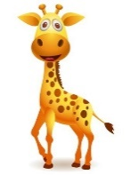 | 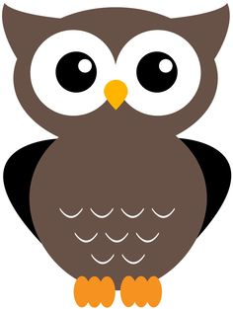 | 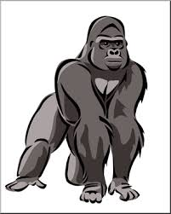 | 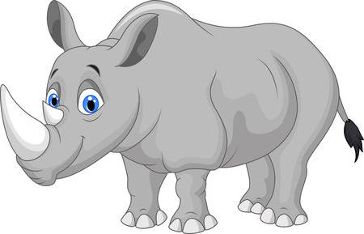 | 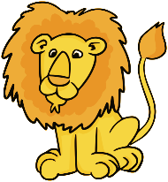 | 
Elephant | Giraffe | Owl | Gorilla | Rhino | Lion | Parrot
 |  | 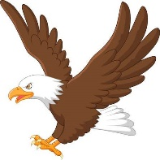 | 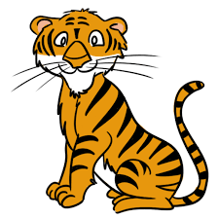 |  | 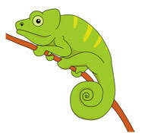 | 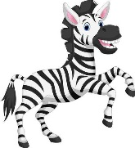
Hippo | Panda | Eagle | Tiger | Mustang | Chamelon | Zebra

- Fill in the blanks according to the pictures given.
Cheetahs………………….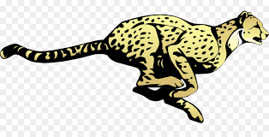 can run very fast. They eat …meat………………. 
Monkeys………… can climb a tree. They eat …banana……… They live in the…forest……………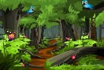 Snakes……….. are poisonous. They are reptile….…. (sürüngen). They live in the …jungle………
Dolphins……… can swim. They eat small …fish……………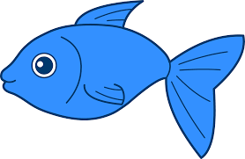They live in the …sea………
Polar bears…………….  are white. They live in the …Arctic………………….

- Use SHOULD or SHOULDN’T according to the sentences below.

- We should protect wild animals.
- We should adopt an animal.
- We sholuldn’t hunt animals.
- We shouldn’t pollute air and rivers.
- We shouldn’t put the animals in cages.
- We shouldn’t cut down trees.

- Match the TV programs’ names with their pictures.
a. Soap opera – b. cartoon – c. news – d. quiz show – e. cookery –
f. documentary – g. chat show – h. reality show – i. music show – j. sport programme
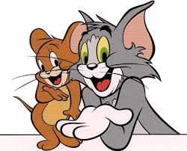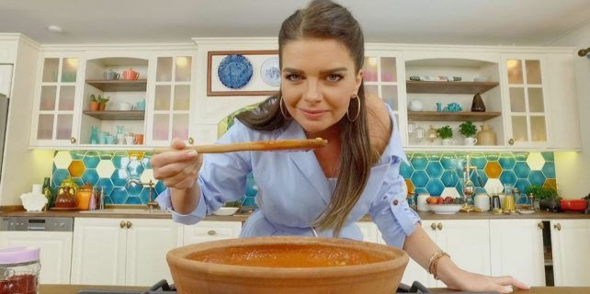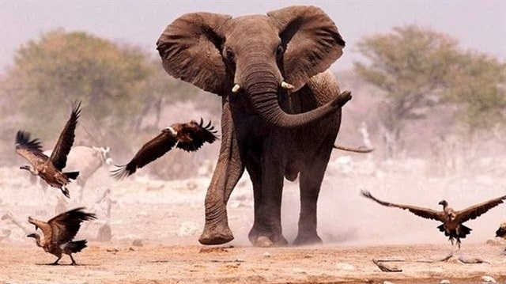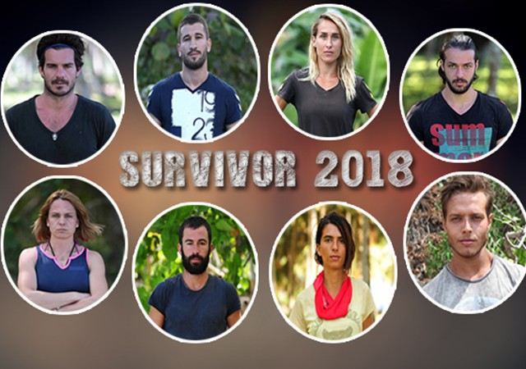
1 cartoon 2 cookery 3 documentary 4 music show5…news. 6quiz Show 7 reality Show 8 Soap opera

- Put a tick or a cross according to the sentences.
 | Romantic Films | Horror Movies | Police Drama | Sports Programme | Talk Show | TV Series
Alex
Sam
Tom
Ann
Pam

- Hello, my name is Alex. I like romantic films and horror movies. I don’t like talk show and TV series.
- Hi, I am Sam. My favorite TV programme is sports programme. I am not keen on series and police drama.
- Hello, my name is Tom. I love talk show and police drama. I don’t love sports programme.
- Hi I am Ann. I am not keen on romantic films. I am keen on TV series. My favorite is sports programme.
- Hello, my name is Pam. I like police drama but I don’t like horror movies. My favorite TV programme is talk show.

- Choose the best answer.

- Where does dolphins live?
- Jungle
- River
- Sea
- Mountain

- What does polar bear eat?
- Vegetables
- Fruit
- Honey
- Fish

- What type of animal is snake?
- Reptile
- Fish
- Bird
- Cat

- What type of TV programme is ‘Diriliş Ertuğrul’?
- News
- Soap Opera
- Cartoon
- Documentary

